
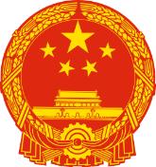
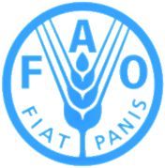

FAO/ GLOBAL ENVIRONMENT FACILITY
PROJECT DOCUMENT
Project Title | On-farm Conservation and Sustainable Use of Genetic Diversity of Crops Originated in China
FAO Project Symbol | GCP/CPR/061/GFF
GEF Project ID | 9876
Recipient Country | People’s Republic of China
Executing partner(s) | Ministry of Agriculture and Rural Affairs
Expected EOD (Starting Date): | October 2019
Expected NTE (End Date): | September 2024
Contribution to FAO’s Strategic Framework | FAO’s Strategic Framework (reviewed, 2017):  Strategic Objective 2: Make agriculture, forestry and fisheries more productive and sustainable.  Strategic Objective 4: Enable more inclusive and efficient agriculture and food production systems.  Country Programming Framework (2016-2020):  Priority Area: Fostering sustainable and climate-resilient agriculture development, Output 1.1 and Output 1.2
Contribution to GEF TF Focal Area Strategic Objectives and Programs | BD-3: Sustainable Use Biodiversity, Program 7: Securing Agriculture’s Future: Sustainable Use of Plant and Animal Genetic Resources
Environmental and Social Risk Classification | low risk moderate risk € high risk €
Gender Marker | G0 € G1 € G2a G2b €
Financing Plan:  GEF-TF Resources:  Co-financing:  Ministry of Agriculture and Rural Affairs (Government, in-kind)  Agriculture Department of Hebei Province (Government, in-kind)  The People’s Government of Muling City, Heilongjiang (Govt, in-kind)  The People’s Government of Kaiyuan County, Liaoning (Govt, in-kind)  The People’s Government of Yuangjiang County, Yunnan (Govt, in-kind)  Youtehulian Zhangjiakou Agriculture Technology Co. Ltd (Private, in-kind)  Zhangjiakou North Oat Food Development Co. Ltd (Private, in-kind)  Li-feng Yuan Farmers’ Professional Cooperative, Muling City (Private, in-kind)  Liaoning Bonong Soybean Planting Cooperative (Private, in-kind)  Yunnan Guyutian Agriculture Development Co. Ltd (Private, in-kind)  Food & Agriculture Organization of the UN (UN organization/ GEF Agency, in-kind)  Sub-total Co-financing  Total Project Budget |  | All figures in USD  2,725,688  3,080,000  3,465,000  3,465,000  4,969,320  3,465,000  270,000  115,000  385,000  385,000  385,000  250,000  20,234,320  22,960,008
Project Summary:
The project contributes to the People’s Republic of China-GEF Partnership Program for Sustainable Agricultural Development, an innovative program to mainstream in situ conservation of agrobiodiversity across China and reduce key threats to globally significant genetic resources for food and agriculture (GRFA). This child project, as part of the program, is designed to mainstream on-farm conservation and sustainable use of traditional genetic diversity of four key, indigenous crops, namely millet, oat, rice and soybean. The target crops were selected as they originate in China; hence their mainstreaming contributes towards strengthening the sustainable use of China’s globally important agrobiodiversity. The project aims to enhance national and provincial policy frameworks; strengthen institutional capacities; establish innovative and sustainable on-farm conservation practices integrating economic benefits for local communities; improve knowledge management to document and disseminate project results; and, institutionalize lessons learnt and best practices for replication and scaling-up.
A key focus of the project is demonstration of innovative, community-based and incentivized approaches that support the achievement of long-term agrobiodiversity conservation and sustainable development outcomes. Participatory approaches that integrate sustainable management of traditional crop varieties and enhanced socio-economic benefits for local communities will be implemented in five project demonstration sites: oats and millets in Hebei province; soybean in Heilongjiang province; soybean in Liaoning province, and rice in Yunnan province. The selected traditional crop varieties are: DaBaigu (for millet); Sanfensan (for oat); Suinong4 (for soybean in Heilongjiang); Kaiyu9, Kai8157 and Dabaimei (for soybean in Liaoning); and Mazha Gu and Hongehzi Gu (for rice in Yunnan). The varieties were selected for their suitability to the local environment and/or higher nutritional content.
The direct project benefits are expected to reach more than 6,600 people in the project demonstration sites. Engagement with women federations is undertaken in a cross-cutting manner, focusing at the grassroots level to ensure that project interventions address the needs of women in relation to the local agrobiodiversity systems. The project will enhance existing policy and strategic frameworks at the national level and in the four target provinces, encompassing the promotion of incentivized mechanisms and the role of women and youth in agrobiodiversity conservation as around 48% of the resident population are females while 20% are aged between 15 to 30 years in the target sites. Institutional mechanisms will also be strengthened at the central level and in the target provinces to ensure a coordinated and synergistic approach to on-farm conservation and sustainable use of agrobiodiversity. Capacity of institutional staff, especially those with responsibilities for agricultural development planning, research and extension services, as well as farmers, farm cooperatives and private sectors will be built through training, awareness-raising, exchange programs, and field guidelines and toolkits for participatory agricultural research and extension services. At least 300 institutional staff related to agricultural development in government agencies at central, provincial, county and township levels are expected to be benefitted from various capacity development activities under the project. Product development and market access for traditional crop varieties will be enhanced through strengthening of value chains and development of business and marketing plans for farmers’ cooperatives/ farmers and private sector agencies in the project demonstration sites. Knowledge management will be intrinsic to the project and it will be actively pursued through strengthening of databases, case studies on key concepts, approaches and practices employed by the project, information and knowledge-sharing within and with other child projects. A knowledge management strategy will be developed based on a knowledge, attitude and practice (KAP) survey carried out in the initial year of the project, and changes in KAP as a result of the project will be assessed towards the end of the project. The aim is to address agrobiodiversity through a multi-sectoral approach and affect policy at the provincial and national levels.

TABLE OF CONTENTS
SECTION I: BACKGROUND AND RATIONALE 7
1.1 Project Context 7
1.1.1 National Context 7
1.1.2 Project Intervention Areas 8
1.2 The Current Situation 14
1.2.1 Main Environmental Threats 14
1.2.2 Baseline Initiatives 16
1.2.3 Barriers to be Addressed 19
SECTION II – PROJECT STRATEGY AND EXPECTED RESULTS 23
2.1 Project Strategy 23
2.1.1 Project Logic and Theory of Change 23
2.1.2 Project Objective, Outcomes and Outputs 25
2.1.3 Project Assumptions 33
2.1.4 Global Environmental Benefits 34
2.1.5 Socio-economic Benefits 36
2.2 Project Stakeholders 36
2.2.1 Stakeholders Engagement 36
2.2.2 Grievance Mechanism 41
2.3 Alignment and Strategic Fit 41
2.3.1 Alignment with National Goals and Strategies 41
2.3.2 Alignment with Global Sustainable Development Goals 2030 42
2.3.3 Alignment with GEF Focal Areas and Strategies and Aichi Biodiversity Targets 42
2.3.4 Alignment with FAO Strategic Framework and Country Programming Framework 44
2.4 FAO’s Comparative Advantage 44
2.5 Knowledge Management and Communication 45
2.5.1 Knowledge Management 45
2.5.2 Communication 45
SECTION III – PROJECT IMPLEMENTATION AND FEASIBILITY 46
3.1 Implementation Arrangement 46
3.1.1 Institutional Framework and Arrangement 46
3.1.2 Management Oversight 46
3.1.3 Technical Guidance and Assistance 49
Technical Assistance 49
3.1.4 GEF Agency 49
3.2 Financial Planning and Management 50
3.2.1 Financial Plan 50
3.2.2 Financial Management 51
3.3 Risk Management 51
3.3.1 Potential Risks 51
3.3.2 Environmental and Social Risks 53
3.3.3 Analysis of Fiduciary Risks 53
3.4 Monitoring, Performance Assessment and Reporting 54
3.4.1 Monitoring Arrangements 54
3.4.2 Evaluation Provisions 57
SECTION IV - SUSTAINABILITY 59
4.1 Capacity Development 59
4.2 Financial Sustainability 59
4.3 Environmental Sustainability 60
4.4 Innovation and Scale-up 60
4.5 Decent Rural Employment 61
4.6 Gender Equality and Women Empowerment 61

APPENDICES 62
Appendix I: Results Matrix 62
Appendix II: Multi-Year Workplan 69
Appendix III: Project Budget 80
Appendix IVa: Stakeholder Engagement Matrix 81
Appendix IVb: Lists of Stakeholder Consultations 85
Appendix Va: Risk Management 98
Appendix Vb: Project Screening of Environmental and Social Standards 100
Appendix VI: Terms of Reference of Project Oversight and Management Entities 102
Appendix VII: FAO’s Role in Internal Organization 106
Appendix VIII: Financial Management 109
Appendix IX: Maps of Project Sites 112

List of Figures
Figure 1: Map of China with location of project demonstration sites 8
Figure 2: Project's Theory of Change 24
Figure 3: Project Organogram 48
List of Tables
Table 1: Project Demonstration Sites and their Locations for the Target Crops 8
Table 2: Summary of the Scores of Capacity Scorecards 20
Table 3: Breakdown of institutional staff by agencies for capacity development 28
Table 4: Breakdown of hectarage by project sites for improved agrobiodiversity management. 30
Table 5: Project Stakeholders and their Role in the Project 37
Table 6: Project Contributions to Aichi Biodiversity Targets 43
Table 7: Summary Table of Project Cost 50
Table 8: Fiduciary Assessment 53
Table 9: Project Monitoring and Evaluation Plan 55

Abbreviations and Acronyms
AWP/B | Annual Work Plan and Budget
BH | Budget Holder (FAO)
CAAS | Chinese Academy of Agricultural Sciences
CNY | Chinese yuan
C-SAP | PRC-GEF Partnership Program on Sustainable Agricultural Development
CTA | Chief Technical Advisor
CWR | Crop Wild Relatives
DARA | Department of Agriculture and Rural Affairs (provincial level)
FAO | Food and Agriculture Organization of the United Nations
FE  FFS | Final Evaluation  Farmer Field School
FLO | Funding Liaison Officer (FAO-GEF Coordination Unit)
GEF | Global Environment Facility
GIAHS | Globally Important Agricultural Heritage System
Ha | Hectare
KAP | Knowledge, Attitudes and Practices
KM | Knowledge Management
LGU | Local Government Unit
LoA | Letter of Agreement
LTO | Lead Technical Officer (FAO)
M&E | Monitoring and Evaluation
MARA | Ministry of Agriculture and Rural Affairs
MEE | Ministry of Ecology and Environment
MNR | Ministry of Natural Resources
MTR | Mid-term Review
NBSAP | National Biodiversity Strategy and Action Plan
NGO | Non-Governmental Organization
NIAHS | Nationally Important Agricultural Heritage System
NPD | National Project Director
NPM | National Project Manager
OP | Operational Partner
OPIM | Operational Partners Implementation Modality
PFD | Program Framework Document
PGRFA | Plant Genetic Resources for Food and Agriculture
PIR | Project Implementation Report
PPG | Project Preparation Grant
PPR | Project Progress Report
PSC | Project Steering Committee
REEA | Rural Energy and Environment Agency (MARA)
SDG | Sustainable Development Goal
STAP | Scientific Technical Advisory Panel (GEF)
TACC | Technical Advisory and Coordination Committee
ToR | Terms of Reference
ToT | Training of Trainers
UNDP | United Nations Development Program
USD | United States Dollar

SECTION I: BACKGROUND AND RATIONALE

Project Context

National Context
China’s landscapes and ecosystems vary significantly across its vast territory, ranging from tropical plains to alpine tundra. The country is one of the most mega-biodiverse countries in the world, traversing two major biogeographic realms – the Palearctic and the Indo-Malaya. It is known to have 34,984 higher plants and 6,445 vertebrate animal species. It is one of the eight global centers of crop genetic diversity identified by Vavilov in the 1920s as original regions for the domestication of plants. According to preliminary statistics about 10,000 species are closely associated with the agriculture and human life in China. The crop diversity include 1,356 cultivated species and 2,172 wild relatives, of which food crops include 103 cultivated species and 311 wild relatives, cash crops include 98 cultivated species and 454 wild relatives, fruit trees include 149 cultivated species and 420 wild relatives, vegetable crops include 222 cultivated species and 150 wild relatives, feed and green manure crops include 196 cultivated species and 353 wild relatives, and ornamental plants include 588 cultivated species and 484 wild relatives.
Agriculture has been the foundation of China’s economy for centuries and remains vital for global food security and sustainability of agrobiodiversity. In fact, China is the world’s largest agricultural economy, feeding a fifth of the global population and accounting for production of 18% of the world’s cereal grains, 29% of the world’s meat, and 50% of the world’s vegetables. It ranks as the largest global producer of several agricultural produce including wheat, rice, tea, and cotton. Many of the agricultural crops that are globally important, such as rice, soybean and foxtail millet, are known to have centres of origin and diversity in China.
Conservation of agrobiodiversity in China is an important part of the country’s strategy and action plan for biodiversity conservation. In this respect, the government has allocated significant resources for conservation of animal and plant genetic resources. There are, however, formidable challenges to achieving these objectives in the face of continued economic development. In particular, the diversity of plant genetic resources is gradually disappearing due to multiple factors including inadequate access to quality seeds, market forces, extremely limited information and knowledge, rural-urban migration, changing food consumption patterns, and inadequate policies and legislations. For instance, before the 1980s, there were more than 100 traditional varieties of oat in China. Now, only 10 traditional varieties of oat are commonly cultivated in the country. Similarly, local rice varieties planted by farmers across the country fell from more than 46,000 in the 1950s to slightly more than 1,000 in 2006, with most being artificially propagated and hybrid rice varieties.

Project Intervention Areas
The project will aim at enhancing the on-farm conservation and sustainable use of the genetic diversity of crops originating in China, with emphasis on four key crops namely millet, oat, rice, and soybean. With respect to the aforesaid crops, the project will operate in four target provinces namely Hebei for millet and oat, Heilongjiang and Liaoning for soybean, and Yunnan for rice. The landraces were selected by the stakeholders as the most useful and available for mainstreaming. The seeds are provided by the MARA and their local partners at each site. The specific project demonstration sites and their locations within the four target provinces are listed in the table and shown on the map below:
Table 1: Project Demonstration Sites, their Locations and Selected Traditional Varieties
Province | Crop | Project Demo Site | Selected Traditional Variety(ies) and Existing Cultivation Area | Characteristics of the Selected Variety(ies)
Hebei | Millet | Shuangyinzi village, Jiajiaying township Xuanhua county | DaBaigu (about 60 ha in all of Hebei, and 6 ha at the project site) | It is characterized by good taste and high nutritional value. Market potential is high compared to other traditional varieties.
Hebei | Oat | Zhonghua village, Dahe township, Zhangbei county | Sanfensan (30 ha in all of Hebei, and 1.3 ha at the project site) | It is early-maturing, with high content of beta-glucan and high level of drought resistance and fineness.
Heilongjiang | Soybean | Shandong village, Maqiaohe township, Muling city | Suinong 4 (133 ha in the project site and surrounding villages, not planted anywhere else in the province) | Suinong 4 is a high-oil variety, its protein content is up to 39%. The yield of tofu is higher than other varieties, and its taste is good. It can be developed into a special variety of high-quality tofu, with huge market potential.
Liaoning | Soybean | Sandaogou village, Jingouzi town, Kaiyuan county | Kaiyu9, Kai8157, Dabaimei (about 10 ha in all of Liaoning, and 8.2 ha in the project site) | The selected varieties are more suitable to the local ecological environment. Their nutritional value is very good, generally with higher protein content and better taste. They also have a long traditional planting history in the region.
Yunnan | Rice | Yangjie village, Yangjie township, Yuanjiang county | Mazha Gu (400 ha in Yuan Jiang county, 133.3 ha in Yangjie township and 21.33 ha in Yangjie village)  Honghezi Gu (100 ha in Yuan Jiang county, 33.3 ha in Yangjie township and 7.46 ha in Yangjie village) | The taste is fragrant and soft. After cooking, rice does not retrograde when cold. They have strong resistance to insects and diseases, and to lodging. High nutritional value and fetches good market price.
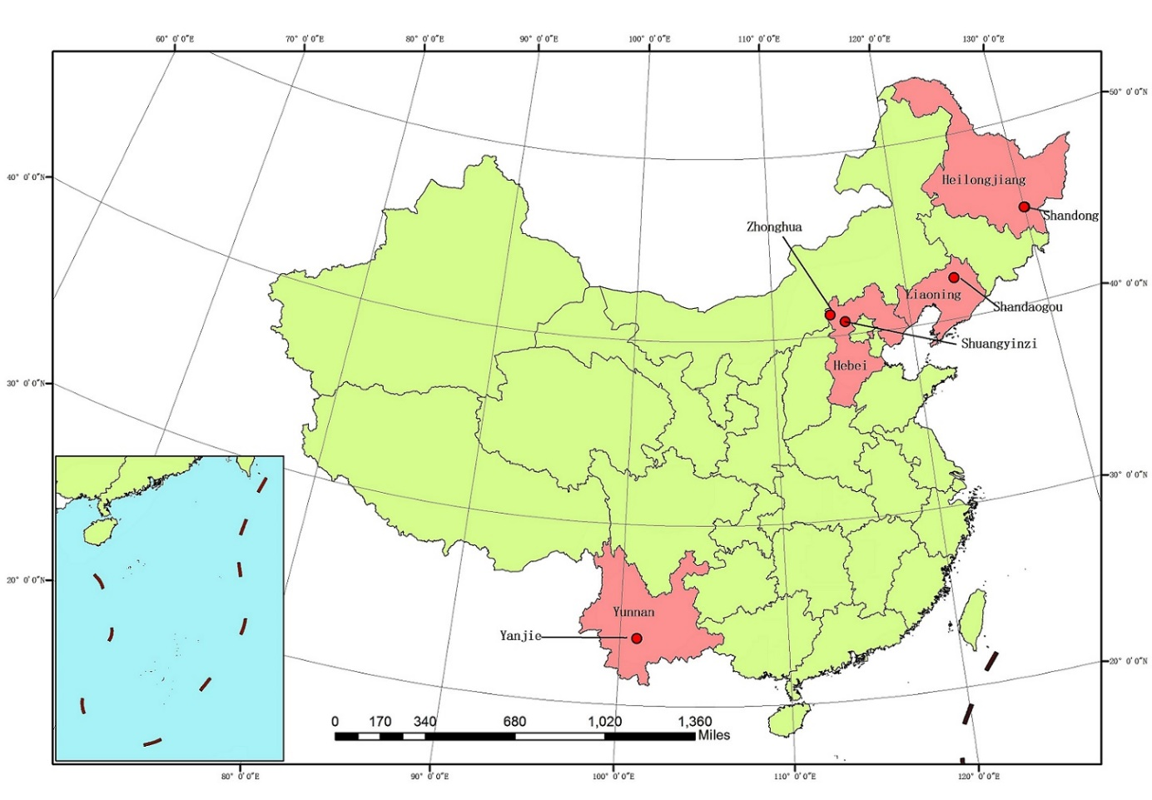
Figure 1: Map of China with location of project demonstration sites
Detailed maps of each project site are given in Appendix IX.
Hebei Province (Millet and Oat)
With a total area of 188,800 km², Hebei province is located in the northern part of China, adjoining Inner Mongolia to the north, Liaoning to the northeast, Shandong to the southeast, Henan to the south and Shanxi to the west. Beijing, the capital of China, and Tianjin, an important trading port in north China, are situated at the center of the province, although are not part of it. A small part of Hebei, Sanhe exclave, is wedged between Beijing and Tianjin. The province has a population of 74.7 million. Majority of the people are Han Chinese, accounting for 96% of the province’s population. Other communities include Manchu, Hui, Mongol and Zhuang. Shijiazhuang is the capital city of the province. Other major cities include Baoding, Tangshan, Qinhuangdao, Handan, and Zhangjiakou.
Hebei has a predominantly continental monsoon climate, with cold and dry winters, and hot and humid summers. Temperatures average −16 to −3 °C (Celsius) in January and 20 to 27°C in July; the annual precipitation ranges from 400 to 800 mm (16 to 31 inch), concentrated heavily in summer.
The province has more than 3,000 species of plants, of which more than 140 are fiber plants, more than 1,000 are medicinal herbs and plants, and more than 100 are timbers. There are 300 or more kinds of forage grass, 140 kinds of oil plants, and more than 450 varieties of cultivated plants. Of them, the output of cotton makes up one-seventh of the nation's total and that of maize and fruits makes one-tenth of the nation's total respectively. There are 215 varieties of farming products in 12 major categories that can be listed as brand name and best products, or native or rare products.
Foxtail millet (Setaria italica) and naked oat (Avena nuda) are both cultivated in Hebei, which is a centre of origin and diversity for both crops. Foxtail millet has the longest history of cultivation among all millets, and was first domesticated in China in around 6,000 BC. China grows 80% of the world’s foxtail millet production. Many ancient millet cultivars are still popular among local farmers. For example, in the Taihang Mountain area in She County, Hebei Province, ancient cultivars such as Laiwugu and Dabaigu are still grown because of their unique adaptation to the local climate. However, the cropping areas for foxtail millet in Hebei, Shanxi, and Inner Mongolia, located in the arid center of northern China, accounted for 36.1% of the total area in 1949, 42.4% in 1981, and up to 58.2% in 2001, whereas the area in the three northeastern provinces shrank from 29.0% in 1949 to 19.6% in 2001. Foxtail millet possesses important traits of drought resistance, as seed germination requires a water content of only 26% by weight, whereas sorghum, wheat, and maize need 40%, 45%, and 48%, respectively. In addition, it tolerates low soil fertility conditions and can achieve satisfactory yields in soils with mineral levels as low as 0.04-0.07% nitrogen, 8 ppm of organic phosphorus, and 0.04% carbon. Foxtail millet can also be used as fodder. Its straw is ideal for livestock because of its high nutritional value (protein content: 6.0%; pentosans: 26.0%; xylogen: 24.2%; fibrin: 42.2%), which is much higher than that of many other crops. In addition, millet straw is relatively soft and easily digested by livestock. About 900,000 farmers in Hebei province grow foxtail millet.
Oat has been cultivated in China for more than 10,000 years. This species grows at a wide range of altitudes with a short growth cycle of 10–12 weeks and requires little water for growth and development. Oat is considered a health-food crop, owing to its unique nutritional value, including higher grain alkaline protein content than wheat and rice. Oat is more tolerant to salt stress than maize, wheat, rice, or foxtail millet. There is large genetic variation in salt tolerance in oat, suggesting that it possesses rich genetic resources for improving productivity in saline soil. However, the evaluation and identification of salt-tolerant genotypes lag behind efforts in other crops, and very few genes associated with salt tolerance have been found in oat. It also has the lowest water requirement and shortest growing season of any cereal, reaching maturity in 60–90 days after sowing, and a low nutrient requirement, so can be cultivated in marginal agricultural land where other cereals do not succeed.
Within Hebei province, the project will implement pilot project activities in Shuangyinzi village, Jiajiaying township (Xuanhua county), to demonstrate innovative and sustainable approaches and practices of on-farm conservation of traditional varieties of foxtail millet. The selected local variety of foxtail millet is DaBaigu. It is among the few local varieties of foxtail millet still grown by the farmers in the project site, and presents the best potential for demonstration among all the local foxtail millet varieties particularly in terms of nutritional quality and economic value. At the present, DaBaigu is grown on less than 300 hectares (ha) in the entire country. In Hebei province, it is grown on about 60 hectares. Its current planting area in the selected project demonstration site is about 6 ha.
Shuangyinzi village has a population of 1,554, which includes 754 females (48.5%). The non-resident population constitutes 106 (62 males and 44 females). Average annual household income is around CNY (Chinese Yuan) 12,000 (USD 1,740). The main sources of income are farming and remittances from family members with jobs in cities and construction projects. Of the 610 households in the project demonstration site, about 150 are engaged in growing traditional varieties of foxtail millet. Corn and watermelon cultivation contribute 25% and 15% respectively to the household income. The contribution of foxtail millet cultivation accounts for 10% of the household income. However, traditional varieties of foxtail millet are grown largely for household consumption and exchange with relatives; only about 20% of traditional varieties of foxtail millet grown by the families are sold in the markets.
In order to demonstrate innovative and sustainable approaches and practices of on-farm conservation of traditional varieties of naked oat, the project will implement pilot project activities in Zhonghua village, Dahe township, Zhangbei county. The selected local oat variety is called Sanfensan (local name: Youmai). The village has a total cultivation area of 283 ha, of which around 100 ha is used for cultivating oat. Other crops grown in the village include potato, corn and pea. The selected local variety is planted on dryland without irrigation. It is expected to be rich in minerals as it is grown on soils with volcanic deposits. The traditional variety is grown free of any chemical fertilizer or pesticides and, therefore, has high potential to be promoted as a niche ‘organic’ variety in the food market and industry.
Zhonghua village has a population of 975 but majority of them reside outside the village pursuing jobs in the cities and construction projects. Only 197 (i.e. 20% live in the village). The village is relatively poor, with an average annual household income of CNY 8,000 (USD 1,159). Remittances from family members working outside the village accounts for about 70% of the income. Crop cultivation contributes 10% and cattle breeding 20% to the family incomes. Oat is mainly cultivated for household consumption; only about 80% of the harvest is sold in the markets. Almost all of the harvest of traditional variety is consumed within the family or exchanged with relatives and friends.
Heilongjiang Province (Soybean)
Heilongjiang province is in the far northeast of China, flanked by Russia to its north and east, Jilin province to its south and Inner Mongolia province to its west. It has an area of 454,800 km² and a population of 38.31 million. The province takes its name from the Heilong river (known as the Amur river in Russia), which marks the border between China and Russia. It is a land of varied topography; while much of the province is dominated by mountain ranges, the east and southwest parts are relatively flat and low in altitude. A humid continental climate predominates the province, with the far north being subarctic. Winters are long and bitter with an average of -31 to -15ºC in January. Summers are short and warm with an average temperature of 18 to 23ºC in July. Annual rainfall averages 400 to 700 mm and is heavily concentrated in summer.
Traditionally, Heilongjiang province was not an important center of agriculture largely due to its cold climate. It was only after 2006, when the Northeast Revitalization Plan was launched that Heilongjiang emerged as a key element in the national grain sector. Today, it is known to be one of the largest agricultural bases in China. The agriculture, heavily influenced by its cold climate, is based upon the cultivation of crops such as soybean, maize, wheat and potato. Important commercial crops grown include beet, flax and sunflower. The province now provides 26.5 percent of China's spring wheat, more than 30 percent of its domestic soybeans and nearly 12 percent of its corn.
Under this project, Heilongjiang has been selected as an additional province for soybean as it is a key province for revitalizing China's soybean industry. Increasing the protection and utilization of traditional soybean varieties in Heilongjiang is of great significance to China and the world. With severe cold, it represents a different agro-climatic zone than that of Liaoning with different traditional soybean variety and planting patterns. The soybean varieties in Heilongjiang have high potential for processed soybean products whereas the ones in Liaoning are primarily meant for consumption as fresh produce.
Within the province, the project will implement pilot project activities in Shandong village, Maqiaohe township (Muling city), to demonstrate innovative and sustainable approaches and practices of on-farm conservation of traditional varieties of soybean. Suinong 4 is the selected local variety of soybean for demonstration of project interventions. It is the only traditional soybean variety that is grown in the entire province. Only about 320 households still plant Suinong 4 in Heilongjiang; 18 of them are in the selected project site. Suinong 4 has good market value; 80% of the harvest is sold in the market and generates significant income, CNY 15,000 (USD 2,174) per year on average, for the households that still cultivate it. It is a high-oil variety with protein content up to 39%. The yield of tofu is higher than other varieties, and its taste is good. It can be developed into a special variety of high-quality tofu with huge market potential. The cultivated area of Suinong 4 in the selected project site is 133 ha but it presents significant demonstration value as there is potential to increase cultivated area of Suinong 4 in the vicinity of Maqiaohe township to 20,000 ha with innovate and sustainable interventions.
Shandong village has a population of 482, including 224 females (46.5% of the population). About 45% of them are non-residents, doing jobs in cities and construction projects. The annual household income averaged CNY 33,500 (USD 4,855) in 2015, CNY 31,300 (USD 4,536) in 2016 and CNY 31,900 (USD 4,623) in 2017. About 54% (i.e. CNY 17,200 (USD 2,493) came from agriculture. The cultivated area in the village is 538 ha and the major crops cultivated here include modern varieties of soybean and corn, respectively accounting for 44% and 56% of the cultivated area. Remittances from non-resident family members is also a major source of income. Livestock rearing is also commonly practiced for income generation and subsistence.
Liaoning Province (Soybean)
With an area of 145,900 km², Liaoning is the smallest province in the northeastern region of China. At the same time, it is the most populated province in the region with a population of 43.9 million (as of 2010). It is bordered by North Korea to the southeast, Jilin to the northeast, Hebei to the southwest, and Inner Mongolia to the northwest. The Yalu river marks its border with North Korea. The province is composed of three major geographic regions; the highlands in the west, the plains in the middle part and the hills in the east. Liaoning has a continental monsoon climate with rainfall averaging 440 to 1130 mm annually. Summer is rainy while the other seasons are dry.
Liaoning is a key soybean-producing area, producing largely varieties that are for fresh consumption. Other main agricultural crops in the province include maize and sorghum. The province also produces three-quarters of China's exported apples and peaches. Cotton is also produced.
Within Liaoning, the project will implement pilot project activities in Sandaogou village, Jingouzi township, Kaiyuan county, to demonstrate innovative and sustainable approaches and practices of on-farm conservation of traditional varieties of soybean. The selected traditional soybean varieties are Kaiyu9, Kai8157 and Dabaimei. These varieties are considered to have excellent characteristics such as better adaptability in the local environment and better nutritional value with high protein content and good taste. The local communities have strong traditional affinity to these varieties although their cultivation has gradually decreased due to high-yielding modern varieties. Kaiyu 9 and Kai 8157, which account for about 90% of the total harvest of traditional soybean varieties, are generally sold in the southern provinces of China whereas Dabaimei, which makes up 10 of the total harvest of traditional varieties, is mainly produced by farmers for household consumption or exchange with relatives and friends.
The population of Sandaogou village is 2,218, of which 1,138 (51.3%) are females. Non-resident population is low compared to other project sites with 150 people (6.8 percent) living outside the village. The average annual household income is CNY 33,000 (USD 4,783). Annual agricultural income is CNY 30,000 (USD 4,345) per household, mainly from corn planting, thus making up more than 90% of the total household income.
Yunnan Province (Rice)
Yunnan province is located in southcentral China. It covers an area of approximately 394,000 km², much of which is mountainous terrain. The province borders the Chinese provinces of Guangxi, Guizhou, Sichuan, and the Tibet Autonomous Region to its west, north and northeast, and the countries of Vietnam, Laos, and Myanmar to the south and east. The population of the province was 45.966 million as of 2010. The province has a generally mild climate with pleasant and fair weather because of the province's location on south-facing mountain slopes, receiving the influence of both the Pacific and Indian oceans. The province is rich in natural resources and is known to have the largest diversity of plant life in China.
The province maintains a strong agricultural focus. Agriculture is restricted to the few upland plains, open valleys, and terraced hillsides. Level land for agriculture is extremely scarce and only about 5 percent of the province is under cultivation. Rice is the main crop and Yunnan is known to be a center of rice diversity. Others include corn, barley, wheat, rapeseed, sweet potato, soybean, tea, sugarcane, tobacco and cotton.
The selected project site for rice, Yangjie village is located in Yangjie township in the Ailao mountain of south-central Yunnan province. Mazha Gu and Honghezi Gu are the traditional rice varieties that have been identified for the project. They are generally referred to as red rice because of their colour. . The local communities have traditionally cultivated these varieties but are faced with the challenges of low yields. Despite favorable characteristics such as high nutritional value and fragrant taste, these varieties are being increasingly replaced by high-yielding modern rice varieties and by other crops such as corn and tobacco which have higher commercial value. Their cultivation has now been reduced to small areas. In the entire Yangjie township, total area under cultivation with Mazha Gu rice variety is about 133 ha and with Honghezi Gu rice variety is about 33 ha. In Yangjie village, Mazha Gu is cultivated only on 21 ha and Honghezi Gu just on a little more than 7 ha. Therefore, their conservation in the selected project site is considered urgent.
Yangjie is representative of traditional rice growing areas in Yunnan province and has multiple ethnicities that are bound by rice-growing traditions. Furthermore, the conservation of Hani rice terraces in Yangjie is considered very important for promoting agritourism. There is significant interest among agricultural cooperatives, private companies and local communities to pursue the dual objectives of conservation of traditional rice varieties and tourism development in mutually-beneficial ways. Yangjie village has a total population of 2,745. Female population is 1,253, making up 45.6% of the total population. Only a small proportion, about 2%, live outside the village. The average annual household income is around CNY 31,200 (USD 4,522). More than 80% of this income comes from agriculture.
All the aforesaid project site descriptions are based on detailed baseline assessments carried out by a team of local technical experts during the PPG phase. The reports of these assessments are too large to be appended with the prodoc. They are available with FAO and MARA, and can be provided if necessary.

The Current Situation

Main Environmental Threats
Commercialization of the agricultural sector: The approach to agricultural development in China over the recent past has been centered on the “three S’s”, i.e., security, sustainability and safety, with a particular emphasis on the first “s”, food security. Driven by commercial demand and the need to produce more to meet the demands of a growing population, agricultural production has been heavily intensified with the introduction of modern varieties, heavy mechanization, larger field sizes and increased application of chemical fertilizers and pesticides. Large-scale intensive agricultural production, characterized by a very narrow range of crops and varieties, has grown exponentially thereby displacing unique crop landraces in the last decades. Consequently, genetic erosion is a major threat as there are many species and varieties at risk of extinction. As traditional genetic resources disappear, so do potentially important means of adaptation (e.g. resilience to extreme weather events and resistance to disease) and valuable sources of nutrients and micronutrients.
Attrition of traditional agricultural production systems: Migration from rural communities to urban areas, a global phenomenon, is also prevalent in China, with the main driver being the search for alternative employment and improved standards of living. Rural-rural migration is also increasing: 16.4% of the population in the target project areas are non-resident. Zhonghua village in Hebei and Shandong village in Heilongjiang particularly have very high proportions of population living away from the villages. The high rate of rural-urban migration has led to the decline of traditional, small-scale farming practices. Moreover, women and the elderly have assumed the primary burden of managing agricultural production systems in the countryside, with little incentive to cultivate or market them, consequently creating disinterest in traditional crop varieties which are generally low-yielding. Many of the traditional cultivation practices also require a high degree of manual labor, which does not attract the young generation nor is it feasible for those residing in the villages (women and older people). 25% of the population in the project sites were above 60 years: 23% in Shuangyinzi (Hebei, millet site), 45% in Zhonghua (Hebei, oat site), 22% in Sandaogou (Liaoning), 27% in Shandong (Heilongjiang), and 18% in Yangjie (Yunnan).
Vulnerability to climate change: Agricultural production is highly vulnerable to climate change. To prevent the loss of crop diversity and maximize availability for the future, there is an urgent need to ensure appropriate conservation and sustainable use at global, regional, national and local levels. This need has been recognized by international conventions and agreements, including the Convention on Biological Diversity (CBD), the International Treaty for Plant Genetic Resources for Food and Agriculture and the Second Global Plan of Action for Plant Genetic Resources for Food and Agriculture (Second GPA). Recently, the international community highlighted the importance of the sustainable use of biodiversity and genetic resources for the achievement of Sustainable Development Goal 2 (End hunger, achieve food security and improved nutrition and promote sustainable agriculture) of the 2030 Agenda for Sustainable Development. The Fifth Assessment Report of the Intergovernmental Panel on Climate Change stressed the vulnerability of plants as cannot naturally shift their geographical ranges sufficiently quickly enough to keep up with current and the projected rapid rates of climate change in most landscapes.
The impacts of climate change that extend to the agricultural sector include loss of crops to extreme weather events, increased volatility of agricultural yields, crop diseases and insect pests. Traditional farming practices offer adaptation benefits and building in buffers that may be crucial in local climate change strategies. For instance, many traditional varieties of crops have inherent resilience traits compared to modern varieties, such as enhanced drought and pest resistance,. Moreover, small-scale traditional farming systems that involve mixed cultivation and rotational cropping are considered more resilient to climate change impacts,. At the same time, it is important to note that agriculture is a significant contributor to human-induced climate change, including the largest contributor of non-CO₂ greenhouse gas emissions. Traditional farming practices, which for example often involve diversified inter-cropping or rotation systems and organic methods for soil fertility management, have been shown to have lower greenhouse gas emissions as compared to monoculture systems that rely on heavy use of chemical fertilizers. The Chinese government has made commitments to promote low-emission development in agriculture, e.g. as a part of the Paris Climate Agreement. In fact, China has already met its 2020 Carbon Target three years ahead of schedule. Recognizing the important role of traditional agricultural approaches will be an important element to further low-emission development strategies.
Urbanization and changes in dietary habits: Urbanization is a trend that transforms drastically food systems. Today, half the world’s population lives in urban areas and that number is increasing rapidly (FAO, 2012). By 2050, about 70 percent of the global population of 9 billion is expected to live in cities, which will have important consequences on consumption patterns and food chains. Indeed, urban consumers usually purchase everything they eat: this deeply influences local food systems, orientating them on new diet patterns or lead access to diversified products, often imported, which replace traditional foods. In China too, there are high migration rates from rural areas to cities with about 56.1 % of the population currently living in urban areas. China has a history of 5,000 years of civilization, different ethnicities, together with different regions with unique food cultures and traditional knowledge in agricultural production practices. In recent years, due to high rates of rural migration into cities, traditional knowledge associated with traditional cultivation methods and the crops and varieties associated with them are being lost. For example, the traditional foods which play an important role in local customs are being replaced, the related traditional, indigenous knowledge has been forgotten, highlighting the urgency for the documentation of traditional knowledge. Traditional staples like oat and millets are being increasingly replaced by other foods, and have been reduced to small-scale consumption in the villages as was evident from the interactions with local communities in Zhonghua and Shuangyinzi villages in Hebei during the preliminary field missions. These crops are also high in dietary fiber and minerals while being a source of slow-release carbohydrate (lower glycemic indices when compared to many varieties of rice), very important as rates of diabetes and heart disease are now extremely prevalent.

Baseline Initiatives
At the national level, the central government has made substantial investments in the conservation of crop genetic diversity, including the Crop Germplasm Resources Protection program which has been implemented by the Ministry of Agriculture and Rural Affairs (MARA) since 2001 with funding of approximately USD 4.5 million annually. The medium term and long-term objectives of this program were updated in the 13th five-year plan in 2016, with a continued focus on collection, ex situ conservation, in situ conservation, evaluation and gene discovery of crop germplasm resources. A national priority list of crop wild relatives (CWR) is regularly evaluated and as of 2018, 205 protected sites for CWR had been established nationwide. The national priority list does not include indigenous agricultural varieties. There is limited funding from the central government for protected sites of CWR; approximately CNY 50,000 (approx. USD 7,246) is allocated annually for basic management of these sites.
After the implementation of the third National Germplasm Resources Survey and Collection in 2015, 623 counties in 12 provinces have been surveyed systematically with a total allocation of USD 21 million from the central government. Apart from the surveys, this has helped the formation of professional team of 24,000 people across the country and the establishment of technical and training system for germplasm resource survey and collection.
In 2014, the Regional Layout Planning of Featured Agricultural Products (2013-2020) was adopted, focusing on 144 agricultural products. This initiative presents a very good opportunity and entry point for the mainstreaming on-farm conservation and sustainable use of traditional/ local varieties, especially given that oat and millet – two of the target crops under this – are also listed in the aforesaid policy.
MARA is also implementing the China Agriculture Research System, 2010-2020, with a total fund of CNY 21 million (USD 3.04 million). This initiative has been directed towards strengthening agricultural research infrastructure, development of genetic breeding program and industrialization of oat. The FAO/GEF project will benefit from the infrastructure and research activities established through China Agricultural Research System, building project interventions on, and integrating them in, the existing agricultural research system.
GEF-financed interventions have also contributed to the baseline of this project. The UNDP-supported, GEF-financed project “Conservation and Sustainable Utilization of Wild Relatives of Crops” (UNDP PIMS 2277; GEF ID 1319) was implemented in partnership with MARA and Chinese Academy of Agriculture Sciences from 2007 through 2013, working in 15 provinces in China, protecting 39 different species in 64 sites. China was also one of the countries that participated in the global GEF-financed project “Conservation and Sustainable Use of Crop Genetic Diversity to Control Pests and Diseases in support of Sustainable Agriculture” (GEF ID 4983). This project was implemented by the United Nations Environment Program, with the Yunnan Agricultural University executing the activities in China and Bioversity International as the project coordinator. These projects have contributed towards raising awareness on the value of agrobiodiversity, strengthened capacities among national, provincial and local government stakeholders and introduced best international management practice.
In coordination with MARA, the Food and Agriculture Organization of the United Nations (FAO) has introduced the Globally Important Agricultural Heritage Systems (GIAHS) program in China. The GIAHS seeks to integrate the protection of traditional production approaches and genetic resources with local economic development and improvement in community livelihoods. China became one of the earliest responders to the GIAHS initiative with the designation of Qingtian Rice-Fish Culture in 2005. It is also one of the best practitioners and one of the most active promoters of the conservation of agricultural heritage systems. Over the past ten years, it has made tremendous achievements in the identiﬁcation, conservation and management of agricultural heritage systems. It is the ﬁrst country that identiﬁed and conserved agricultural heritage systems at the national level and currently has the largest number of Nationally Important Agricultural Heritage Systems (NIAHS) sites as well as the largest number of GIAHS sites in the world. Among the 91 NIAHS sites, 18 are located within the provinces targeted by this project. These include five in Hebei, two in Heilongjiang, three in Liaoning, and eight in Yunnan. Among the 15 GIAHS sites in China, one is located in Hebei and two are located in Yunnan.
Over the past 10 years, through the Technical Cooperation Program, FAO has implemented more than 300 Farmer Field Schools (FFSs) in eight provinces and autonomous regions of China in collaboration with government agencies covering a wide range of issues such as soil health, water resource management, crop production, post-harvest technology, integrated pesticide management, and crop residue management. These FFSs have effectively extended agricultural development concepts and technical practices directly to over 8,500 farmers. Another 110,000 farmers have also indirectly benefited from the related information and educational campaigns. The FFS approach has been well integrated into the national agriculture extension system and provides useful reference for major domestic rural capacity development programs, such as the Training of New Professional Farmers Program. The FFS experience and knowledge built through FAO’s Technical Cooperation Program will provide a major platform to learning and disseminating sustainable methods and practices using people-centered approaches for on-farm conservation and sustainable use of traditional crop varieties and enhancing local agrobiodiversity systems.
Several plans, policies and legislations are in place that provides the basis to promote and strengthen the on-farm conservation and sustainable use of traditional agricultural genetic resources. These include the following:
- Seed Law of the People’s Republic of China, 2000, was developed and adopted to protect and sustainably utilize germplasm resources. It aims to regulate varietal selections, seed production, seed enterprise business and management, patent new varieties, safeguard the rights and interests of seed producers and users, promote the development of seed enterprises, and contribute to the development of sustainable agriculture and forestry.
- Crop Germplasm Resources Management Measures was adopted in 2003 to strengthen the protection and promote the exchange and utilization of crop germplasm resources. Specifically, this policy states that the State shall undertake surveys, assessments and collections of crop germplasm. In cases where germplasm is likely to be affected to the point of extinction due to engineering, construction, environmental changes, etc., these resources should be collected and stored ex situ prior to their extinction in situ. Further, it forbids the collection and harvesting of listed germplasm resources of wild species, wild relatives, endangered rare species in protected areas and germplasm nurseries. It also stresses that in situ conservation should be undertaken in synergy with ex situ conservation strategies for the optimal conservation of crop genetic resources.
- Regional Layout Planning of Featured Agricultural Products (2006-2015) identified five key areas and established the characteristic agricultural product variety database, marketing network and information platform and the utilization of high-quality germplasm resources. It has played an important role in forming a large-scale crop industrialization and ensuring national food security. It is worth noting that it lists millet and oats in Hebei as priorities for new modern breeding based on traditional varieties.
- National Plan for the Conservation and Utilization of Biological Species Resources (2006-2020) aims to: use modern science and technology and traditional knowledge to conserve biodiversity; protect species and their habitats; sustainably use biological resources; equitably share the benefits arising from the use of genetic resources and associated traditional knowledge; and promote harmonious coexistence between human communities and nature. At present, there are about 400,000 crop varieties listed in the National Crop Germplasm Resources catalogue, including the traditional varieties as well as the wild varieties of major crops originated in China.
- China’s National Biodiversity Conservation Strategy and Action Plan (2011-2030), puts forward China's overall goal, strategic tasks and priority actions for biodiversity conservation in order to implement the relevant provisions of the Convention on Biological Diversity, further strengthen the protection of biodiversity, and effectively deal with the emerging problems and challenges of biodiversity conservation, including agricultural genetic resources, in China.
- Regional Layout Planning of Featured Agricultural Products (2013-2020), was adopted, focusing on developing 144 agricultural products of 10 categories, like the characteristic cereals such as oat and millet in Hebei. The policy addresses the formulation and fine-tuning of relevant national and industrial standards. It also includes: setting up standardized demonstration plots; establishing the geographical indication system; breeding improved varieties; promoting relevant, sustainable technologies for production, processing and storage; supporting professional associations and rural cooperatives; developing quality inspection systems, marketing system and information platforms; developing a number of well-known superior producing areas; and gradually developing committees recognized and owned independent intellectual property rights both at home and abroad. And it also pointed out that developing and protecting local characteristic germplasm resources according to local conditions by promoting characteristic agriculture are conducive to better maintaining biodiversity and achieving sustainable development.
- China’s National Plan on Implementation of the 2030 Agenda for Sustainable Development outlines a comprehensive framework of specific national action plans to pursue sustainable development in line with the global Sustainable Development Goals (SDGs) 2030 and their constituent targets. This includes implementation of the National Plan for Sustainable Agricultural Development (2015-2030) to achieve notable progress in sustainable agricultural development and establish a new model of sustainable agricultural development featuring adequate supplies, high resource efficiency, fertile farmlands, stable ecosystems, and prosperous rural households. It also envisages to set up a national system for germplasm collection, conservation and research, and build national and regional breeding bases to conserve the genetic diversity of cultivated crops and domesticated animals and their wild relatives.

Barriers to be Addressed
A number of barriers exist to the on-farm conservation and sustainable use of traditional agricultural genetic resources. The major barriers are described below:
Barrier 1: Disjointed policy and regulatory framework and deficient inter-institutional coordination. There are significant efforts ongoing in China targeting the conservation and use of crop genetic resources; however, coordination and communication among government sectors, management agencies and research institutions is weak, limiting the efficiency of work in this area. Existing laws and regulations and the policies of China encourage farmers to plant new varieties, use new technologies, and promotes intensive, large-scale, mechanized farming. Due to the lag of the biodiversity conservation, China has not formulated related laws and regulations, even if some departments issued relevant policies, they are only targeted to some parts of biodiversity with almost no aspects covering on service functions provided by agricultural ecological system, and on conservation and use of species diversity and genetic diversity. Imperfect laws, regulations and the policies for biodiversity conservation hinder the conservation and sustainable use of local varieties to a certain extent. Despite current initiatives, public policies are not harmonized and still generate perverse incentives. While there are various policy and regulatory provisions for the conservation and use of crop genetic resources, they are fragmented and appear in bits and pieces in various policies and legislations. There is a need for coherent, synergistic policies and to analyze the different impacts and develop supplementary provisions to provide a clear and comprehensive policy and regulatory framework for the conservation and use of crop genetic resources. These objectives should be clearly harmonized with other development objectives such as poverty alleviation, rural development, community entrepreneurship, climate change adaptation, health and nutrition, youth development and gender mainstreaming. For a holistic and concerted approach, it is critical that there is regular dialogue, coordination and collaboration between various relevant sectors and institutions. Currently, this is lacking as suggested by baseline assessments on stakeholders and institutional coordination.
Barrier 2: Lack of awareness and knowledge on, and capacity for, approaches to support the on-farm conservation and sustainable use of local varieties in China. Many stakeholders including decision-makers and farmers are not sufficiently aware of the importance of local varieties and have adopted contradictory policies that affect their conservation. Capacity within the government institutions responsible for agricultural development services is severely wanting in with respect to conservation of traditional varieties of agricultural genetic resources both at national and provincial levels (see Table 2, Summary of Capacity Scorecards of Government Institutions). The low level of capacity induces major risks and negative pressures through the design and implementation of public policies, plans and regulations that inadvertently have negative impact on crop diversity. The promotion of modern agricultural practices to feed global and national markets has created serious challenges to conserve traditional species and varieties and agro-ecosystems in rural areas. In addition, rural poverty and migration towards urban zones and abroad have deepened the effects of inter-generational loss of traditional knowledge and varieties management. Affected by national policies and the capital investment-orientation, few agricultural scientific and technical personnel engage in the conservation of genetic resources. Even the few experts who work on genetic diversity mainly carry out projects to collect germplasm to identify adaptive genotypes for the purpose of breeding for crop improvement or to be conserved ex situ in genebanks. Consequently, there is a need for technical and social innovation pertaining to traditional crop varieties to be cultivated on-farm,,,. Essential approaches in slowing down the present rate of loss of agrobiodiversity need further support, such as the active involvement of the rural population in on-farm conservation, documentation of traditional knowledge and local innovation. Targeted capacity development is therefore necessary (at systemic, institutional and individual level) for the conservation and sustainable use of traditional crop diversity, and the market development in support of improved livelihood, food security and nutrition. Strengthening the capacity of farmers to anticipate and plan for climate-related changes or for appropriate nutritional requirements through effective local management of crop diversity is necessary for sustainable production systems.
Table 2: Summary of the Scores of Capacity Scorecards of Government Institutions
Capacity Area | National | Hebei | Heilongjiang | Liaoning | Yunnan
Area 1: Capacities for engagement | 11% | 33% | 33% | 11% | 11%
Area 2: Capacities to generate, access and use information and knowledge | 13% | 33% | 20% | 20% | 13%
Area 3: Capacities for strategy, policy and legislation development | 11% | 33% | 11% | 11% | 0%
Area 4: Capacities for management implementation | 17% | 33% | 17% | 17% | 0%
Area 5: Capacities to monitor and evaluate | 17% | 17% | 0% | 0% | 0%
Overall | 13% | 31% | 18% | 13% | 7%

Barrier 3: The persistence of unsustainable agriculture practices and lack of market/non-market incentive mechanisms. At farm level, many areas have been incorporated in large-scale production systems using farming practices and technologies that deplete natural resources and affect loss of local varieties. As a consequence, future food security is threatened, given that important species are being lost or disused. Limited research or action has been taken to rescue them and promote their conservation. Chinese market economy is still at an early stage, and the main crops are still subject to government guidance prices. Agricultural subsidies are largely directed towards improving production of improved crop varieties. Although in recent years the prices for the quality and special agricultural products and the common agricultural products has formed a certain price difference, lack of market consciousness and ability to open up the market of the farmers, along with the market operation mode which limit the market competitiveness of products from local varieties. There is also a lack of market and non-market-based incentive mechanisms for the conservation and sustainable use of traditional genetic resources important for food and agriculture in China. In absence of such incentives, traditional crop varieties that are often labor-intensive and low yielding are considered disadvantageous (see table below for yield comparisons between selected traditional crop varieties and modern varieties). This has gradually led to depletion of traditional crop varieties.
Table 3: Comparative Yields of Selected Traditional Crop Varieties and Modern Varieties
Province | Crop (Selected Traditional Varieties) | Yield (Kg per ha)
Province | Crop (Selected Traditional Varieties) | Selected Traditional Variety(ies) | Modern Varieties
Hebei | Millet (DaBaigu) | 3,000 | 7,500
Hebei | Oat (Sanfensan) | 900 – 1,800 | 1,125 – 2,250
Heilongjiang | Soybean (Suinong 4) | 2,250 | 3,000
Liaoning | Soybean (Kaiyu9, Kai8157, Dabaimei) | 2,200 | 3,100
Yunnan | Rice (Mazha Gu, Honghezi Gu) | 4,500 – 5,000 | 6,000 – 8,750

Barrier 4: Limited systematization of scientific information and lack of reliable databases. Despite the long-standing traditional knowledge present in local areas of China, the scientific information about those on-going processes are scattered. The relationships among the domesticated diversity, wild or only semi-domesticated varieties, and human practices/uses that add value to these species have not been sufficiently studied and analyzed. Therefore, information is fragmented and not systematized. Large groups of native species of local interest or used by rural communities are not recorded. This lack of standardized information has prevented these species from being protected through public policies. There is a lack of easily accessible documentation of agrobiodiversity and traditional knowledge – often Community Biodiversity Registers and catalogues exist but are not digitized and linked into larger, provincial/national databases. Decision-making has not always been adequately informed. Improving agrobiodiversity data and information, and understanding them are key to maintain these species, local varieties and associated traditional systems valid over time. There is a need to address existing agrobiodiversity information gap in China not only to inform decision-making but also due to the immense global importance of China’s agrobiodiversity.

SECTION II – PROJECT STRATEGY AND EXPECTED RESULTS

Project Strategy

Project Logic and Theory of Change
The key threats and barriers impacting the conservation of traditional agricultural genetic resources in China are described in sections 1.2.1 and 1.2.3. The intervention pathways to address the barriers and their linkages to sustainable development outcomes at national and global levels are illustrated in the theory of change diagram in Figure 2, in which the GEF project alternative will aim to remove the identified barriers to achieving the long-term solution for on-farm conservation of traditional agricultural genetic resources for food security and sustainable agriculture in China.
The key barriers can be broadly summarized as: (1) lack of policies and inter-institutional mechanisms for holistic and coordinated approach; (2) insufficient technical and management capacity at national as well as provincial and local levels; (3) very low level of awareness on the importance and benefits on conserving traditional crop varieties; (4) highly underdeveloped markets for traditional crop varieties; and (5) lack of systematized data, information and knowledge on traditional crop varieties and their management practices. These barriers will be removed through the implementation of a set of activities, whose results will contribute towards the accomplishment of a series of project outputs, which in turn will achieve the four main project outcomes:
- In-situ conservation and sustainable use of genetic diversity of significant indigenous local crops and varieties mainstreamed into policies or plans at different levels, and also in four targeted provinces, to support the development of national strategies that protect agrobiodiversity;
- Capacities strengthened to support long-term plans and up-scaling of incentive-based approaches for on-farm conservation and sustainable use of crop diversity for resilient agriculture and sustainable production;
- Improved marketing of products made from local varieties, including through the use of both traditional knowledge and modern technologies, taking into account market /non-market incentives to increase local crop diversity production and availability; and
- Information and knowledge of social, cultural, economic, research and marketing aspects related to crops and their local varieties will be collected, documented and published for providing basic support for further conservation and sustainable utilization.
The project outcomes, in turn, will contribute to the project objective and produce long-term impacts of improving agrobiodiversity and creating sustainable agricultural livelihoods and contributing to global SDGs, particularly SDG 2 (zero hunger) and SDG 15 (life on land).

Figure 2: Project's Theory of Change
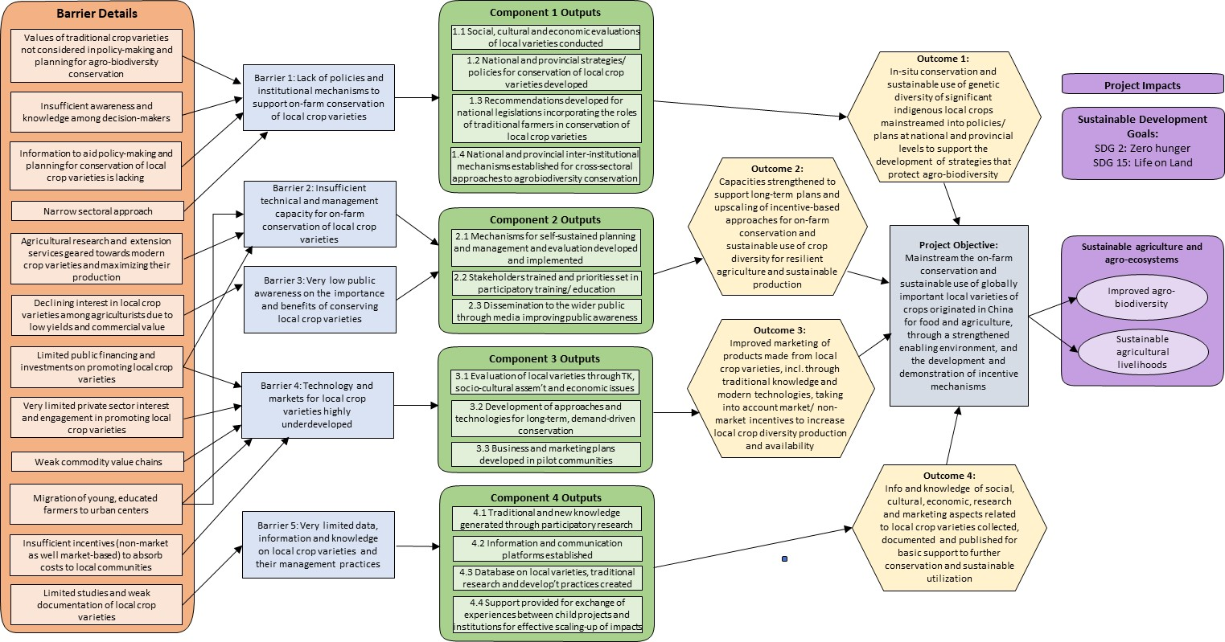

Project Objective, Outcomes and Outputs
The project objective is to mainstream on-farm conservation and sustainable use of globally important local varieties of crops originated in China for food and agriculture, through a strengthened enabling environment, and the development and demonstration of long-term incentive mechanisms. This objective will be achieved through four key components: (1) strengthening the enabling environment to promote the on-farm conservation and sustainable use of the genetic diversity of important indigenous local crops and varieties; (2) capacity building to promote adaptive management and improved conservation and sustainable use of crop diversity for resilient agriculture and sustainable production; (3) mainstreaming diversity of local varieties through biological, socio-cultural and economic evaluation and the development of market/non-market incentives and linkages in target sites; and (4) strengthening knowledge management. These components correspond to the following inter-related project outcomes:
- In situ conservation and sustainable use of genetic diversity of significant indigenous local crops and varieties mainstreamed into policies or plans at different levels, and also in four targeted provinces, to support the development of national strategies that protect agrobiodiversity;
- Capacities strengthened to support long-term plans and up-scaling of incentive-based approaches for on-farm conservation and sustainable use of crop diversity for resilient agriculture and sustainable production;
- Improved marketing of products made from local varieties, including through the use of both traditional knowledge and modern technologies, taking into account market /non-market incentives to increase local crop diversity production and availability; and
- Information and knowledge of social, cultural, economic, research and marketing aspects related to crops and their local varieties will be collected, documented and published for providing basic support for further conservation and sustainable utilization.
Each of the project components/ outcomes will be achieved through the realization of a set of outputs and constituent activities. A multiple-year work plan is provided in Appendix II. Planned project interventions with GEF resources are described below:
Component 1: Strengthening the enabling environment to promote mainstreaming of on-farm conservation and sustainable use of the genetic diversity of important indigenous local crops and varieties.
The project will support the mainstreaming on-farm conservation and sustainable use of local varieties as indicated as a priority area in the National Biodiversity Strategies and Action Plans (NBSAP) for 2011-2030 submitted to the Secretariat of the Convention on Biological Diversity, as well as other national development plans such as the 13th Five-Year Plan (2016 -2020) which underlines the importance of environmental protection and the creation of China as an ‘ecological civilization’.
This component will lend support to the strengthening of conservation and sustainable utilization of local varieties into strategies/policies at national/provincial levels; to make recommendations for streamlining into the national legislation framework. The efforts under this component will directly benefit the activities under component 2 and 3. Beyond establishing conservation and sustainable utilization of local crop varieties as a policy-level priority, this component is also envisioned to create the necessary policy and legal conditions for premium market development for the activities under component 2 and 3.
In-depth analysis of existing policies and legislations relevant to agrobiodiversity conservation with emphasis on traditional crop varieties and incentive mechanisms for their in situ conservation will be carried out to develop recommendations for formulation of suitable policies/ strategies at the national and provincial levels. Socio-cultural and economic evaluations of traditional crop varieties and studies on appropriate market/ non-market incentive mechanisms will be carried out to inform the formulation of the national and provincial policies/ strategies. These evaluations and studies will also closely examine the role of women and youth in sustaining traditional agrobiodiversity systems and offer necessary policy recommendations for enhancing their roles.
This component will also focus on creating inter-institutional mechanisms for agrobiodiversity conservation at the national level and in the target provinces based on detailed studies of existing institution mechanisms and gaps for coordinated and inter-sectoral approach. With vastly improved policy and institutional frameworks at the national level and in the target provinces, this component will be instrumental in creating an enabling environment for successful implementation of other project components and the sustainability of project results in the long term.
Outcome 1.1: In situ conservation and sustainable use of genetic diversity of significant indigenous local crops and varieties mainstreamed into policies or plans at different levels, and also in four targeted provinces, to support the development of national strategies that protect agrobiodiversity
Output 1.1.1: Social, cultural and economic evaluation of local varieties (e.g. nutrition and food security, public health, environmental benefits among others) conducted to serve as the basis for policy and legislation development.
This output will involve the development of technical guidelines so that there is coherence in the methodology applied for the evaluations across the target local crops and provinces and comparative evaluation results can be generated. The evaluations will examine the traditional crop varieties with respect to particularly their various characteristics such as nutrition and health, food security, environmental benefits, significance to local culture and traditions, and climate-resilience. The evaluation findings will be used or informed formulation of the national and provincial strategies/ policies for on-farm conservation and sustainable use of traditional crop varieties. The evaluations will be completed by the end of second year of the project.
Output 1.1.2: One national strategy or policy for conservation and sustainable use of the genetic diversity of important indigenous local crop and variety prepared and submitted to MARA; four provincial strategies/policies prepared for the targeted provinces respectively.
A national task force and provincial task forces in the target provinces will be formed to guide, review and provide inputs to the formulation of the national and provincial strategies/ policies. In-depth analysis of existing policies, strategies and legislation that have bearing on on-farm conservation of the genetic diversity of traditional crops will be carried out. This analysis will identify policy gaps and opportunities for mainstreaming conservation of traditional crop varieties and will take into account the findings and recommendations generated by the evaluations conducted under Output 1.1.1 and the studies on market and non-market incentives and the role of women and youth for indigenous crop diversity conservation carried out under Output 1.1.3. Extensive consultations will also be carried out with various stakeholders at the national and provincial levels to elicit information and insights to supplement information derived from desk reviews. The national and provincial policies/strategies will be completed by the end of project year 5.
Output 1.1.3: Recommendations developed as reference for revision / reform of national legislations that incorporates valuing the roles of the traditional farmers, including women and young people to support on-farm conservation and sustainable use of crop genetic diversity, promoting sustainable agrobiodiversity systems.
Studies to examine and offer policy and legislative recommendations for market and non-market incentives and promotion of the roles of traditional farmers especially women and youth in the conservation of indigenous crop diversity will be carried out. The studies will be completed by the end of second year of the project. The findings and recommendations of these studies will be submitted to the national and provincial authorities as reference for formulation of policies/ strategies for conservation and sustainable use of the genetic diversity of important indigenous local crop and variety (Output 1.1.2).
Output 1.1.4: A national and four provincial inter-institutional cooperation mechanisms established to streamline cross-sectoral approaches to agro-biodiversity conservation.
A detailed review of existing institutional set-up for agrobiodiversity conservation will be carried out at the national level as well as in the target provinces to identify gaps and opportunities for strengthening inter-institutional mechanisms for a coordinated and cross-sectoral approach. Based on this in-depth review, inter-institutional cooperation mechanisms will be set up with well-defined ToRs describing the composition, roles and responsibilities, and procedures of functioning. Sensitization workshops will be organized for members of the inter-institutional cooperation mechanisms to familiarize them with their ToRs and enhance their understanding of coordinated, inter-sector approach to agro-biodiversity conservation. These institutional mechanisms will be functional by the mid of the project.
Component 2: Capacity building to promote adaptive management and improved conservation and sustainable use of crop diversity for resilient agriculture and sustainable production.
Component 2 is aimed at developing the capacity of government agencies at the national level and in the provinces, research institutions, local communities, private sector and farmers. Training needs assessment of national institutions and various agencies in the provinces for participatory agricultural research and extension services will be carried out. Based on this assessment, a training module will be developed. The training module will describe training contents for different training recipients. Based on this module, training materials will be developed for the various training contents and in accordance with the target recipients that will have different training contents for different participants. The training module will also identify the main bodies and recipients of technical trainings. Training of trainers (ToT) will be conducted to create a core team of well-trained professionals with training skills to impart training on participatory agricultural research and extension services for the local agricultural staff in all the four target provinces. Farmers and private sector will be encouraged to put social and commercial value to their own roles in the society for empowerment by creating co-management mechanisms to carry out self-sustained planning, management and evaluation for the on-farm conservation and use of local varieties. Organization of exchange programs will promote information sharing among farmers to learn from other successful experiences. The outputs from component 2 are envisioned to provide a base for the activities in component 3.
Public awareness of the importance and benefits of traditional crop varieties and of sustainable methods and practices to improve the management and production of traditional crop varieties will be increased through a series of communication and information activities in partnership with media agencies. Study tours, both in-country and overseas, will be organized by the project to secure wider exposure and knowledge from national and international institutions to supplement knowledge and skills in participatory training and extension acquired from in-country training workshops.
With implementation of component 2, it is expected that by the end of the project, at least 50% increase in awareness of the importance of crop genetic diversity amongst key stakeholders, compared to baseline established at year 1 of the project and no less than 15% of new households (men and women) involved in the on-farm conservation and sustainable use of local varieties will have increased significantly.
The project primarily through this component, but also the third component, envisages to develop the capacity of 300 institutional staff responsible for agricultural development in central, provincial and local government agencies. Their breakdown by agencies is provided in the table below:
Table 4: Breakdown of institutional staff by agencies for capacity development
Institution | Indicative number of staff members for capacity development
Ministry of Agriculture and Rural Affairs | 40
Hebei Department of Agriculture and Rural Affairs | 15
Yunnan Department of Agriculture and Rural Affairs | 15
Liaoning Department of Agriculture and Rural Affairs | 15
Heilongjiang Department of Agriculture and Rural Affairs | 15
Zhangjiakou City Agriculture and Rural Affairs Bureau | 10
Xuanhua County Agriculture and Rural Affairs Bureau | 10
Zhangbei County Agriculture and Rural Affairs Bureau | 10
Yuxi City Agriculture and Rural Affairs Bureau | 10
Yuanjiang County Agriculture and Rural Affairs Bureau | 15
Mudanjiang City Agriculture and Rural Affairs Bureau | 10
Muling County Agriculture and Rural Affairs Bureau | 15
Tieling City Agriculture and Rural Affairs Bureau | 10
Kaiyuan County Agriculture and Rural Affairs Bureau | 15
Chinese Academy of Agricultural Sciences | 20
China Agriculture University | 10
Yunan Academy of Agricultural Sciences | 15
Liaoning Academy of Agricultural Sciences | 15
Zhangjaikou Academy of Agricultural Sciences | 20
Heilongjiang Academy of Agricultural Sciences | 15
Total | 300

Outcome 2.1: Capacities strengthened to support long-term plans and up-scaling of incentive-based approaches for on-farm conservation and sustainable use of crop diversity for resilient agriculture and sustainable production.
Output 2.1.1: Development/ implementation of management mechanisms that carry out self-sustained planning, management and evaluation for on-farm conservation and use of local varieties by empowering and improving farmers’ capacities and promoting information sharing among farmers.
Various mechanisms for participatory management of on-farm conservation and sustainable use of traditional/ local crop varieties for their suitability in the target provinces and their selected demonstration sites will be examined. The most suitable participatory management mechanisms will be identified and customized for integration in the local agrobiodiversity systems. Training workshops will be conducted in all the target provinces to train farmers, agricultural extension agents and other relevant partners (e.g. local enterprises and cooperatives) on the participatory management mechanisms. The mechanisms will be ready for roll-out in the field by the middle of the third year of the project. They will be rolled out in the field incrementally, concurrent with improvement in the technical and management capacity of the government staff in the field and of the local communities.
Output 2.1.2: Stakeholders trained and priorities set (based on needs identified by the communities and coordination with research groups dedicated to agricultural development) in participatory training/education services for on-farm conservation and use of local crop varieties.
At the outset, a training needs assessment will be conducted to identify existing training priorities to enhance the knowledge and skills of farmers, private sector, agricultural researchers and extension agents in the field to employ participatory tools and techniques for research and extension services for on-farm conservation and sustainable use of local crop varieties. This will lead to development of training curricula and materials to address training priorities identified through the above assessment. Based on this training curricula and materials, training of trainers (ToT) will be conducted to create a core group of agricultural researchers and extension agents with the knowledge and skills to train other researchers and extension agents as well as farmers/ farm cooperatives in the field. This core group will train agricultural researchers, extension agents, private sector and farmers in the target provinces giving first priority to those located in the project demonstration sites. To supplement knowledge and skills in participatory training and extension acquired from in-country training workshops, inter-provincial exchange workshops and overseas study tours will be organized for relevant government staff to secure exposure and knowledge from national and foreign institutions with expertise and experience in participatory training and extension in the field of agrobiodiversity conservation.
Output 2.1.3: Dissemination to the wider public through media, such as TV, radio, programs, internet, publications, etc. to improve public awareness of on-farm conservation and sustainable use of local varieties.
In collaboration with media agencies, the project will develop a communication plan to disseminate information and raise public awareness on important local crops and landraces. The communication plan will be ready in the first year of the project. Based on the communication plan, the project will develop and disseminate a series of documentaries, radio programs and social media materials highlighting the importance and benefits of local/ traditional crop varieties and their sustainable production and management practices in association with relevant media agencies. In addition, pictorial booklets on the selected traditional/ local varieties will be disseminated and circulated to all relevant institutions to create wider awareness.
Component 3: Mainstreaming diversity of local varieties through biological, socio-cultural and economic evaluation and the development of market/non-market incentives and linkages in target sites.
This component will support farmers, private sector and farmers’ cooperatives and demonstrate the effectiveness of a market/non-market incentive mechanism to make agrobiodiversity conservation economically profitable for local communities. Such incentives will derive from providing special recognition to farmers who maintain local diversity (“custodian” or “heritage farmers”), improving market access and prices for products that follow good practices. Where market mechanisms alone are not adequately effective, incentives through non-market such as “certification and payment as inheritors of local crop varieties heritage”, “eco-compensation”, market access assistance and green or organic products labelling (eco-labelling) will enable complementarity. Involvement of farmers’ cooperatives and companies that use local crop diversity will be encouraged to participate in detailing the market incentive schemes. The market demand and future potential for products like local varieties and species that contribute to the conservation of local varieties is an important aspect of the proposed project. This component will benefit from improved policy and institutional frameworks created through Component 1 and capacity built for participatory agricultural research and extension services through Component 2.
This project will also support the combination of traditional and modern technologies, as well as conservation and sustainable technologies, comprehensively integrate the existing technologies adapting to the farmers’ needs by enhancing researchers’ ability to understand what processes underlie the generation and maintenance of local crop varieties. Farmer field schools (FFS) will be established and operated at the project demonstration sites to facilitate community-based learning and farmer-to-farmer transfer of knowledge on sustainable methods and practices for improved management and production of traditional crop varieties. Improved on-farm conservation practices developed through the FFS will be linked to strengthening of value chains and marketing of the products from traditional crop varieties. Value chain analysis and market studies will be conducted to help farmers/ farm cooperatives develop marketing and business plans to identify and secure markets and develop products in accordance with location-specific comparative advantages and market situation. Small grants will be disbursed to farmers/ farm cooperatives for use as collaterals to secure bank loans to implement their business/ marketing plans. Partnerships between private companies and local farmers/ farm cooperatives will be fostered to improve product development and marketing. These activities will maximize farmers’ economic benefits from conservation, providing not only incentives to expand corresponding practices, but also sustainable financing to maintain, replicate and scale up dynamic conservation beyond the project itself. At the end of the project, pilot communities will have the necessary knowledge and skills and access to markets to derive substantial economic benefits from on-farm conservation of traditional crop varieties.
Primarily through this component, the project will bring 36,000 hectares of farmland under improved and sustainable agrobiodiversity management based on community-based approaches and integration of economic incentives, both market and non-market. The breakdown of the hectarage by project sites is given in the following table:
Table 5: Breakdown of hectarage by project sites for improved agrobiodiversity management.
Project Sites | Agriculture area (ha)
Jingouzi Township, Kaiyuan county, Liaoning Province | 8,600
Maiqiaohe Township, MulingCity, Heilongjiang Province | 16,900
Dahe Township, Zhangbei County,Zhangjiakou City, Hebei Province | 4,740
JIajiaying Township, Xuanhua County,Zhangjiakou City, Hebei Province | 3,800
Yanjie Township, Yuanjiang County, Yunnan Province | 2,290
Total | 36,330

Outcome 3.1: Improved marketing of products made from local varieties, including through the use of both traditional knowledge and modern technologies, taking into account market /non-market incentives to increase local crop diversity production and availability
Output 3.1.1: Evaluation of local varieties through traditional knowledge, socio-cultural assessment and economic issues.
To realize this output, the project will conduct technical evaluation of the selected traditional/ local crop varieties in terms of productivity, sustainable technology, traditional knowledge, ecosystem services and associated socio-economic issues. It will also involve localized studies on potential market and non-market incentives, including “certification and payment as inheritors of local crop varieties heritage”, “eco-compensation”, market access assistance and green or organic products labelling (eco-labelling), and recommendation of appropriate incentives for the selected traditional/ local crop varieties in the project demonstration sites. Cultivation and on-farm management techniques to improve yield, quality, adaptability and other characteristics of the selected local crop varieties will also be studied.
Output 3.1.2: Development of on-farm conservation approaches and technologies to ensure long term, demand-driven conservation of local varieties.
With respect to this output, the project will develop guidelines for planning, formation and operation of farmer field schools or similar on-farm activity for improved production and management of selected traditional/ local crop varieties using eco-friendly methods and practices. Training will be conducted for field researchers, agriculture extension agents, progressive farmers and private sector to build their knowledge and understanding of the concept and approach of FFS or similar on-farm activity and the employment of the above guidelines in the project demonstration sites. It will then establish and operationalize FFSs or similar on-farm activity in the project demonstration sites in accordance with the guidelines. The FFSs or similar on-farm activity in the project demonstration sites will be evaluated after a year they are operational. Based on the evaluation results of the FFSs or similar on-farm training activity, the project will develop on-farm conservation approaches and practices for sustainable management of selected traditional/ local crop varieties integrating appropriate market and non-market incentives identified in Output 3.1.1. It will then roll out the FFS-tested approach and practices with necessary technical support and backstopping to the participating farmers/ farmer cooperatives.
Output 3.1.3: Business and marketing plans developed in pilot communities to maximize opportunities for product development and revenue creation based on strengthening market linkages among breeders, small-scale farmers and local and provincial markets to mainstream local crop diversity.
This output will involve value chain analysis and market studies for commodities of selected traditional/ local crop varieties in the project demonstration sites. The project will examine value addition and development of commodities, improvement of access to markets, potential business partnerships in the private sector, including for e-commerce and corporate social responsibility, for the selected traditional/ local crop varieties in the project demonstration sites. Based on the value chain analysis and market studies, the project will help local communities/ farmers’ cooperatives in the project demonstration sites develop business and marketing plans for the selected traditional/ local crop varieties. It will also provide fiscal and finance support, such as small grants as collaterals for loans, agricultural insurances and financial or ecological subsidies, to the pilot communities/ farmers cooperatives and private sectors to support key prioritized commodity development and marketing activities envisaged in their business and marketing plans.
Component 4: Strengthened knowledge management.
Component 4 will seek to strengthen the linkages between the critical stakeholders, identifying, validating, documenting and promoting the knowledge base that underpin traditional agrobiodiversity ecosystems and the traditional practices and research that maintain local varieties. There is little recognition of the important role of traditional crops in sustainable agricultural development in China and little recognition of the importance of on-farm conservation of local varieties for long term food security, and thus for poverty alleviation and sustainable development.
This component will improve the accessibility of information and knowledge on agrobiodiversity including local crop varieties, effective approaches for on-farm conservation and sustainable use of local varieties and tools and guidelines, in order to support up-scaling of approaches and impacts across China. Multi-sectoral information sharing networks, databases, monitoring networks and web- based information platforms for conservation of local varieties will be developed. These will be institutionalized within MARA and within provincial level departments of agriculture in target provinces to enable the exchange of knowledge and information between child projects, the exchange of information with other initiatives outside the program, and will ensure that resources and experiences developed within child projects are captured, stored and shared, to support scaling up of program results. Independent evaluations and regular feedback from stakeholders will be used to ensure that the project undergoes adaptive management and can provide support to the real-time dynamic platform for decision making.
A knowledge, attitude and practice (KAP) survey will be conducted at the initial stage of the project, leading to the development of a knowledge management strategy in concert with other child projects under the C-SAP program. Also, an end-of-project KAP survey will be conducted in the final year of the project to assess actual changes realized through the project. The KAP surveys will be conducted and the knowledge management strategy will be developed by a qualified service provider/institute recruited through a competitive procurement process. Indicative targets for measuring changes to knowledge, attitudes and practices are presented in the project results framework; these will be reviewed and finalized as part of the baseline KAP survey.
Outcome 4.1: Information and knowledge of social, cultural, economic, research and marketing aspects related to crops and their local varieties will be collected, documented and published for providing basic support for further conservation and sustainable utilization.
Output 4.1.1: Traditional and new knowledge, generated through participatory research for on-farm conservation and sustainable use of local varieties, documented together with best practices/lessons learnt from pilot sites to applicability to other local crops and varieties in China.
The project will support case studies to demonstrate how specific concepts, approaches, practices and issues were addressed by the project, e.g. integration of market and non-market incentives in on-farm conservation of traditional/ local crop varieties or capacity building of farmers and agriculture extension agents through ToT and development of sustainable management methods and practices through FFSs. Furthermore, it will assess, document and disseminate lessons learnt and best practices related to the following project components: (a) strengthening policy and institutional framework; (b) capacity-building; and (c) on-farm demonstrations.
Output 4.1.2: Establishing information and communication platforms (web-based information platform and inter-sector working groups), dedicated to on-farm conservation.
This output will be realized through creation of a project website, on-line group for communication and exchange of queries and information, and publication of electronic newsletter. The project website will among other things have a dedicated web page on approaches and technologies applied for on-farm conservation and sustainable use of traditional/ local crop varieties and with links to other relevant websites including to those of other child projects and the program (C-SAP) as a whole. The on-line group, with a moderator, will help facilitate communication and exchange of queries and information on various aspects of on-farm conservation and sustainable use of traditional/ local crop varieties and provide updates and articles on on-farm conservation and sustainable use of traditional/ local crop varieties.
Output 4.1.3: Databases of species, varieties, traditional research and development practices for conservation and sustainable use of local varieties created.
The project proposes to design and carry out inventories on traditional/ local crop varieties of rice, oat, millet and soybean and overhaul existing agrobiodiversity databases in MARA and in the provincial agricultural departments, integrating data acquired from the inventories on traditional/ local crop varieties of rice, oat, millet and soybean.
Output 4.1.4: Support provided for exchange of experiences and lessons between child projects, inter-institutions, national/ international organizations for effective scaling-up of project impacts.
At the outset, the project will design and carry out a KAP survey and using the KAP survey results, develop a knowledge management strategy that among other things engenders linkages and synergy between the child projects. It will organize annual fora for the child projects (tied up with annual Program SC meetings which will be rotated each year between the child projects) and associated institutions to exchange information and experiences, and draw lessons from project implementation including those emanating from the case studies and lessons learnt/ best practices reports (Output 4.1.1). Towards the end of the project/ program, an international seminar will be organized involving participation of other countries engaged in, or planning for, similar projects/ programs to disseminate project/ program achievements and experiences, and highlight lessons learnt and best practices. Exchange visits will also be organized to facilitate exchange of information, experiences and ideas across the child projects and foster cooperation and linkages between them.

Project Assumptions
The following key assumptions have been made in the formulation of this project:
Component 1:
- National and provincial governments will be receptive to recommended policy and institutional reforms;
- Proactive advocacy and stakeholder engagement for consensus on the policies/ strategies can be achieved within the given timeframe;
- There will be cooperation from other sectors/ agencies for the inter-institutional cooperation mechanisms;
- Farmers are able to recover and revalue the traditional knowledge linked to native cultivars, are able to improve cultivation and production practices and therefore increase the value of their native species and associated products.
- Financial data on budget allocation for PGRFA conservation will be readily available to assess increase in government support for PGRFA conservation.
Component 2:
- Capacity development activities are efficiently and effectively designed and conducted;
- Government staff involved in agrobiodiversity conservation have the inclination for participatory approaches, including gender-inclusivity;
- Training of trainers will involve people with aptitude and inclination for training others;
- There is interest and willingness among the local stakeholders to engage in the recommended participatory agrobiodiversity management mechanisms.
Component 3:
- Incentive mechanisms and market conditions put in place through the project are favorable to sustain active engagement of local communities and their partners;
- There is interest and willingness in the private sector to collaborate with local communities in the conservation and marketing of traditional crop varieties.
Component 4:
- The design of the KAP survey will be participatory and lead to a genuine assessment of the level of knowledge, attitudes and practices among project stakeholders;
- Priority is given to completing the design and baseline KAP survey during project inception;
- The database and knowledge platform will be designed through a participatory process;
- Sufficient training will be provided to users as well as database managers and proactive advocacy will be undertaken to facilitate widespread usage among stakeholders;
- Expertise to carry out genuine case-studies and analysis of lessons learnt/ best practices are available.
Other Assumptions:
- Project timeframe is sufficient to achieve in situ conservation and sustainable use of traditional crop diversity in the demonstration landscapes in a participatory and coordinated manner;
- Co-financing materializes as planned;
- The intended beneficiaries will not move out of their villages.

Global Environmental Benefits
The project will generate socio-economic benefits for more than 6,600 direct beneficiaries, including 48% females. These benefits will contribute towards GEF-7 Core Indicator No. 7, “Number of direct beneficiaries disaggregated by gender”.
Consistent with GEF-6 biodiversity strategy 3, Program 7, “Securing Agriculture’s Future: Sustainable Use of Plant and Animal Genetic Resources”, the project will increase the diversity status of millet, oat, rice and soybean through creation of favorable policies/ strategies, including incentive-based mechanisms, strengthening of institutional mechanisms, product and market development, building of capacity and knowledge, and establishment of participatory approaches to promote sustainable methods and practices for on-farm conservation and sustainable use of traditional crop varieties.
The national, provincial and local governmental agencies, the local communities, farmers (especially women and young people), the academia and FAO will help deliver the following Global Environmental Benefits (GEBs) through this project:
- Securing species and varieties that constitute a reservoir of genetic resources and knowledge for the whole mankind, both for global future security and future agricultural research;
- Ensuring the conservation of local varieties (through ensuring the continuity of the diversification process), and reducing the uniformity of global crops and their vulnerability to extreme situations;
- Conserving genetic diversity fundamental to face future challenges - like food supply and adaptation of crops to upcoming social and environmental pressures (i.e. increase of global population and climate change);
- Reintroducing and improving traditional landrace cultivars with potential for food use, which can broaden the range of products arising from agro-biodiversity, with a view to improved livelihoods;
- Providing tested methodologies, innovative mechanisms and lessons learned that can be scaled up in China, and adapted to other centers of origin around the world, through South-South Cooperation, FAO’s fora and partnerships, including the Commission on Genetic Resources for Food and Agriculture and Biodiversity;
- Generating systematized documentation on species and varieties that are poorly known or threatened to be disused at present due to their invisibility;
- Generating characterization and evaluation data, including their agronomical requirements, such as their ranges, the environmental conditions under which they thrive, and environmental resilience (resistance to pests, diseases, drought, salinity, frost, etc.). This will support cultivation in appropriate agroecological zones, and in plant breeding programs;
- Improving the value addition of products based on local varieties and incentivizing the access of poor farmers to local and regional markets in China to reduce the abandonment of rural areas and urban-rural migration rates;
- Through improved knowledge management, genetic resources can be provided in a timely manner in areas where they may be required, such as in times of drought, flood, frost, pests and other natural disasters may occur. The problems mentioned above can also be addressed through breeding and improved access and distribution to the seeds and planting materials, so as to ensure the seed security of farmers in affected areas;
- Increasing the conservation and use status of targeted species: improved knowledge of the conservation, use and monitoring of these diverse crops species and varieties that are globally important for food security.

Socio-economic Benefits
The sustainability of agrobiodiversity is closely linked to the well-being of the local communities that are engaged in their conservation and of the larger public who derive health and nutritional benefits from their consumption. Women play a particularly important role in this regard, considering their tasks and responsibilities for food production, upkeep of the health of the family especially children, management of agricultural systems in rural areas where many men have migrated for jobs in cities and construction projects.
The project is expected to generate the following socioeconomic benefits:
- Improved livelihoods from sustainable traditional agricultural practices directly benefitting a total of more than 6,600 local people, including at least 3,000 females, in the five project demonstration villages.
- More than 300 institutional agricultural relevant staff related to agricultural development in national, provincial and local government agencies will have strengthened capacities with regard to in situ conservation and sustainable use of agrobiodiversity.
- Enhanced community knowledge on sustainable agricultural methods and practices for on-farm conservation and improved production of traditional crop varieties through farmer field schools established in the project demonstration villages.
- Product development and increased access to markets for better incomes from production of traditional crop varieties through value chain analysis and market/ business plan development for farm communities.
- Increased involvement of youth and women in the conservation and sustainable use of traditional crop varieties, thus increasing the likelihood that results achieved will be sustained among future generations.
- Increased membership into agricultural associations such as cooperatives to enhance production and marketing of traditional crop varieties.

Project Stakeholders

Stakeholders Engagement
During the course of the project preparatory grant (PPG) phase, some 300 people in the central government agencies, provincial and local governments, private sector, farmers’ cooperatives, civil society and local communities were consulted. Stakeholder consultations took place through the following key activities/ events:
- PPG Inception Workshop, 21 May 2018 at Beijing. There were altogether 37 participants at the workshop, representing MARA, FAO, provincial government agencies for rural energy and environment, academia and research, and media. The workshop introduced the project concept and components, the process and timeline to conduct and complete the project design (PPG work), and the activities and tasks for the PPG team.
- Preliminary field missions for local stakeholder consultations and appraisal of potential project sites. The PPG team undertook two preliminary field missions: the first to Yunnan province from 22-24 May 2018; and the second to Hebei, Heilongjiang and Liaoning provinces from 1-9 July 2018. During the preliminary field missions, the PPG team visited potential project sites and consulted local stakeholders to appraise local conditions and issues related to the conservation of traditional crop varieties and confirm the project sites. During this field mission, stakeholder consultations involved 117 people in the provincial and local government agencies, local communities, academia and research agencies, farm cooperatives, women federations, and local agri-businesses. Women constituted more than 21 percent of the people consulted during the preliminary field missions.
- Baseline assessments for the project design were carried out by the local technical experts to collect detailed socio-economic, technical, policy and institutional information related to the conservation of target crops in the selected project sites. These baseline assessments altogether involved consultations with 137 people in local government agencies, academia and research, local communities, farm cooperatives, women federations, and local agri-businesses. More than 23 percent of the people consulted during the baseline assessments constituted women.
- Project Design Review Workshop, 7 November 2018 at Beijing. A total of 46 people representing central government agencies, provincial government agencies, research and academia, international conservation organizations, private sector, media, and FAO participated in the workshop to review the key elements of the project design including the overall project logic and strategy, results matrix, work plan, implementation arrangements, co-financing, and baseline assessments.
Detailed lists of people consulted during the above activities/ events are provided in Appendix IV(b).
During the project implementation, the involvement of a wide range of stakeholders is envisaged. The following table identifies key project stakeholders and their roles in the project implementation:
Table 6: Project Stakeholders and their Role in the Project
Name of the Stakeholder | Stakeholder Type | Role in the Project | Project Impact on the Stakeholder
Ministry of Finance | Government ministry | GEF focal point; guidance and oversight | Improved understanding of financial resources planning and management for agrobiodiversity conservation.
Ministry of Agriculture and Rural Affairs | Government ministry | Overall supervision and management of the project;  Guidance and backstopping to provincial agriculture departments;  Communication and coordination with other central government agencies where necessary for project implementation;  Coordination with FAO. | Policy and management capacity of MARA for on-farm conservation of traditional crop varieties will be built.
Food and Agriculture Organization of the United Nations | UN organization (GEF Agency) | Facilitation of delivery of GEF resources for the project;  Quality assurance as per GEF project requirements/ standards including progress reporting;  Facilitation of knowledge-exchange and communication;  Guidance and technical backstopping. | Scalable lessons learnt in the conservation and sustainable use of crop diversity, resulting in the strengthening of FAO’s capacity and experience for managing GEF project in this sector.
Ministry of Ecology and Environment | Government ministry | Responsible for biodiversity conservation in national level; coordinate with project on sustainable use and conservation of GRFA; member of the inter-sectoral coordination committee; member of PSC. | Within MEE there is a need for raising the awareness of other departments and their staff of particularly the importance of on-farm conservation of traditional crop varieties to China's biodiversity. In addition, more general awareness on on-farm conservation of traditional crop varieties needs to be raised, and trainings related to the project developed/revised regulations and guidelines will also be needed.
Ministry of Natural Resources | Government ministry | Members of the project steering committee, responsible for the planning, management, protection and effective use of natural resources such as land and resources. | Within MNR there is a need for raising the awareness of other departments and their staff of particularly the importance of on-farm conservation of traditional crop varieties to China's biodiversity. In addition, more general awareness on on-farm conservation of traditional crop varieties needs to be raised, and trainings related to the project developed/revised regulations and guidelines will also be needed.
All-China Women’s Federation (ACWF) | Government ministry | As a member of the project steering committee, it guides project design and implementation, guarantees equal opportunities for women participation | Although not specifically target towards ACWF, ACWF representatives will be invited to a subset of the project trainings as part of the project overall awareness raising initiatives but also to enable ACWF to provide feedback on the trainings with the aim to improve the gender aspect of said trainings.
The State Council Leading Group for Poverty Alleviation and Development | Government ministry | As a member of the project steering committee, it guides the design and implementation of the project, and provides guidance and suggestions for complementing and integrating the project activities and poverty alleviation work. | The role and capacity of the State Council Leading Group for Poverty Alleviation and Development in on-farm conservation of traditional crop varieties will be strengthened.
Rural Energy and Environment Agency, MARA | Government ministry | Responsible for the day-to-day management and fund management of the project, and provide technical support and coordination for the project team. | The staff of REEA and in particular staff in the Project's Management Office will be participating in as many of the project developed trainings as possible to increase the PMOs knowledge but also to provide feedback on the developed training materials.
Chinese Academy of Agriculture Sciences | National scientific research institute | Research on traditional crop varieties;  Technology development and technical backstopping;  Training of farmers and agriculture extension agents. | Research work and training capacity of CAAS in the area of on-farm conservation of traditional crop varieties will be strengthened.
Local Women Federations | Community-based organization | Facilitation of women’s participation in project activities and ensuring that they address women’s specific needs;  Creation of awareness and development of skills for new technology among women farmers. | The role and capacity of women federations in on-farm conservation of traditional crop varieties will be strengthened, enabling gender mainstreaming in project activities
Hebei Department of Agriculture and Rural Affairs | Local department | As the focal point in Hebei province, Hebei DARA will be responsible for supervision and guidance of project implementation in Hebei, assisting the government at the county level in project coordination and resource integration. Promote the establishment of a coordination mechanism for the GRFA management department of the province. | The Hebei DARA will be the target for a range of project developed trainings. Relevant staff will also be receive training in the more practical on the ground trainings of on-farm conservation of traditional crop varieties
Yunnan Department of Agriculture and Rural Affairs | Local department | As the focal point in Yunnan province, Yunnan Provincial DARA will be responsible for supervision and guidance of project implementation in Yunnan, assisting the government at the county level in project coordination and resource integration. Promote the establishment of a coordination mechanism for the GRFA management department of the province | The Yunnan Provincial DARA will be the target for a range of project developed trainings. Relevant staff will also be receive training in the more practical on the ground trainings of on-farm conservation of traditional crop varieties
Heilongjiang Department of Agriculture and Rural Affairs | Local department | As the focal point in Heilongjiang province, Heilongjiang Provincial DARA will be responsible for supervision and guidance of project implementation in Heilongjiang, assisting the government at the county level in project coordination and resource integration. Promote the establishment of a coordination mechanism for the GRFA management department of the province. | The Heilongjiang Provincial DARA will be the target for a range of project developed trainings. Relevant staff will also be receive training in the more practical on the ground trainings of on-farm conservation of traditional crop varieties
Liaoning Department of Agriculture and Rural Affairs | Local department | As the focal point in Liaoning province, Liaoning Provincial DARA will be responsible for supervision and guidance of project implementation in Liaoning, assisting the government at the county level in project coordination and resource integration. Promote the establishment of a coordination mechanism for the GRFA management department of the province. | The Liaoning Provincial DARA will be the target for a range of project developed trainings. Relevant staff will also receive training in the more practical on the ground trainings of on-farm conservation of traditional crop varieties
China Agricultural University | National scientific research institute | As one of the important technical support units of the project, responsible for provide technical support on GRFA in the province; assist government departments on policy research, technical promotion and training of grassroots agricultural technicians, preparation of publicity information materials. | Research work and training capacity of CAU in the area of on-farm conservation of traditional crop varieties will be strengthened.
China Society of Agro-Ecological Environment Protection | NGO | Specialized association for the protection of agricultural biodiversity, in conjunction with the project to carry out relevant training and publicity activities | The role and capacity of CSAEEP in on-farm conservation of traditional crop varieties will be strengthened.
Crops Germplasm Resources Committee | National scientific research institute | Responsible for the management of national germplasm and the development of national germplasm strategies and policies | The role and capacity of CGRC in on-farm conservation of traditional crop varieties will be strengthened.
Farming communities | Local people | Implementation of planned activities on their farms;  Knowledge-sharing;  Self-mobilization for project activities including sustainable production, value addition and marketing;  Participation in training and agricultural activities. | Improved livelihoods and incomes, better knowledge and skills, access to improved markets.

Grievance Mechanism
FAO is committed to ensuring that its programs are implemented in accordance with the its environmental and social obligations. In order to better achieve these goals, and to ensure that beneficiaries of FAO programs have access to an effective and timely mechanism to address their concerns about non-compliance with these obligations, the Organization has entrusted the Office of the Inspector-General with the mandate to independently review the complaints that cannot be resolved at that level.
FAO will facilitate the resolution of concerns of beneficiaries of FAO programs regarding alleged or potential violations of FAO’s social and environmental commitments. For this purpose, concerns may be communicated in accordance with the eligibility criteria of the Guidelines for Compliance Reviews Following Complaints Related to the Organization’s Environmental and Social Standards, which applies to all FAO programs and projects.
Concerns must be addressed at the closest appropriate level, i.e. at the project management/technical level, and if necessary, at the Regional Office level. If a concern or grievance cannot be resolved through consultations and measures at the project management level, a complaint requesting a Compliance Review may be filed with the Office of the Inspector-General (OIG) in accordance with the Guidelines. Program and project managers will have the responsibility to address concerns brought to the attention of the focal point.
The principles to be followed during the complaint resolution process include: impartiality, respect for human rights, including those pertaining to indigenous peoples; compliance and coherence with national norms, equality, transparency, honesty, and mutual respect.
A detailed description of the project-level grievance mechanism is included in Appendix IV(a).

Alignment and Strategic Fit

Alignment with National Goals and Strategies
The proposed project is consistent with the China’s National Biodiversity Strategy and Action Plan 2011-2030 (NBSAP). The NBSAP 2011-2030 identifies ten priority areas. This project will specifically contribute to five of the identified priority areas, namely: priority area 1 - improve the policy and legal system of biodiversity conservation and sustainable use; priority area 4 - strengthen in-situ biodiversity conservation; priority area 6 - to promote rational use and benefit sharing of biological genetic resources and associated traditional knowledge; priority area 9 - strengthen scientific research and human resources development in the field of biodiversity; and priority area 10 - establish public participatory mechanisms and partnerships for biodiversity conservation.
The project is also in line with China’s National Plan on Implementation of the 2030 Agenda for Sustainable Development. It will specifically contribute to the implementation of the National Plan for Sustainable Agricultural Development (2015-2030), which among other things seeks to achieve notable progress in sustainable agricultural development and establish a new model of sustainable agricultural development featuring adequate supplies, high resource efficiency, fertile farmlands, stable ecosystem, prosperous rural households, and pastoral beauty. This national action plan corresponds to SDG 2, Target 2.4 - by 2030, ensure sustainable food production systems and implement resilient agricultural practices that increase productivity and production, help maintain ecosystems, strengthen capacity for adaptation to climate change, extreme weather, drought, flooding and other disasters and progressively improve land and soil quality.

Alignment with Global Sustainable Development Goals 2030
It will primarily contribute to: SDG 2: End Hunger, achieve food security and improved nutrition and promote sustainable agriculture; and SDG 15: Protect, restore and promote sustainable use of terrestrial ecosystems, sustainably manage forests, combat desertification, and halt and reverse land degradation and halt biodiversity loss.
It will particularly contribute to:
- SDG 2, Target 2.4: By 2030, ensure sustainable food production systems and implement resilient agricultural practice that increase productivity and production, that help maintain ecosystems, that strengthen capacity for adaptation to climate change, extreme weather, drought, flooding and other disasters and that progressively improve land and soil quality.
- SDG 2, Target 2.5: By 2020, maintain the genetic diversity of seeds, cultivated plants and farmed and domesticated animals and their related wild species, including through soundly managed and diversified seed and plant banks at the national, regional and international levels, and promote access to and fair and equitable sharing of benefits arising from the utilization of genetic resources and associated traditional knowledge, as internationally agreed.
- Secondary contributions towards SDG 1 (end poverty), SDG 5 (gender equality), SDG 10 (reduce inequality), SDG 13 (climate change), and SDG 17 (global partnerships for sustainable development).

Alignment with GEF Focal Areas and Strategies and Aichi Biodiversity Targets
The proposed project is designed around the GEF focal area of biodiversity. It will focus on goal BD-3: Sustainable Use Biodiversity and Program 7: Securing Agriculture’s Future: Sustainable Use of Plant and Animal Genetic Resources. The conservation and sustainable use of the genetic diversity of cultivated plants, particularly traditional varieties in the case of this project, is central to achieving food security and nutrition of a growing world population, improving rural livelihoods, developing more sustainable agriculture practices, and improving ecosystem function and the provision of ecosystem services in production landscapes. As climates and production environments change, in often unpredictable ways, genetic diversity is also essential to providing the necessary adaptability and resilience.
It will focus on innovations to sustainable production systems and practices for on-farm conservation of traditional crop varieties that: (a) link genetic diversity maintenance to improved food security and economic returns for rural communities and farmers (including local market access and market regulations); (b) develop policies, strategies, legislation, and regulations that promotes diversity rich approaches to agricultural production, including appropriate economic incentives to promote or conserve on-farm crop diversity; (c) strengthen capacity of the agricultural development, extension and research communities and institutions that are needed for in-situ conservation; and (d) strengthen the capacities of community and smallholder organizations, and farmers (both men and women) to participate in the identification, development, and implementation of solutions.
This project will be contributing to several Aichi Biodiversity Targets, in particular targets 1, 2, 13, 18 and 19. The table below shows the project outputs corresponding to various Aichi Biodiversity Targets:
Table 7: Project Contributions to Aichi Biodiversity Targets
Aichi Biodiversity Target | Project Outputs
Target 1 - By 2020, at the latest, people are aware of the values of biodiversity and the steps they can take to conserve and use it sustainably. | 2.1.1 Development of management mechanism that carry out self-sustained planning, management and evaluation for the on-farm conservation and use of local varieties by empowering and improving farmers’ capacities and promoting information sharing among farmers.  2.1.3 Series of public dissemination such as TV, radio, programs, internet, publications, etc. to improve public awareness of on-farm conservation and sustainable utilization of local varieties.
Target 2- By 2020, at the latest, biodiversity values have been integrated into national and local development and poverty reduction strategies and planning processes and are being incorporated into national accounting, as appropriate, and reporting systems. | 1.1.2 One national strategy or policy for conservation and sustainable use of the genetic diversity of important indigenous local crop and variety developed, issued by MARA; four provincial strategies/policies issued by each targeted province respectively.  3.1.2 Development of on-farm conservation approaches, technologies, strategies and plans with incentive mechanisms to ensure long term conservation of local varieties.
Target 13 - By 2020, the genetic diversity of cultivated plants and farmed and domesticated animals and of wild relatives, including other socio-economically as well as culturally valuable species, is maintained, and strategies have been developed and implemented for minimizing genetic erosion and safeguarding their genetic diversity. | 1.1.2 One national strategy or policy for conservation and sustainable use of the genetic diversity of important indigenous local crop and variety developed, issued by MARA; four provincial strategies/policies issued by each targeted province respectively.
Target 18 - By 2020, the traditional knowledge, innovations and practices of indigenous and local communities relevant for the conservation and sustainable use of biodiversity, and their customary use of biological resources, are respected, subject to national legislation and relevant international obligations, and fully integrated and reflected in the implementation of the Convention with the full and effective participation of indigenous and local communities, at all relevant levels. | 1.1.1 Social, cultural and economic evaluation of local varieties (e.g. nutrition and food security, public health, environmental benefits among others) conducted to serve as the basis for policy and legislation development.  3.1.1 Evaluation of local varieties with traditional knowledge as well as social, cultural and economic issues in targeted sites for developing conservation and sustainable use strategies and plans.  3.1.2 Development of on-farm conservation approaches, technologies, strategies and plans with incentive mechanisms to ensure long term conservation of local varieties.  4.1.1 Traditional and new knowledge generated through participatory research for on-farm conservation and sustainable use of agro-biodiversity.
Target 19 - By 2020, knowledge, the science base and technologies relating to biodiversity, its values, functioning, status and trends, and the consequences of its loss, are improved, widely shared and transferred, and applied. | 2.1.2 Stakeholders trained and priorities set (based on needs identified by the communities and coordination with research groups dedicated to agricultural development) in participatory training/education services for on-farm conservation and use of crop agro-biodiversity.  4.1.1 Traditional and new knowledge generated through participatory research for on-farm conservation and sustainable use of agro-biodiversity.  4.1.3 Databases of species, varieties, traditional research and development practices for conservation and sustainable use of agro-biodiversity created.

Alignment with FAO Strategic Framework and Country Programming Framework
The project is in line with the following strategic objectives of FAO’s Strategic Framework (reviewed, 2017): Strategic Objective 2: Make agriculture, forestry and fisheries more productive and sustainable; and Strategic Objective 4: Enable more inclusive and efficient agriculture and food production systems.
At the country level, the project aligns with the following priority area and outputs of FAO Country Programming Framework (2016-2020):
Priority Area: Fostering sustainable and climate-resilient agriculture development.
Output 1.1: Introduction and adoption of innovative approaches and best practices in global agriculture development, such as agro-ecology, nutrition-sensitive agriculture, ICT, facilitated and strengthened to contribute to sustainable agricultural development in China;
Output 1.2: Biodiversity conservation and development interventions supported to revitalize key forest, water and wetland agro-ecosystems in the country.

FAO’s Comparative Advantage
FAO is a specialized agency of the United Nations that leads international efforts to achieve food security and eliminate hunger. FAO works in 130 countries worldwide. It has been actively pursuing agricultural development and improvement of food security in close partnership with the Government of China since the establishment of the FAO Representation Office in China in 1982. In close consultation with the government and other stakeholders in China, FAO developed the Country Programming Framework (2016-2020) to address food security and sustainable agriculture in the country. FAO has a long experience in projects and programs related to agrobiodiversity conservation. This includes Globally Important Agriculture Heritage Systems (GIAHS) and Nationally Important Agriculture Heritage Systems (NIAHS) to identify and vitalize traditional agricultural systems that are globally and nationally important through close integration of their sustainable management and economic benefits to the local communities.
FAO is the custodian agency for 21 of the 232 SDG indicators and contributing agency to four more. Through these, FAO supports member countries efforts to monitoring the 2030 Agenda for Sustainable Development. China is implementing the SDGs in harmony with its national development plans.
FAO also specializes in farmer field schools (FFS), an innovative on-farm approach and process for community-based learning of sustainable agricultural practices. Over the last three decades, FAO has set up a widespread network of FFS at the global, regional and national levels including in China. These two FAO programs will provide valuable experience and expertise to guide the implementation of the project, particularly in relation to establishing participatory and inclusive approaches and practices that integrate in situ sustainable management of traditional crop varieties and improved community livelihoods.
In China, FAO has been a longstanding development partner on a broad range of issues related to agriculture and food security. The strong working relationship FAO has built with counterparts in China’s is an important element of FAO’s comparative advantage, as it ensures efficient and effective communications and implementation of activities. FAO can build on the experience of a broad portfolio of projects successfully implemented in China as well as a rapidly growing portfolio of GEF projects in China on a range of environmental issues.

Knowledge Management and Communication

Knowledge Management
Knowledge management is an intrinsic part of the project. Component 4 of the project is entirely dedicated to strengthening knowledge management. This component will strengthen existing databases on agrobiodiversity with focus on the target traditional crop varieties at the national and provincial levels and enhancing their utility and user base, including linkages to global agrobiodiversity database such as the ones maintained by FAO. It will also improve information and communication platforms, facilitate knowledge-sharing among the C-SAP child projects, develop case studies to highlight important concepts, approaches, practices and issues addressed by the project, and review, document and disseminate lessons learnt and best practices.
At the inception of the project, a KAP survey will be designed and carried out to assess the level of knowledge, attitudes and practices among stakeholders. A knowledge management strategy will be developed based on the results of this KAP survey and taking into account knowledge management in the other project components. Advocacy on the project socio-economic benefits and global environmental benefits will be a key part of this strategy. In the final year of the project, another KAP survey will be conducted to assess change in knowledge, attitudes and practices among the stakeholders as a result of the project.

Communication
The project will develop a communication plan in collaboration with a media agency or a group of media agencies to raise widespread awareness on the importance, benefits and sustainable practices related to on-farm conservation of traditional crop varieties and the work that the project is doing to promote indigenous agrobiodiversity. This will involve the use of a wide range of media – electronic, print, broadcast and others. See Output 2.1.3 for details on communication and awareness-raising.

SECTION III – PROJECT IMPLEMENTATION AND FEASIBILITY

Implementation Arrangement

Institutional Framework and Arrangement
The Ministry of Agriculture and Rural Affairs (MARA) will be the principal government agency for project implementation. MARA will have the overall executing and technical responsibility for project execution, with FAO providing technical oversight and quality assurance as the GEF Agency for the project. Within MARA, the national project management office (NPMO) will be located at Department of Science, Technology and Education，MARA. The project will be implemented in accordance with the FAO’s Operational Partners Implementation modality (OPIM).
At the provincial level, the project will receive project management and implementation support from the provincial Departments of Agriculture and Rural Affairs in Hebei, Heilongjiang, Liaoning and Yunnan provinces where the project sites are located. The implementation of the activities in the field will be the responsibility of the County bureaus for agricultural and rural affairs with backstopping and monitoring from provincial agricultural departments. A project focal person will be appointed in each province and county where the project sites are located.
The apex body for project management oversight and guidance will be the Project Steering Committee (PSC). In addition, a Technical Advisory and Coordination Committee (TACC) will function as an intermediate multi-disciplinary group to provide inter-disciplinary technical guidance and coordination to the project in keeping with the holistic and integrated approach that it seeks to pursue in project implementation.
Details are provided in the ensuing sections. For project organogram see Figure 3.

Management Oversight
Project Steering Committee
A PSC will be established to provide high-level oversight and management guidance to the project. The PSC will be chaired by the Director General, Rural Energy and Environment Agency, MARA, and will have members from the Ministry of Finance, MARA, Ministry of Ecology and Environment, Ministry of Natural Resources, the provincial DARAs in Hebei, Heilongjiang, Liaoning and Yunnan, and FAO. The National Project Manager will serve as the secretary to the PSC.
The PSC will meet at least once a year to oversee and steer project implementation through provision of management decisions and guidance in keeping with the policies and agreed standards of the Government of PRC, GEF and FAO and to ensure that the project is implemented, outputs are delivered and resources are mobilized and used as per project design. The terms of reference of the PSC is provided in Appendix VI.
National Project Management Office
The Ministry of Agriculture and Rural Affairs (MARA) will be the principal government agency for project implementation. MARA will have the overall executing and technical responsibility for project execution, with FAO providing technical oversight and quality assurance as the GEF Agency for the project. Established in 1949, MARA was restructured in 2018. It is made up of 24 different departments and bureaus. MARA will coordinate all efforts to implement the project, aligning with other initiatives and assuring timely implementation of all project activities as planned in concert with other project partners. Within MARA, the national project management office (NPMO) will be located at the Department of Science, Technology and Education, MARA.
The NPMO will be responsible for day-to-day project management, including planning, monitoring and evaluation, and coordination with the various agencies at the central and provincial levels for implementation of the activities planned for the delivery of project results in a timely and effective manner and as per standards set for FAO/GEF projects. Under the overall supervision and guidance of the National Project Director, the NPMO will be run by a National Project Manager on a day-to-day basis with the support of a Project/ Finance Assistant, and a Knowledge Management/ Monitoring & Evaluation Officer. The PMO will also engage a part-time Chief Technical Advisor for technical guidance and backstopping to the project activities from time to time.
The ToRs for the various positions in the NPMO are provided in Appendix VI.
Provincial-level Project Management
Project level project management and implementation support will be delivered by provincial Departments of Agriculture and Rural Affairs in Hebei, Heilongjiang, Liaoning and Yunnan provinces，Provincial level PSCs will be established in each province; County level project coordination committees /PMO will be established in the counties where the project demonstration sites are located to guide and support the implementation of the project activities in the field. Each province and county covered by the project will appoint a focal person for the project. At the project demonstration sites, local agricultural agencies will mobilize and facilitate community participation in the project activities in close consultation with local government authorities and to ensure that field activities are being implemented as planned. Women federations at local level will be engaged to facilitate the participation of women farmers and to ensure that project activities are also responsive to the interests and needs of local women.

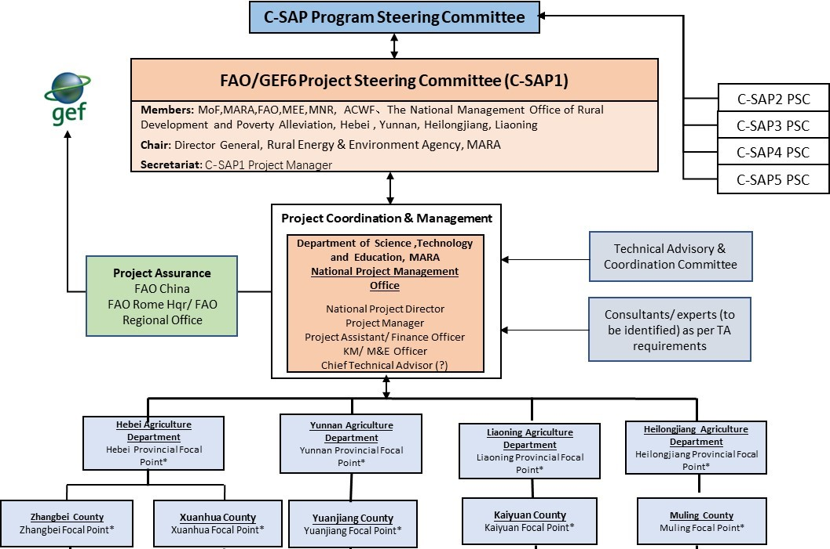
Figure 3: Project Organogram

Technical Guidance and Assistance
Technical Advisory and Coordination Committee
A Technical Advisory and Coordination Committee (TACC) will function as an intermediate group to provide inter-disciplinary technical guidance and coordination to the project to ensure that the project interventions are technically sound and there is coordination among the relevant technical sectors/ agencies for a holistic approach to project implementation. The TACC will meet at least once a year before the PSC meetings so that all key technical issues relevant to project implementation are deliberated in advance and are ready for presentation at the PSC meetings.
The ToR for the TACC is provided in Appendix VI.

Technical Assistance
Short-term consultancies will be procured through competitive bidding processes for technical assistance required for project implementation. The types of expertise envisaged on short-term assignments include but are not limited to the following:
- Agrobiodiversity policy/ strategy development;
- Technical evaluation of traditional crop varieties;
- Farmer field school design and guidance;
- Value chain analysis and business/ marketing plan development.
For mid-term review and terminal evaluation of the project, independent evaluators will be recruited directly by FAO using its internal procurement system.

GEF Agency
In accordance with its comparative advantage as illustrated in section 2.4, the Food and Agriculture Organization of the United Nations (FAO) will be the GEF Agency for the project. FAO will provide technical guidance and ensure quality assurance during the project execution. Administration of the GEF grant will be in compliance with the rules and procedures of FAO, and in accordance with the agreement between FAO and the GEF Trustee.
As the GEF agency for the project, FAO will:
- manage and disburse funds from GEF in accordance with the rules and procedures of FAO;
- oversee Project implementation in accordance with the Project Document, work plans, budgets, Agreements with co-financiers and the rules and procedures of FAO;
- provide technical support to ensure that appropriate technical quality is applied to all activities;
- review expenditure and financial statements, monitor financial management of the Project and carry out spot checks and audits, contracting the services of an audit firm, as necessary;
- supervise and monitor contracting and procurement processes;
- carry out at least one supervision mission per year;
- ensure independent mid-term and final evaluations are conducted; and
- report to the GEF Secretariat and Evaluation Office, through the annual Project Implementation Review on Project progress, and provide Financial Reports to the GEF Trustee.
Details of FAO’s roles and responsibilities as the GEF Agency for the project is provided in Appendix VII.

Financial Planning and Management

Financial Plan
The total project cost is USD 22,960,008 with a GEF grant of USD 2,725,688. Total co-financing from government partners, private agencies and FAO is USD 20,234,320. FAO, as the GEF Implementing Agency, is responsible for the monitoring and execution of the GEF resources. The actual realization of project co-financing will be assessed during the mid-term review and terminal evaluation, and will be accordingly reported to the GEF.
The breakdown of the project cost by outcome, co-financing and GEF resources is provided in the following table:
Table 8: Summary Table of Project Cost
Outcome | Co-financing (USD) |  | GEF resources (USD)
Outcome 1.1: In-situ conservation and sustainable use of genetic diversity of significant indigenous local crops and varieties mainstreamed into policies or plans at different levels, and also in four targeted provinces, to support the development of national strategies that protect agrobiodiversity. | MARA  Provincial Gov’ts  Total Co-financing | 640,000  1,240,000  1,880,000 | 277,877
Outcome 2.1: Capacities strengthened to support long-term plans and up-scaling of incentive-based approaches for on-farm conservation and sustainable use of crop diversity for resilient agriculture and sustainable production. | MARA  Provincial Gov’ts  Total Co-financing | 800,000  3,880,000  4,680,000 | 992,752
Outcome 3.1: Improved marketing of products made from local varieties, including through the use of both traditional knowledge and modern technologies, taking into account market /non-market incentives to increase local crop diversity production and availability. | MARA  Provincial Gov’ts  Private Enterprises  Agri Cooperatives  Total Co-financing | 800,000  8,004,320  770,000  770,000  10,344,320 | 970,127
Outcome 4.1: Information and knowledge of social, cultural, economic, research and marketing aspects related to crops and their local varieties will be collected, documented and published for providing basic support for further conservation and sustainable utilization. | MARA  Provincial Gov’ts  Total Co-financing | 570,000  2,120,000  2,690,000 | 355,432
Project Management | MARA  Provincial Gov’ts  FAO  Total Co-financing | 270,000  120,000  250,000  640,000 | 129,500
Total |  | 20,234,320 | 2,725,688
Detailed GEF budget as per FAO oracle budget codes and by year are provided in Appendix III.

Financial Management
Financial planning and budgeting mechanisms have been well established in MARA in executing programs and projects by various international development agencies including several funded by the GEF. As a key government ministry, MARA uses governmental computerized financial management system, which is sufficiently safeguarded and easy to generate reports. It is audited annually by external auditors. As a government agency, the operating partner (OP) strictly follows internal control procedures and the government policies. It receives close and regular supervisions from Ministry of Finance and National Audit Office.
The financial management procedures in MARA are in accordance with the National Financial Accounting Regulations which in turn are coherent with International Financial Accounting Standard.
For this project, the NPMO will carry out the following financial management tasks with support from project focal persons in the provinces of Hebei, Heilongjiang, Liaoning and Yunnan:
- Prepare the annual work plan and budget (AWP/B) with detailed description of outputs, activities and timeline of implementation and actors responsible for implementation, including provinces and sub-contractors, etc.;
- Prepare the annual financial plan based on the AWP, procurement plan, consultancy recruitment plan as well as overall financial budget included in the project document. The financial budget plan will be submitted to PSC and FAO for review and approval;
- The approved financial budget plan will be used by NPMO for mobilizing the fund application from FAO and fund disbursement;
- The financial plans and detailed budget will be provided to the responsible financial officer of REEA and will used as reference documents for guiding their daily accounting and book keeping and monitoring the bank account balance.
In general, financial management of GEF resources will be carried out according to FAO rules and procedures. A detailed description of financial management provisions is included In Appendix VIII.
Financial management of resources entrusted to the OP will be carried out in line with the OP’s rules and regulations, as assessed by the capacity assessment and in strict compliance with all OPA provisions and other FAO and GEF requirements.

Risk Management

Potential Risks

The following risks may hinder realization of the project objectives:
Risks | Risk rating | Mitigation measures
Policy risks: The project involves rice, oat, millet, and soybean. Compared to the improved varieties of staple crops, the government attaches less importance to the traditional local varieties. At present the country has witnessed bumper harvest for ten consecutive years. As such, it is easy to gain government support to carry out conservation and sustainable use of traditional crop varieties, and relevant policy recommendations are also likely to be formulated and implemented. However, if the grain yield decreases, the government may not want to invest in conservation of traditional crop varieties but increase its focus on expanding the planting area of the main grain crops and promoting new high-yielding varieties for increased grain production because ensuring food security is a major priority for the Chinese government. In such circumstance, government may deviate policy support, adversely impacting the efforts to conserve traditional crop varieties. | Low | The operational partner and main government counterpart for the project is the Ministry of Agriculture and Rural Affairs. MARA is the country's main government agency for the development of agricultural policy. Prior to the formulation of any policy, research must be carried out in the agricultural systems, thus project officials including the National Project Director, are the first ones to obtain information related to the policy development. The project can develop response plans to mitigate the policy risk before the new policy is issued. In addition, the main distribution areas of the traditional crop varieties are generally not suitable for the cultivation of the improved varieties of staple crops. As a result, even if China developed policies to encourage the cultivation of the improved varieties, the impact on the project will be very limited. Furthermore, the project will pilot field interventions on small-scale farms in a few sites, which are unlikely to be intervened for large-scale production.
Natural risks: Because the targeted local crop varieties are mainly distributed in the local and special ecosystems, which are prone to natural disasters such as drought, there are risks of natural disasters during project implementation, resulting in loss of crop production. In such an event, local communities may misconceive the impact as one due to project design, discouraging the active participation of all stakeholders of the project. | Low | During the project implementation, new commercial varieties will be selected as reference. In case of natural disasters, the advantage of the local variety will be proved by the performance of the new variety and the selected local variety, thus to eliminate the doubt stakeholders, so they will continue to implement the project and achieve the expected objectives.
Market risk: One important aspect of this project is to reflect the market value of the genetic diversity of local varieties through markets, providing the farmers with relatively large benefit while at the same time protecting the genetic diversity. However, since China is still in the primary stage of socialist market economy, If the market is fluctuating or even falling back under the impacts of the external environment, it may affect the market outlook for the local crop varieties. | Moderate | The commercialization of the genetic diversity of local varieties is only one way for sustainable utilization; the project will enable farmers to benefits from the conservation and utilization of agricultural diversity. Market and business plans will be developed by the project to improve economic benefits and enhance market resilience of the traditional crop varieties.
Co-financing risk: Since the Chinese economy is in the stage of slowing down of the growth rate, whether the committed co-finance can be in full or in time is subject to the influences of many factors including China's economic development. Due to the high proportion of project co-finance, the governments would be in difficulty if the economy were to decline during project implementation. | Low | Co-financing has been be guaranteed through letters of commitment by MARA, provincial/ local governments, private companies and FAO. The co-financing commitments will be monitored and their status assessed during mid-term review and terminal evaluations. In addition, with the adjustment of the agricultural industry policy by the Chinese government, more and more private investment will be involved in the project, so as to ensure that the project has adequate funding sources.
Climate change risks: Climate change is increasing impacting many spheres of development including agriculture. The target project provinces are located in different geoclimatic conditions of China, thereby increasing the likelihood of risks from extreme weather events. | Low | The project will focus on sustainable agricultural methods and practices, which will include increasing resilience to climate change. In addition, close communication will be maintained with meteorological stations in the provinces to alert farmer and mitigate any major impacts due to extreme weather.
With FAO support and guidance, the Project Steering Committee will be responsible for the management of the above risks as well as the effective implementation of mitigation measures.

Environmental and Social Risks
The project was screened for environmental and social risks pertaining to: (i) natural resource management; (ii) biodiversity, ecosystem and natural habitats; (iii) plant genetic resources for food and agriculture; (iv) animal- livestock and aquatic genetic resources for food and agriculture; (v) pest and pesticides management; (vi) involuntary resettlement and displacement; (vii) decent work; (viii) gender equality; and (ix) indigenous people’s and cultural heritage in accordance FAO’s environmental and social management guidelines, 2015. It was classified as low risk. Appendix Vb provides the project screening against the various FAO environmental and social standards.
During the PPG phase, baseline assessments were conducted by local technical experts. These assessments included identification of potential environmental and social risks from the project. The baseline assessments indicated that there were no environmental and social risks associated with the project, thereby confirming the ‘low risk’ category of the project. During project implementation, annual work plans will be subjected to review by a Technical Advisory and Coordination Committee, which will among other things ensure that the planned activities are in keeping with agreed technical standards including the environmental and social standards described in the FAO guidelines. Furthermore, should there be any project-related complaints, including those pertaining to adverse environmental and social impacts, they will be addressed through the grievance mechanism instituted for the project.

Analysis of Fiduciary Risks
The project will be implemented through the OPIM – Operational Partner Implementation Modality. The selected Operational Partner is MARA. A micro-assessment of MARA was carried out by the Ruihua Certified Public Accountants, commissioned by the UNDP. This assessment also addresses the needs of FAO for fiduciary risk analysis. The overall risk assessment is low. The table below shows the risk assessment against various aspects of fiduciary areas:
Table 9: Fiduciary Assessment
Fiduciary area | Level of Risk | Brief Explanation
Implementing partner | Low | The Ministry of Agriculture and Rural Affairs of the People's Republic of China is a legally registered government ministry which receives annual financial allocation and regular supervisions from the Ministry of Finance. No significant issues have been reported in the receipt and management of funds in the past.
Program Management | Low | Some project planning and monitoring documents were reviewed, and confirmed that the OP is strictly following the internal/donor’s project management policies.
Organizational structure and staffing | Low | As a government ministry, the IP follows the national civil servant recruiting and training policies. The annual civil servant examination guaranteed the transparency of recruitment and make sure qualified staffs are selected. Therefore, it is considered the personnel of the OP have sufficient capability to manage the fund/program.
Accounting policies and procedures | Low | The IP sets up different account codes for different programs. Its accounting system is formally regulated and duties are segregated. No substantial expenditure paid in cash. The OP’s Audit Office under Department of Finance of IP is in charge of the internal audit work and acts on the internal auditor’s recommendations.
Fixed Assets and Inventory | Low | The OP follows the Measures for the Administration of Government Fixed Assets, and has regular physical verifications. The main issue identified is that its fixed assets are not adequately covered by insurances policies.
Financial Reporting and Monitoring | Low | The OP uses the governmental computerized financial management system, which is sufficiently safeguarded and easy to generate reports. It is audited annually by external auditors; no major issues reported by the external auditors.
Procurement | Low | The procurement procedures and systems of the OP are transparent and fair. There have been no major issues or post-facto actions on contracts for the OP in the past.
Overall Risk Assessment | Low | As a government ministry, the OP follows strictly to the internal control procedures and the government policies. The IP receives close and regular supervisions from Ministry of Finance and National Audit Office.
The assessment noted only one issue: OP’s fixed assets are not adequately covered by insurance policies, except for cars. Recommendation has been made for application of adequate insurance policies for the fixed assets

Monitoring, Performance Assessment and Reporting

Monitoring Arrangements
Project oversight will be carried out by the PSC, FAO GEF Coordination Unit and relevant technical units in FAO headquarters. Oversight will ensure that: (i) project outputs are produced in accordance with the project results framework and leading to the achievement of project outcomes; (ii) project outcomes are leading to the achievement of the project objective; (iii) risks are continuously identified and monitored and appropriate mitigation strategies are applied; and (iv) agreed project global environmental benefits/adaptation benefits are being delivered.
The FAO GEF Coordination Unit and HQ Technical Units will provide oversight of GEF financed activities, outputs and outcomes largely through the annual Project Implementation Reports (PIRs), periodic backstopping and supervision missions.
Project monitoring will be carried out by the NPMO and the FAO BH. Project performance will be monitored using the project results matrix, including indicators (baseline and targets) and annual work plans and budgets. At project inception, the results matrix will be reviewed to finalize identification of: i) outputs; ii) indicators; and iii) missing baseline information and targets. A detailed M&E plan, which builds on the results matrix and defines specific requirements for each indicator (data collection methods, frequency, responsibilities for data collection and analysis, etc.) will also be developed during project inception by the Knowledge Management/ M&E Officer appointed at the NPMO.
Table 10: Project Monitoring and Evaluation Plan
M&E Activity | Responsible Parties | Time-frame | GEF Budget (USD)
Inception Workshop | National Project Management Office | Within two months of project document signature | 20,000
Project Inception Report | National Project Manager | Within two weeks of inception workshop | None
Annual financial audits | FAO China Representation Office/ NPMO | Annually | 30,000  (6,000 per year)
Project Progress Reports | National Project Manager and Knowledge Management/ M&E officer | Annually | None
Project Implementation Review report (PIR) | National Project Manager | Annually in July | None
Co-financing Reports | FAO China Representation Office | Annually | Co-financing
Mid-term Review | FAO Office of Evaluation | In the 3rd quarter of the 3rd year of the project | 40,000
Final evaluation | FAO Office of Evaluation | At least three months before operational closure | 40,000
Terminal Report | FAO China Representation Office/ NPMO | Within two months of project closure | 6,550
Total Budget |  |  | 136,550
Specific reports that will be prepared under the M&E program are: (i) Project inception report; (ii) Annual Work Plan and Budget (AWP/B); (iii) Project Progress Reports (PPRs); (iv) annual Project Implementation Review (PIR); (v) Technical Reports; (vi) co-financing reports; and (vii) Terminal Report. In addition, assessment of the relevant GEF-7 core indicators (see Appendix I: Results Matrix) and capacity scorecards against the baselines (completed during project preparation) will be required at mid-term and final project evaluation.
Project Inception Report. It is recommended that the NPMO prepare a draft project inception report in consultation with the LTO, BH and other project partners. Elements of this report should be discussed during the Project Inception Workshop and the report subsequently finalized. The report will include a narrative on the institutional roles and responsibilities and coordinating action of project partners, progress to date on project establishment and start-up activities and an update of any changed external conditions that may affect project implementation. It will also include a detailed first year AWP/B, a detailed project monitoring plan. The draft inception report will be circulated to the PSC for review and comments before its finalization, no later than one month after project start-up. The report should be cleared by the FAO BH, LTO and the FAO GEF Coordination Unit and uploaded in FPMIS by the BH.
Results-based Annual Work Plan and Budget (AWP/B). The draft of the first AWP/B will be prepared by the NPMO in consultation with the FAO Project Task Force and reviewed at the project Inception Workshop. The Inception Workshop (IW) inputs will be incorporated and the NPMO will submit a final draft AWP/B within two weeks of the IW to the BH. For subsequent AWP/B, the NPMO will organize a project progress review and planning meeting for its review. Once comments have been incorporated, the BH will circulate the AWP/B to the LTO and the FAO GEF Coordination Unit for comments/clearance prior to uploading in FPMIS by the BH. The AWP/B must be linked to the project’s Results Framework indicators so that the project’s work is contributing to the achievement of the indicators. The AWP/B should include detailed activities to be implemented to achieve the project outputs and output targets and divided into monthly timeframes and targets and milestone dates for output indicators to be achieved during the year. A detailed project budget for the activities to be implemented during the year should also be included together with all monitoring and supervision activities required during the year. The AWP/B should be approved by the Project Steering Committee and uploaded on the FPMIS by the BH.
Project Progress Reports (PPR): PPRs will be prepared by the NPMO based on the systematic monitoring of output and outcome indicators identified in the project’s Results Framework (Annex 1). The purpose of the PPR is to identify constraints, problems or bottlenecks that impede timely implementation and to take appropriate remedial action in a timely manner. They will also report on projects risks and implementation of the risk mitigation plan. The Budget Holder has the responsibility to coordinate the preparation and finalization of the PPR, in consultation with the NPMO, LTO and the FLO. After LTO, BH and FLO clearance, the FLO will ensure that project progress reports are uploaded in FPMIS in a timely manner.
Annual Project Implementation Review (PIR): The BH (in collaboration with the NPMO and the LTO) will prepare an annual PIR covering the period July (the previous year) through June (current year) to be submitted to the FAO GEF Coordination Unit Funding Liaison Officer (FLO) for review and approval no later than (check each year with GEF Unit but roughly end June/early July each year). The FAO GEF Coordination Unit will submit the PIR to the GEF Secretariat and GEF Evaluation Office as part of the Annual Monitoring Review report of the FAO-GEF portfolio. PIRs will be uploaded on the FPMIS by the FAO GEF Coordination Unit.
Key milestones for the PIR process:
- Early July: the LTOs submit the draft PIRs (after consultations with BHs, project teams) to the GEF Coordination Unit (faogef@fao.org , copying respective GEF Unit officer) for initial review;
- Mid July: FAO GEF Coordination Unit responsible officers review main elements of PIR and discuss with LTO as required;
- Early/mid-August: the FAO GEF Coordination Unit prepares and finalizes the FAO Summary Tables and sends to the GEF Secretariat by (date is communicated each year by the GEF Secretariat through the FAO GEF Coordination Unit;
- September/October: PIRs are finalized. PIRs carefully and thoroughly reviewed by the FAO GEF Coordination Unit and discussed with the LTOs for final review and clearance;
- Mid November: (date to be confirmed by the GEF): the FAO GEF Coordination Unit submits the final PIR reports -cleared by the LTO and approved by the FAO GEF Coordination Unit - to the GEF Secretariat and the GEF Independent Evaluation Office.
Technical Reports: Technical reports will be prepared by national, international consultants (partner organizations under LOAs) as part of project outputs and to document and share project outcomes and lessons learned. The drafts of any technical reports must be submitted by the NPMO to the BH who will share it with the LTO. The LTO will be responsible for ensuring appropriate technical review and clearance of said report. The BH will upload the final cleared reports onto the FPMIS. Copies of the technical reports will be distributed to project partners and the Project Steering Committee as appropriate.
Co-financing Reports: The BH, with support from the NPMO, will be responsible for collecting the required information and reporting on co-financing as indicated in the Project Document/CEO Request. The NPMO will compile the information received from the executing partners and transmit it in a timely manner to the LTO and BH. The report, which covers the period 1 July through 30 June, is to be submitted on or before 31 July and will be incorporated into the annual PIR. The format and tables to report on co-financing can be found in the PIR.
Terminal Report: Within two months before the end date of the project, and one month before the Final Evaluation, the NPMO will submit to the BH and LTO a draft Terminal Report. The main purpose of the Terminal Report is to give guidance at ministerial or senior government level on the policy decisions required for the follow-up of the project, and to provide the donor with information on how the funds were utilized. The Terminal Report is accordingly a concise account of the main products, results, conclusions and recommendations of the project, without unnecessary background, narrative or technical details. The target readership consists of persons who are not necessarily technical specialists but who need to understand the policy implications of technical findings and needs for insuring sustainability of project results.

Evaluation Provisions
The MTR will assess the project progress and the likelihood of achieving the various project results, identify issues and challenges, and provide recommendations for enhancing project implementation. The FE will aim to identify the project impacts and sustainability of project results and the degree of achievement of long-term results. This evaluation will also have the purpose of indicating future actions needed to sustain project results and disseminate products and best-practices within the country and to other countries.
Two independent project evaluations, one a mid-term review (MTR) in the 3rd quarter of project year 3 and the other a final evaluation (FE) three months prior to the terminal review meeting of the project partners, will be carried out. The BH will arrange an independent MTR in consultation with the PSC, the NPMO, the LTO and the FAO-GEF Coordination Unit. The MTR will be conducted to review progress and effectiveness of implementation in terms of achieving project objective, outcomes and outputs. The MTE will allow mid-course corrective actions, if needed. The MTE will provide a systematic analysis of the information on project progress in the achievement of expected results against budget expenditures. It will refer to the Project Budget (see Appendix III) and the approved AWP/Bs. It will highlight replicable good practices and key issues faced during project implementation and will suggest mitigation actions to be discussed by the PSC, the LTO and FAO-GEF Coordination Unit.
An independent Final Evaluation (FE) will be carried out three months prior to the terminal report meeting. The FE will aim to identify the project impacts, sustainability of project outcomes and the degree of achievement of long-term results. The FE will also have the purpose of indicating future actions needed to expand the existing project results, mainstream and up-scale its products and practices, and disseminate information to management authorities and institutions with responsibilities for food security, conservation and sustainable use of agrobiodiversity, and improvement of agricultural livelihoods to assure continuity of the project initiatives. Both the MTR and FE will pay special attention to outcome indicators, including the GEF core indicators and the capacity scorecards.

SECTION IV - SUSTAINABILITY

Capacity Development
In essence, the entire project is a capacity development project as it seeks to improve capacity at various levels. Systemic capacity will be built through development of favorable policies and strategies, institutional capacity will be strengthened through better inter-institutional coordination mechanisms, development of technical guidelines and toolkits, and knowledge management including improved databases and communication platforms, and individual capacity will be developed through trainings to improve knowledge and skills of government staff as well farmers and other stakeholders. Capacity development at systemic, institutional and individual levels will complement each other and create a larger capacity environment for sustainability of project results.
The approach of the project will be to engage with a wide range of stakeholders so that there is broad-based ownership of the project interventions. Inter-institutional coordination mechanisms developed and instituted through the project are expected to contribute to a holistic and inter-disciplinary approach to the delivery and management of project interventions, which in turn will enhance the sustainability of the project. Participatory approaches and practices such as through farmer field schools will create a community-based learning environment which is linked to the lives and livelihoods of the local communities in a very practical manner. These are expected to stimulate the interest and engagement of the local communities and built their capacity for the long-term management of traditional crop varieties. The ToT approach for participatory research and extension services for on-farm conservation of traditional agrobiodiversity will create in-house training capacity, which will be valuable beyond the conclusion of the project. By the end of the project, at least 300 institutional staff related to agricultural development in relevant government agencies at the national, provincial, county and township levels will have received training in one or more subjects addressed by the project. At the same time, widespread public awareness will be built through a series of communication and public awareness-building activities. An increased public and professional understanding will contribute to improved public and professional support for the conservation of traditional crop varieties.

Financial Sustainability
With respect to the financial dimension of sustainability, the project will help facilitate improved and broader uptake of incentive mechanisms, both market-based and non-market-based. Partnerships will be built with the private sector and corporate social responsibility mechanisms will be pursued to promote domestic financing over the long-term. The project will help the communities/ farmers cooperatives in project demonstration sites to come up with business and marketing plans that generates economic benefits, which can be ploughed back to financially sustain the on-farm conservation of traditional crop varieties. Policy-level advocacy will be pursued to increase government budget allocation for the conservation of indigenous agrobiodiversity (reflected as an indicator under Outcome 1.1, see Appendix I). The project will avoid expensive interventions and instead focus on low-cost interventions which can be sustained at the community level over a long term.

Environmental Sustainability
In terms of environmental sustainability, the project will primarily pursue and promote the on-farm conservation of traditional crop varieties. The selected traditional crop varieties for project interventions are those may also be more suitable for cultivation in organic conditions than the modern varieties with the potential to be developed and marketed as niche crops and products.
Agricultural researchers and extension agents in general and on indigenous plant genetic resources in particular, will also be trained in participatory approaches and on-farm conservation, thus meeting the much needed expertise at the research institute and educational institution level, as these topics, at the moment, are not adequately covered by formal agricultural research and educational establishments, contributing to environmental sustainability while improving local communities’ livelihoods. Further, the project will add value to the traditional crop diversity with respect to resistance to biotic and abiotic stresses and important quality and nutrition traits leading to sustainability. Sustainability is further assured though the strengthening of links between farmers, extension workers and researchers through participatory approaches in selection of technologies and decision making at various levels. It will promote and demonstrate an integrated and participatory approach towards agrobiodiversity conservation, which will facilitate more effective protection of biodiversity and ecosystem services, and increase the resilience of local communities to the potential impacts of climate change. AWP/Bs will be reviewed by the TACC to ensure that the activities proposed therein meet FAO’s environmental and social standards and have no undue environmental and social risks.

Innovation and Scale-up
At the policy level, the project is designed to create conducive policies/ strategies that among other things will focus on fostering incentivize mechanisms and creating better economic opportunities for local communities, especially women and youth in the conservation and sustainable use of indigenous crop diversity. The project will develop and institute inter-institutional coordination mechanisms at the national as well as provincial levels to facilitate a collaborative and holistic approach, conduct community-based learning to infuse sustainable on-farm crop diversity management methods and practices in local agricultural systems, promote local community partnerships with private sector for better product development and marketing, and introduce incentive mechanisms to offset the higher production costs, e.g. due to labor-intensive practices and low yields, associated with the cultivation traditional crop varieties. In this respect, the project will not only address market-based incentives but also explore and demonstrate how non-market incentives, e.g. eco-compensation and eco-labelling, can be effectively employed in the on-farm conservation of traditional crop varieties.
Building on FAO’s experience in FFS in China and elsewhere, the project will develop and operationalize FFS customized to the local circumstances and needs in the project sites and create a hands-on community-based learning environment based on interactions between agricultural researchers, extension workers and farmers and between farmers themselves. It will also employ ToT approach to training, which will have a multiplier effect and is more sustainable.
The project will maintain close linkages with other individual child projects of C-SAP to learn and share knowledge, ideas and experiences. It will take turn with other child projects to organize the program steering committee meeting, which will enable it to facilitate exchange of knowledge and information with other projects.

Decent Rural Employment
In the project demonstration sites, the on-farm conservation approaches and practices will be closely linked to the livelihoods of the farmers and local economy by integrating sustainable economic incentives, value addition and improved market access. Where conservation interventions generate direct economic benefits, local communities, private sector and the government are expected to actively continue with the project activities, and up-scale them, beyond the conclusion of the project. Engagement with youth, which constitutes 20% of the resident population in the project demonstration sites, will be pursued to attract them to agrobiodiversity conservation through creation of incentives and economic benefits based on sound policies and linkages with markets and private sector. Partnership with private sector is expected to improve commodity development and marketing whilst also improving the awareness of farmers for good commercial practices and standards in agricultural production, thereby improving their capacity for decent jobs. The project seeks to achieve at least 15% increase in annual household income in the project demonstration sites.

Gender Equality and Women Empowerment
The project will equally benefit men and women. There are more than 6,600 people living in the project demonstration sites; 48% of them are females. Women in rural communities throughout China play an important role in the management of local agricultural systems, including cultivation and harvesting, collection and storage of seeds, maintaining home gardens, gathering of ‘wild crops’ alongside a range of other aspects of agrobiodiversity conservation and sustainable use. Although in the project demonstration sites the male population is slightly higher, in many communities in China women farmers outnumber male farmers as men have the tendency to migrate to urban areas for jobs in cities, factories and construction projects. Even though women in many communities have in effect the primary role of managing households and farms, men generally retain the decision-making role. It is, therefore, important to recognize distinct gender roles in agrobiodiversity management, considering the distinct roles and responsibilities, interests, and needs between men and women.
The All China Women’s Federation (ACWF) is a women's rights organization established in China in 1949. It was originally called the All-China Democratic Women's Foundation, and was renamed the All-China Women's Federation in 1957. The ACWF is responsible for promoting government policies on women, and protecting women’s rights within the government. Its institutional presence runs way from the national level to provincial, county, township and all the way down to village levels. The local women’s federations engage in grassroots community development including agriculture. The national and provincial inter-institutional coordination mechanisms that are to be instituted for agrobiodiversity conservation at the national and provincial levels will have representation from ACWF at their respective levels. This will help ensure that women’s interests and needs are recognized and incorporated in the planning and implementation of agrobiodiversity conservation programs and activities. In the project demonstration sites, the project will maintain close contact with representatives of the ACWF at the local level to mobilize women’s participation and integrate women’s issues and needs in the planned field activities.

APPENDICES

Appendix I: Results Matrix
The project will contribute primarily to the following Sustainable Development Goals:
SDG 2: End Hunger, achieve food security and improved nutrition and promote sustainable agriculture. It will particularly contribute to SDG 2, Target 2.5: By 2020, maintain the genetic diversity of seeds, cultivated plants and farmed and domesticated animals and their related wild species, including through soundly managed and diversified seed and plant banks at the national, regional and international levels, and promote access to and fair and equitable sharing of benefits arising from the utilization of genetic resources and associated traditional knowledge, as internationally agreed. In addition, it will contribute to SDG 2, Target 2.4: By 2030, ensure sustainable food production systems and implement resilient agricultural practice that increase productivity and production, that help maintain ecosystems, that strengthen capacity for adaptation to climate change, extreme weather, drought, flooding and other disasters and that progressively improve land and soil quality.
SDG 15: Protect, restore and promote sustainable use of terrestrial ecosystems, sustainably manage forests, combat desertification, and halt and reverse land degradation and halt biodiversity loss.
It will make secondary contributions towards SDG 1 (end poverty), SDG 5 (gender equality), SDG 10 (reduce inequality), SDG 13 (climate change), and SDG 17 (global partnerships for sustainable development)
FAO’s Strategic Framework (reviewed, 2017):
Strategic Objective 2: Make agriculture, forestry and fisheries more productive and sustainable.
Strategic Objective 4: Enable more inclusive and efficient agriculture and food production systems.
FAO Country Programming Framework (2016-2020):
Priority Area: Fostering sustainable and climate-resilient agriculture development.
Output 1.1: Introduction and adoption of innovative approaches and best practices in global agriculture development, such as agro-ecology, nutrition-sensitive agriculture, ICT, facilitated and strengthened to contribute to sustainable agricultural development in China;
Output 1.2: Biodiversity conservation and development interventions supported to revitalize key forest, water and wetland agro-ecosystems in the country.
Development Objective: Strengthen sustainable livelihoods through improved management and utilization of crop genetic diversity.
Project Objective: Mainstream on-farm conservation and sustainable use of globally important local varieties of crops originated in China for food and agriculture, through a strengthened enabling environment, and the development and demonstration of long-term incentive mechanisms.

Results Chain | Indicator(s) | Baseline | Mid-term Milestone | Target | Means of Verification | Assumption(s)
GEF-7 Core Indicator | Core Indicator 4:  Area of landscapes under improved practices (hectares; excluding protected areas). | - | Sustainable agrobiodiversity management approaches and practices developed and initiated in the project sites | 36,000 hectares of farmland under sustainable agrobiodiversity management in the project sites. | Project progress reports;  Project mid-term review and final evaluation reports. | There is active participation by local farmers and other stakeholders;  Co-financing materializes as planned;  Project timeframe is sufficient to achieve in situ conservation and sustainable use of traditional crop diversity in the demonstration landscapes;  Local population will not move out of the selected project sites.
GEF-7 Core Indicator | Core Indicator 11:  Number of direct beneficiaries disaggregated by gender as a co-benefit of GEF investment. | - | At least 50% of the target local people;  At least 50% of the target agricultural relevant government officials. | 6,600 local people in the project sites, including at least 48% female local population;  300 institutional agricultural relevant staff in government agencies at central and provincial/ local levels. | Project progress reports;  Project mid-term review and final evaluation reports.
Component 1: Strengthen the enabling environment to promote mainstreaming of on-farm conservation and sustainable use of the genetic diversity of important indigenous local crops and varieties
Outcome 1.1: In situ conservation and sustainable use of genetic diversity of significant indigenous local crops and varieties mainstreamed into policies or plans at different levels, and also in four targeted provinces, to support the development of national strategies that protect agro-biodiversity. | Existence of a comprehensive framework of policies and strategies across sectors at the national level and in the target provinces based on the results of social, cultural and economic evaluations of local crop varieties. | No policy or strategy for on-farm conservation and sustainable use of traditional/ local crop varieties at the national level and in target provinces | Draft national policy/ strategy in place, and draft provincial policy/ strategy in place in all four target provinces | Drafts of national and provincial policies/ strategies reviewed by MARA and submitted to the concerned government authority | Policy/ strategy drafts;  Evaluation reports;  Project progress reports. | National and provincial governments are receptive to recommended policy and institutional reforms;  Proactive advocacy and stakeholder engagement for consensus on the policies/ strategies can be achieved within the given timeframe;  There will be cooperation from other sectors/ agencies for the inter-institutional cooperation mechanisms;  Financial data on budget allocation for PGRFA conservation will be readily available;  Capacity scorecards have been accurately interpreted and completed.
 | Number of coordination mechanisms between sectors and agencies at the national level and in the target provinces for on-farm conservation and sustainable use of local crop varieties. | No cross-sector coordination mechanism specific to on-farm conservation and sustainable use of local crop varieties at the national level and in target provinces | Cross-sector coordination mechanisms developed at the national level and in the four target provinces | Cross-sector coordination mechanisms instituted and fully operational at the national level and in the four target provinces | Minutes of the meetings of the cross-sector coordination bodies
 | Increased allocation of funds for programs and activities for conservation and sustainable use of genetic resources in the budgets of MARA and the provincial agriculture departments (four target provinces) | CNY 40 million (USD 5.8 million) per year – overall (central level and provinces) | At least 2% increase over 2019 baseline | At least 5% increase over 2019 baseline | Documents of finance support proof of MARA and the provincial agriculture departments
 | Scores for capacities for: (a) strategy, policy and legislation development; and (b) stakeholder engagement as indicated by capacity scorecard | National level: 11%  Hebei: 33%  Heilongjiang: 11%  Liaoning: 11%  Yunnan: 0% | National level: 25%  Hebei: 40%  Heilongjiang: 25%  Liaoning: 25%  Yunnan: 25% | National level: 50%  Hebei: 50%  Heilongjiang: 50%  Liaoning: 50%  Yunnan: 50% | Capacity scorecards;  Project progress reports.
Component 2: Capacity building to promote adaptive management and improved conservation and sustainable use of crop diversity for resilient agriculture
Outcome 2.1: Capacities strengthened to support the long-term plans and upscaling of incentive-based approaches for on-farm conservation and sustainable use of crop diversity for resilient agriculture and sustainable production. | Number of communities/ farm cooperatives with capacity to implement management mechanisms for incentive-based on-farm conservation and sustainable use of local crop varieties. | No communities/ farm cooperatives with capacity to implement management mechanisms for incentive-based on-farm conservation and sustainable use of local crop varieties in the target provinces | Five communities/ farm cooperatives with capacity to implement management mechanisms for incentive-based on-farm conservation and sustainable use of local crop varieties in the target provinces. | Ten communities/ farm cooperatives/ private sectors with capacity to implement management mechanisms for incentive-based on-farm conservation and sustainable use of local crop varieties in the target provinces (i.e. five project demo sites plus five additional sites to be extended during project implementation). | Site visits;  Project progress reports;  Local stakeholder consultations. | Capacity development activities are efficiently and effectively designed and conducted;  Government staff involved in agrobiodiversity conservation have the inclination for participatory approaches, including gender-inclusivity;  ToT involves people with training aptitude and inclination;  There is interest and willingness among the local stakeholders to engage in the recommended participatory agrobiodiversity management mechanisms;  Capacity scorecards have been accurately interpreted and completed.
 | Proportion of key stakeholders, viz. farmers, agricultural researchers, extension workers, and private entrepreneurs in the target sites with knowledge and awareness for on-farm conservation and sustainable use of local crop varieties. | X%  Baseline survey to be done in year 1 (preferably within the first six months) | 20% more than the baseline (less than half of the end-of-the-project target considering that the initial period may take more time in development of training modules and materials). | 50% more than the baseline (as per concept note) | Sample surveys;  Project progress reports;  Training/ workshop reports.
 | Score for capacities for management implementation as per capacity scorecard | National level: 17%  Hebei: 33%  Heilongjiang: 17%  Liaoning: 17%  Yunnan: 17% | National level: 25%  Hebei: 40%  Heilongjiang: 25%  Liaoning: 25%  Yunnan: 25% | National level: 50%  Hebei: 50%  Heilongjiang: 50%  Liaoning: 50%  Yunnan: 50% | Capacity scorecards; Project progress reports;  Training/ workshop reports.
Component 3: Mainstreaming diversity of local varieties through biological, socio-cultural and economic evaluation and the development of market/ non-market incentives and linkages in target sites
Outcome 3.1: Improved marketing of products from local varieties including through the use of both traditional knowledge and modern technologies, taking into account market/ non-market incentives to increase local crop diversity production and availability. | Number of local communities/ farm cooperatives with incentive-based schemes on-farm conservation of traditional/local crop varieties in the target provinces. | No local community/ farm cooperatives with incentive-based schemes for on-farm conservation of traditional/ local crop varieties | Five local communities/ farm cooperatives and private sectors with incentive-based schemes for on-farm conservation of traditional/local crop varieties. | Ten local communities/ villages and private sectors with incentive-based schemes on-farm conservation of traditional/local crop varieties, including five that are fully operational in the project demo sites. | Site visits;  Local stakeholder consultations;  Project progress reports. | Incentive mechanisms and market conditions are favorable to sustain active engagement of local communities and their partners;  There is interest and willingness in the private sector to collaborate with local communities in the conservation and marketing of traditional crop varieties.
 | Number of local communities/ farm cooperatives with business and marketing plans for products of traditional/ local crop varieties in the target provinces | No local community/ farm cooperatives with business and marketing plan for products of traditional/ local crop varieties | Five local communities/ farm cooperatives with business and marketing plans for products of traditional/ local crop varieties. | Ten local communities/ farm cooperatives with business and marketing plans for products of traditional/ local crop varieties, including five that are fully operational in the project demo sites. | Marketing and business plan documents;  Site visits;  Local stakeholder consultations;  Project progress reports.
 | Increase in household income of the farmers involved in the project from improved business and marketing schemes in the target project sites. | Baseline to be established (there are tentative figures in the baseline assessments but a proper baseline survey will be necessary to determine more accurate figures, recommended to be done in Year 1. | Business and marketing plans developed for improved income of farmers involved in the target project sites | 15% increase in annual household income of the farmers involved in the project from improved business and marketing schemes in the target project sites. | Household surveys;  Site visits;  Local stakeholder consultations.
Component 4: Strengthened knowledge management
Outcome 4.1: Information and knowledge of social, cultural, economic, research and marketing aspects related to crops and their local varieties will be collected, documented and published for providing basic support for further conservation and sustainable utilization. | Proportion of various categories of stakeholders (policy-makers, researchers, extension workers, farmers and private entrepreneurs) with improved knowledge and awareness of the traditional/ local crop varieties and their importance/benefits | Baseline % (Knowledge, attitude and practice – KAP - survey to be conducted in Year 1, preferably within the first six months) | 15 % improvement over baseline for policy-makers;  10 percent for researchers;  20 percent for extension workers  30 percent for farmers;  30 percent for private sectors managers. | 30 percent improvement over baseline for policy-makers;  15 percent for researchers;  50 percent for extension workers;  70 percent for farmers;  70 percent for private sectors managers. | KAP surveys (baseline, mid-term and end-of-the-project);  Project progress reports. | The design of the KAP survey will be participatory and lead to a genuine assessment of the level of knowledge, attitudes and practices among project stakeholders. Priority is given to completing the design and baseline KAP survey during project inception;  The database and knowledge platform will be designed through a participatory process; Sufficient training will be provided to users as well as database managers;  Proactive advocacy will be undertaken to facilitate broad usage among stakeholders;  Expertise to carry out genuine case-studies and analysis of lessons learnt/ best practices is available.
 | Number of knowledge products, including databases and case studies, developed and disseminated | Some agrobiodiversity databases exist within MARA and in the target provinces but they are not systematized. There are also various FAO databases, which could integrate data dissemination needs. | Five case studies, one from each project site, developed and disseminated;  Agrobiodiversity databases in MARA and in the provinces strengthened, including integration of data on traditional crop varieties and linkage with FAO databases. | 10 case studies, two from each project site, developed and disseminated;  Improved agrobiodiversity databases in MARA and in the provinces fully operational backed up with necessary technical capacity | Knowledge products;  Access to databases;  Project progress reports;  Stakeholder consultations.
 | Score for capacity to generate, access and use information and knowledge as per capacity scorecards | National level: 13%  Hebei: 33%  Heilongjiang: 20%  Liaoning: 20%  Yunnan: 13% | National level: 25%  Hebei: 40%  Heilongjiang: 30%  Liaoning: 30%  Yunnan: 25% | National level: 50%  Hebei: 50%  Heilongjiang: 50%  Liaoning: 50%  Yunnan: 50% | Capacity scorecards;  Project progress reports.

Appendix II: Multi-Year Workplan
Output | Activity | Responsible Entity | Year 1 |  |  |  | Year 2 |  |  |  | Year 3 |  |  |  | Year 4 |  |  |  | Year 5
Output | Activity | Responsible Entity | Q1 | Q2 | Q3 | Q4 | Q1 | Q2 | Q3 | Q4 | Q1 | Q2 | Q3 | Q4 | Q1 | Q2 | Q3 | Q4 | Q1 | Q2 | Q3 | Q4
Component 1: Strengthen the enabling environment to promote mainstreaming of on-farm conservation and sustainable use of the genetic diversity of important indigenous local crops and varieties
Outcome 1.1: In-situ conservation and sustainable use of genetic diversity of significant indigenous local crops and varieties mainstreamed into policies or plans at different levels, and also in three targeted provinces, to support the development of national strategies that protect agro-biodiversity.
Output 1.1.1: Social, cultural and economic evaluation of local varieties (e.g. nutrition and food security, public health, environmental benefits among others) conducted to serve as the basis for policy and legislation development. | Activity 1.1.1.1: Develop the guidelines for social, cultural and economic evaluations of local crops and landraces. | MARA
 | Activity 1.1.1.2: Conduct training on the use of the above technical guidelines for national and provincial staff. | MARA
 | Activity 1.1.1.3: Conduct the investigation and evaluations of local crops and landraces in all the respective target provinces. | MARA
 | Activity 1.1.1.4: Carry out analysis and documentation of the evaluations. | MARA
 | Activity 1.1.1.5: Validate the findings and conclusions of the evaluations through peer reviews and consultative meetings. | MARA
Output 1.1.2: One national strategy or policy for conservation and sustainable use of the genetic diversity of important indigenous local crop and variety prepared and submitted to MARA; four provincial strategies/policies prepared for each targeted province respectively. | Activity 1.1.2.1: Establish a national task force and provincial task forces, with well-developed ToRs, and carry out in-depth review and analysis of existing policies and strategies that have bearing on the conservation and sustainable use of the genetic diversity of important local crops and landraces. | MARA
 | Activity 1.1.2.2: Based on the in-depth policy review and analysis (activity 1.1.2.2), in combination with the findings and recommendations of the evaluations (output 1.1.1) and legislation review for incentive-based conservation (output 1.1.3), formulate draft national strategy/ policy and draft provincial strategies/ policies for conservation and sustainable use of the genetic diversity of important local crops and landraces. | MARA
 | Activity 1.1.2.3: Carry out broad-based stakeholder consultations at the national level and in the target provinces to elicit feedback on the draft national strategy/ policy and draft provincial strategies/ policies, and incorporate them in the finalization of the strategies/ policies. | MARA
 | Activity 1.1.2.4: Conduct high-level national and provincial workshops to present the strategies/ policies and submit recommendations to the national and provincial governments. | MARA
Output 1.1.3: Recommendations developed for revision/ reform of national legislations (i.e. eco-compensation legislation) that incorporates valuing the roles of the traditional farmers, including women and young people to support on-farm conservation and sustainable use of crop genetic diversity, promoting sustainable agrobiodiversity systems. | Activity 1.1.3.1: Conduct desk reviews for the existing national policy and legal framework for promoting market and non-market incentives and enhancing the roles of women and youth in sustainable agro-biodiversity systems with emphasis on local crop varieties. | MARA
 | Activity 1.1.3.2: Conduct investigations and studies in consultation with farmers, enterprise and government staff to examine existing national policy and legal framework for promoting market and non-market incentives and enhancing the roles of women and youth in sustainable agro-biodiversity systems with emphasis on local crop varieties.
 | Activity 1.1.3.3: Formulate recommendations for strengthening the national policy and legal framework to promote market and non-market incentives and enhance the roles of women and youth in sustainable agrobiodiversity systems, and incorporate them in the formulation of national and provincial strategies or policies for conservation and sustainable use of the genetic diversity of important local crops and landraces (Output 1.2). | MARA
Output 1.1.4: A national and four provincial inter-institutional cooperation mechanisms established to streamline cross-sectoral approaches to agro-biodiversity conservation. | Activity 1.1.4.1: Carry out detailed assessments of existing institutional mechanisms, identifying existing gaps for inter-sectoral approach and providing recommendations to strengthen inter-institutional mechanisms for a cross-sector and coordinated approach to agro-biodiversity conservation. | MARA
 | Activity 1.1.4.2: Based on the aforesaid assessment, constitute inter-institutional mechanisms with necessary ToRs at the national level and in the target provinces | MARA
 | Activity 1.1.4.3: Conduct sensitization workshops for members of the inter-institutional cooperation mechanisms to familiarize them with their ToRs and enhance their understanding of coordinated, inter-sector approach to agro-biodiversity conservation. | MARA
Component 2: Capacity building to promote adaptive management and improved conservation and sustainable use of crop diversity for resilient agriculture.
Outcome 2.1: Capacities strengthened to support the long-term plans and upscaling of incentive-based approaches for on-farm conservation and sustainable use of crop diversity for resilient agriculture and sustainable production.
Output 2.1.1: Development/ implementation of management mechanisms that carry out self-sustained planning, management and evaluation for on-farm conservation and use of local varieties by empowering and improving farmers’ capacities and promoting information sharing among farmers. | Activity 2.1.1.1: Examine various mechanisms for participatory management of on-farm conservation and sustainable use of traditional/ local crop varieties for their suitability in the target provinces and their selected demonstration sites. | MARA
 | Activity 2.1.1.2: Identify the most suitable participatory management mechanisms and customize them for integration in the local agrobiodiversity systems. | MARA
 | Activity 2.1.1.3: Conduct training workshops in all the target provinces to train farmers, agricultural extension agents and other relevant partners (e.g. local enterprises and cooperatives) on the participatory management mechanisms designed under activity 2.1.1.2. | MARA
 | Activity 2.1.1.4: Provide technical support and guidance to the farmers/ farm cooperatives to operationalize the participatory management mechanisms in the demonstration sites. | MARA
Output 2.1.2: Stakeholders trained and priorities set (based on needs identified by the communities and coordination with research groups dedicated to agricultural development) in participatory training/education services for on-farm conservation and use of local crop varieties. | Activity 2.1.2.1: Carry out a training needs assessment and identify existing training priorities to enhance the knowledge and skills of farmers, agricultural researchers and extension agents in the field to employ participatory tools and techniques for training and extension services for on-farm conservation and sustainable use of local crop varieties. | MARA
 | Activity 2.1.2.2: Develop training curricula and materials to address training priorities identified through the above assessment. | MARA
 | Activity 2.1.2.3: Train and create a core group of agricultural researchers and extension agents (ToT - training of trainers) with the knowledge and skills to train other researchers and extension agents as well as farmers/ farm cooperatives in the field using the above training curricula and materials. | MARA
 | Activity 2.1.2.4: Using the above core group, train all agricultural researchers, extension agents and farmers in the target provinces giving first priority to those located in the project demonstration sites. | MARA
 | Activity 2.1.2.5: Organize inter-provincial exchange workshops in participatory research and extension in the field of agrobiodiversity conservation. | MARA
 | Activity 2.1.2.6: Organize overseas study tours to secure wider exposure and knowledge from international institutions to supplement knowledge and skills in participatory agrobiodiversity training and extension acquired from in-country training and exchange programs. | MARA
Output 2.1.3: Dissemination to the wider public through media, such as TV, radio, programs, internet, publications, etc. to improve public awareness of on-farm conservation and sustainable use of local varieties. | Activity 2.1.3.1: In collaboration with media agencies, develop a communication plan to disseminate information and raise public awareness on important local crops and landraces. | MARA
 | Activity 2.1.3.2: Develop and disseminate a series of documentaries, radio programs and social media materials on the importance and benefits of local/ traditional crop varieties and their sustainable production and management practices in association with relevant media agencies. | MARA
 | Activity 2.1.3.3: Publish and disseminate pictorial booklets and electronic media on the selected traditional/ local varieties and circulate them to all relevant institutions. | MARA
Component 3: Mainstreaming diversity of local varieties through biological, socio-cultural and economic evaluation and the development of market/ non-market incentives and linkages in target sites
Outcome 3.1: Improved marketing of products from local varieties including through the use of both traditional knowledge and modern technologies, taking into account market/ non-market incentives to increase local crop diversity production and availability.
Output 3.1.1: Evaluation of local varieties through traditional knowledge, socio-cultural assessment and economic issues. | Activity 3.1.1.1: Conduct technical evaluation of the selected traditional/ local crop varieties in terms of productivity, sustainable technology, traditional knowledge, and associated socio-economic issues. | MARA
 | Activity 3.1.1.2: Conduct localized studies on potential market and non-market incentives, including “certification and payment as inheritors of local crop varieties heritage”, “eco-compensation”, market access assistance and green or organic products labelling, and recommend appropriate incentives for the selected traditional/ local crop varieties in the project demo sites. | MARA
 | Activity 3.1.1.3: Conduct studies on cultivation techniques for improving yield, quality, adaptability and other characteristics. | MARA
Output 3.1.2: Development of on-farm conservation approaches and technologies to ensure long term, demand-driven conservation of local varieties. | Activity 3.1.2.1: Develop guidelines for planning, formation and operation of farmer field schools (FFS) or similar on-farm activity for improved production and management of selected traditional/ local crop varieties using eco-friendly methods and practices. | MARA
 | Activity 3.1.2.2: Train field researchers, agriculture extension agents and progressive farmers in the concept and approach of FFS or similar on-farm activity and the employment of the above guidelines in the project demonstration sites. | MARA
 | Activity 3.1.2.3: Establish and operationalize FFSs or similar on-farm training activity in the project demonstration sites in accordance with the guidelines (activity 3.1.2.1). | MARA
 | Activity 3.1.2.4: Evaluate the FFSs or similar on-farm training activity in the project demonstration sites and document the process and results, including lessons and best practices, for reference and application. | MARA
 | Activity 3.1.2.5: Based on the results of the FFSs or similar on-farm training activity, develop on-farm conservation approaches and practices for the selected traditional/ local crop varieties integrating appropriate market and non-market incentives (activity 3.1.1.2). | MARA
 | Activity 3.1.2.6: Roll-out the FFS-tested approach and practices and provide technical support and guidance and backstopping to farmers/ farmer cooperatives to implement them. | MARA
Output 3.1.3: Business and marketing plans developed in pilot communities to maximize opportunities for product development and revenue creation based on strengthening market linkages among breeders, small-scale farmers and local and provincial markets to mainstream local crop diversity. | Activity 3.1.3.1: Carry out value chain analysis of the commodities of selected traditional/ local crop varieties in the project demonstration sites. | MARA
 | Activity 3.1.3.2: Conduct market studies and explore potential business partnerships in the private sector, including for e-commerce, green or organic products labelling, market access certification, marketing strategy improvement and corporate social responsibility, for the selected traditional/ local crop varieties in the project demonstration sites. | MARA
 | Activity 3.1.3.3: Develop business and marketing plans in the pilot communities/ farmers cooperatives and enterprises for the selected traditional/ local crop varieties, and provide small grants to support key prioritized commodity development and marketing activities. | MARA
 | Activity 3.1.3.4: Provide fiscal and finance support, such as small loans, agricultural insurances and financial or ecological subsidies, guidance and backstopping to facilitate the implementation of the business and marketing plans.
Component 4: Strengthened knowledge management
Outcome 4.1: Information and knowledge of social, cultural, economic, research and marketing aspects related to crops and their local varieties will be collected, documented and published for providing basic support for further conservation and sustainable utilization.
Output 4.1.1: Traditional and new knowledge, generated through participatory research for on-farm conservation and sustainable use of local varieties, documented together with best practices/lessons learnt from pilot sites to applicability to other local crops and varieties in China. | Activity 4.1.1.1: Carry out and document case studies to demonstrate specific concepts, approaches, practices and issues addressed by the project, e.g. integration of market and non-market incentives in on-farm conservation of traditional/ local crop varieties or capacity building of farmers and agriculture extension agents through farmer field schools. | MARA
 | Activity 4.1.1.2: Assess, document and disseminate lessons learnt related to the following project components: (a) strengthening policy and institutional framework; (b) capacity-building; and (c) on-farm demonstrations. | MARA
 | Activity 4.1.1.3: Publish reports of all evaluations and studies carried out through various project activities and disseminate through electronic media and in print. | MARA
 | Activity 4.1.1.4: Conduct mid-term and terminal project evaluations
Output 4.1.2: Establishing information and communication platforms (web-based information platform and inter-sector working groups), dedicated to on-farm conservation. | Output 4.1.2.1: Create a project website with a dedicated web page on approaches and technologies applied for on-farm conservation and sustainable use of traditional/ local crop varieties and with links to other relevant websites including to those of other child projects and the program (C-SAP) as a whole. | MARA
 | Output 4.1.2.2: Create an on-line group, with a moderator, to facilitate communication and exchange of queries and information on various aspects of on-farm conservation and sustainable use of traditional/ local crop varieties on a regular basis. | MARA
 | Output 4.1.2.3: Create and disseminate a periodic electronic newsletter providing updates and articles on on-farm conservation and sustainable use of traditional/ local crop varieties. | MARA
Output 4.1.3: Databases of species, varieties, traditional research and development practices for conservation and sustainable use of local varieties created. | Activity 4.1.3.1: Design and carry out inventories on traditional/ local crop varieties of rice, oat, millet and soybean. | MARA
 | Activity 4.1.3.2: Overhaul existing agrobiodiversity databases in MARA and in the provincial agricultural departments, integrating data acquired from the inventories on traditional/ local crop varieties of rice, oat, millet and soybean (activity 4.1.3.1) and with linkage to the FAO global database. | MARA
Output 4.1.4: Support provided for exchange of experiences and lessons between child projects, inter-institutions, national/ international organizations for effective scaling-up of project impacts. | Activity 4.1.4.1: (a) Design and carry out a KAP survey; and (b) Using the KAP survey results, develop a knowledge management strategy that among other things engenders linkages and synergy between the child projects. | MARA
 | Activity 4.1.4.2: Organize annual fora for the child projects (tied up with annual Program SC meetings rotated between the child projects) and associated institutions to exchange information and experiences, and draw lessons from project implementation. | MARA
 | Activity 4.1.4.3: Towards the end of the project/ program, organize an international seminar involving participation of other countries engaged in, or planning for, similar projects/ programs to disseminate project/ program achievements and experiences, and highlight lessons learnt and best practices. | MARA
 | Activity 4.1.4.4: Organize exchange visits to facilitate exchange of information, experiences and ideas across the child projects. | MARA

Appendix III: Project Budget
Click the following icon for the MSExcel file on project budget:


Appendix IVa: Stakeholder Engagement Matrix
A wide range of stakeholders were consulted during the project design. These included central government agencies, provincial and local government institutes, local communities, local agricultural cooperatives, private sector companies, academia, agricultural research and extension service agencies, women federation, international conservation organizations, and media. The table lists the stakeholders and their engagement in the PPG process. For more detailed lists of stakeholder consultations, see Appendix IVb.
Stakeholder Name | Stakeholder Type | Profile | When Involved
Ministry of Agriculture & Rural Affairs | Principal partner/ direct beneficiary | National government institution | Field missions, PPG inception workshop, PPG review workshop, overall coordination of PPG process in concert with FAO China
Provincial departments of agriculture and rural affairs: Hebei, Heilongjiang, Liaoning and Yunnan | Partner/ direct beneficiary | Regional government institutions | Field missions, baseline assessments, PPG inception workshop, PPG review workshop
Rural Energy & Environment Agencies: Hebei, Heilongjiang, Liaoning and Yunnan | Direct beneficiary | Regional government institutions | Field missions, baseline assessments, PPG inception workshop, PPG review workshop
Chinese Academy of Agricultural Sciences | Other | National government institution | National expertise for project design, coordination of local technical inputs for project design
Provincial Academy of Agricultural Sciences: Heilongjiang, Liaoning and Yunnan | Other | Regional government institution | Regional/ local expertise for baseline assessments and project design
Provincial Rural/ Agricultural Environment Protection and Monitoring Stations: Hebei, Heilongjiang, Liaoning and Yunnan | Direct beneficiary | Regional government institution | Field missions, baseline assessments, PPG inception workshop, PPG review workshop
City Academy of Agricultural Sciences: Zhangjiakou (Hebei) | Other | Regional academic institution | Regional/ local expertise for baseline assessments and project design
County Governments: Yuanjiang (Yunnan) | Indirect beneficiary | Local government institutions | Field missions and baseline assessments
Township Governments: Dahe, Jiajiaying (Hebei), Yangjie (Yunnan), | Indirect beneficiary | Local government institution | Field missions and baseline assessments
County Agricultural Bureaus: Zhangbei (Hebei), Yuanjiang (Yunnan) | Direct beneficiary | Local government institution | Field missions and baseline assessments
City Agricultural Bureaus: Muling (Heilongjiang); Yuxi (Yunnan) | Direct beneficiary | Local government institution | Field missions and baseline assessments
District Agricultural Bureaus: Xunahua (Hebei) | Direct beneficiary | Local government institution | Field missions and baseline assessments
Rural Economic Development Bureaus: Kaiyuan city (Liaoning) | Indirect benefic
Agricultural Technology Extension Centers: Kaiyuan city (Liaoning); Mudanjiang city, Muling city (Heilongjiang) | Direct beneficiary | Local government institution | Field missions and baseline assessments
Village Administrations: Nan Zhangzi (Zhangjiakou, Hebei) | Direct beneficiary | Local government institution | Field missions and baseline assessments
Local Cooperatives: Huihong Breeding Professional Cooperative (Zhangbei, Hebei); Shandong farmers’ cooperative, Beisheng Modern Agricultural Machinery Farmers Professional Cooperative; Lifengyuan Breeding Farmers Professional Cooperatives (Heilongjiang); Liaoning bonong bean planting professional cooperative; Hani Aromatic Rice Cooperatives (Yunnan) | Direct beneficiary | NGO | Baseline Assessments
Local communities: Taer, Wu Laoer Fangzi and Zhong Hua villages (Hebei); Guchengbo village, Hongqiyingzi and Sandaogou villages (Liaoning); Beisheng and Shandong villages (Heilongjiang); | Direct beneficiary | Local community | Field missions and baseline assessments
Private sector: Hebei Universe Agri Science & Technology Co. Ltd; Zhangjiakou Beiyan Oats Food Development Co. Ltd | Other | Other | Baseline assessments
All China Women’s Federation | Indirect beneficiary | NGO | Baseline assessments, PPG review workshop
International organizations: WWF and Bioversity International | Other | CSO | PPG review Workshop
Media: CCTV | Other | Other | PPG inception workshop, PPG review workshop

Project Level Grievance Mechanism
Focal Point Information
Contact Details
Explain how the grievance mechanism has been communicated to stakeholders

The project will establish a grievance mechanism at field level to file complaints during project inception phase. Contact information and information on the process to file a complaint will be disclosed in all meetings, workshops and other related events throughout the life of the project. In addition, it is expected that all awareness raising material to be distributed will include the necessary information regarding the contacts and the process for filing grievances.
The project will also be responsible for documenting and reporting as part of the safeguards performance monitoring on any grievances received and how they were addressed.
The mechanism includes the following stages:
- In the instance in which the claimant has the means to directly file the claim, he/she has the right to do so, presenting it directly to the Project Management Unit (PMU). The process of filing a complaint will duly consider anonymity as well as any existing traditional or indigenous dispute resolution mechanisms and it will not interfere with the community’s self-governance system.
- The complainant files a complaint through one of the channels of the grievance mechanism. This will be sent to the Project Coordinator (PC) to assess whether the complaint is eligible. The confidentiality of the complaint must be preserved during the process.
- Eligible complaints will be addressed by the Project Advisory Committee (PAC). The PGC will be responsible for recording the grievance and how it has been addressed if a resolution was agreed.
- If the situation is too complex, or the complainer does not accept the resolution, the complaint must be sent to a higher level, until a solution or acceptance is reached.
- For every complaint received, a written proof will be sent within five (5) working days; afterwards, a resolution proposal will be made within thirty (30) working days.
- In compliance with the resolution, the person in charge of dealing with the complaint, may interact with the complainant, or may call for interviews and meetings, to better understand the reasons.
- All complaint received, its response and resolutions, must be duly registered.

Internal process
Level 1. Project Management Unit (PMU). The complaint could come in writing or orally to the PCU directly. At this level, received complaints will be registered, investigated and solved by the PCU.
Level 2. If the complaint has not been solved and could not be solved in level 1, then the Project Coordinator (PC) elevates it to the FAO Representative.
Level 3. Project Steering Committee (PSC). The assistance of the PSC is requested if a resolution was not agreed in levels 1 and 2.
FAO Regional Office. If necessary FAO Representative will request the advice of the Regional Office to resolve a grievance, or may transfer the resolution of the grievance entirely to the regional office, if the problem is highly complex.
The FAO Regional Representative will request only on very specific situations or complex problems the assistance on the FAO Inspector General who follows its own procedures to solve the problem.

Resolution
Upon acceptance of a solution by the complainer, a document with the agreement should be signed with the agreement.
Project Management Unit (PMU) | Must respond within 5 working days.
FAO Representation | Anyone in the FAO Representation may receive a complaint and must request proof of receipt. If the case is accepted, the FAO Representative must respond within 5 working days in consultation with FAO's Representation and Project Team.  (insert contact details of the FAO Representative in the country)
Project Steering Committee (PSC) | If the case cannot be dealt by the FAO Representative, he/she must send the information to all PSC members and call for a meeting to find a solution. The response must be sent within 5 working days after the meeting of the PSC.
FAO Regional Office | Must respond within 5 working days in consultation with FAO's Representation.  (insert contact details of the FAO Regional Representative)
Office of the Inspector General (OIG) | To report possible fraud and bad behavior by fax, confidential:  (+39) 06 570 55550  By e-mail: Investigations-hotline@fao.org  By confidential hotline: (+ 39) 06 570 52333

Appendix IVb: Lists of Stakeholder Consultations
- Participants of the PPG Inception Workshop, 21 May 2018
Sl. No. | Name | Institution | Title | Gender
1 | Li Bo | Department of Science, Technology & Education, MARA | Deputy Director General | Male
2 | Cao Ziyi | Department of Science, Technology & Education, MARA | Consultant | Female
3 | Xu Xuewang | Department of International Cooperation, MARA | Deputy Division Director | Male
4 | Wu Xiaochun | Rural Energy & Environment Agency, MARA | Deputy Director General | Male
5 | Wang Quanhui | Rural Energy & Environment Agency, MARA | Division Director | Male
6 | Guan Dahai | Rural Energy & Environment Agency, MARA | Doctor | Male
7 | Wang Li | Rural Energy & Environment Agency, MARA |  | Female
8 | Arshiya Noorani | FAO-HQ Rome | Agricultural Officer (Plant Genetic Resources) | Female
9 | Zhang Zhongjun | FAO China Office | Assistant Representative
10 | Li Ling | FAO China Office | GEF Program Officer | Female
11 | Ma Chaode | UNDP China Office | Program Manager | Male
12 | Wu Hongbin | Rural Energy & Environment Agency,Hebei | Deputy Director | Male
13 | Liu Li | Rural Energy & Environment Agency,Hebei | Section chief | Female
14 | Liu Mengran | Rural Energy & Environment Agency,Yunnan Province | Deputy Director General | Male
15 | Yue Ying | Rural Energy & Environment Agency,Yunnan Province | Researcher | Female
16 | Dong Shuping | Rural Energy & Environment Agency, Liaoning | Deputy Director General | Female
17 | Qu Zhi | Rural Energy & Environment Agency, Liaoning | Section chief | Female
18 | Li Zhanjun | Rural Energy & Environment Agency,Heilongjiang | Deputy Director | Male
19 | Jiang Baoyi | Rural Energy & Environment Agency,Heilongjiang | Deputy Director | Male
20 | Yang Qingwen | Institute of Crop Sciences, CAAS | National Consultant | Male
21 | Chen Yuanquan | China Agriculture University | Associate Professor
22 | Liu Jie | Heilongjiang Academy of Agricultural Sciences | Director/Researcher | Male
23 | Zhong Peng | Heilongjiang Academy of Agricultural Sciences | Researcher | Male
24 | Song Shuhong | Institute of Crop Sciences, Liaoning Academy of Agricultural Sciences | Director/researcher | Male
25 | Xue Renfeng | Institute of Crop Sciences, Liaoning Academy of Agricultural Sciences | Associate Researcher | Male
26 | Fan Guangyu | Zhangjiakou Academy of Agricultural Sciences | Deputy Director / Associate Researcher | Male
27 | Ge Junyong | Zhangjiakou Academy of Agricultural Sciences | Deputy Director / Associate Researcher | Male
28 | Cheng Zaiquan | Institute of Biotechnology and Germplasm Resources, Yunnan Academy of Agricultural Sciences | Deputy Director / Researcher | Male
29 | Li Chengyu | Project Management Office, MARA | Project Director | Female
30 | Zhang Yanping | Project Management Office, MARA | Project Director | Female
31 | Huang Jie | Project Management Office, MARA | Project Officer | Female
32 | Xue Lin | Project Management Office, MARA | Project Assistant | Female
33 | Su Xing |  | Interpreter | Female
34 | Ma Hong | CCTV |  | Female
35 | Meng Xianglu | CCTV |  | Male
36 | Cheng Yuanlian | CAAS |  | Female
37 | Ugen Norbu | (By skype) | International consultant | Male

- People Consulted During Preliminary Field Missions
Sl. No. | Name | Unit | Title | Gender
Preliminary Field Mission 1, Beijing and Yunnan Province, 22-24 May 2018
1 | Wu Xiaochun | Rural Energy &Environment Agency, MARA | DDG | M
2 | Wang Quanhui | International Exchange Division, Rural Energy &Environment Agency, MARA | Director | M
3 | Zhang Yanping | Project Management Office, MARA | Project Coordinator | F
4 | Wang Li | International Exchange Division,Rural Energy &Environment Agency, MARA | Project Assistance | F
5 | Xue Renfeng | Institute of crops, Liaoning Academy of Agricultural Sciences | Agronomist | M
6 | Mu Lin | Hebei Agro-environment Protection and Monitoring Station | Director | M
7 | Guo Jing | Hebei Agro-environment Protection and Monitoring Station |  | M
8 | Zhang Dunyu | Yunnan Academy of Agricultural Sciences | Professor | M
9 | Zeng Weiqing | Yuxi Agro-environment Protection and Rural Energy Station
10 | Bai Xiaoshan | Agriculture Bureau, Yuanjiang County | Deputy Director | M
11 | Yang Xiongtai | Yangjie Town Government
12 | Li Li | The People’s Government of Yuanjiang County | Deputy Director | F
13 | Liu Mengping | Agriculture Bureau, Yuanjiang County | Director | F
14 | Wang Sen | Yuanjiang County party Committee/Yanjie Township | Secretary of the township | M
15 | Ding Wenping | Yangjie township | head of township | F
16 | Hou Yanmei | Agriculture Bureau, Yuxi City |  | F
17 | Ma Hong | CCTV |  | F
18 | Meng Xianglu | CCTV |  | M
19 | Arshiya Noorani | FAO-HQ Rome | Agricultural Officer (Plant Genetic Resources) | F
20 | Li Ling | FAO China office | GEF Portfolio Officer | F
Preliminary Field Mission 2, Beijing and Hebei, Liaoning and Heilongjiang Provinces, 1-9 July 2018
1 | Wang Quanhui | International Exchange Division, Rural Energy &Environment Agency, MARA | Director | M
2 | Zhang Yanping | Project Management Office, MARA | Project Coordinator | F
3 | Xue Lin | Project Management Office, MARA | Project Assistant | F
4 | Li Ling | FAO China office | GEF Portfolio Officer | F
5 | Zhao Wei | FAO China office | GEF Portfolio Officer | F
Hebei province, 1-5 July 2018
1 | Yang Qingwen | Chinese Academy of Agricultural Sciences | Professor | M
2 | Wu Hongbin | Hebei Agro-environment Protection and Monitoring Station | Deputy director | M
3 | Liu Li | Hebei Agro-environment Protection and Monitoring Station |  | F
4 | Chen Yuanquan | China Agricultural University | Associate professor | M
5 | Fan Guangyu | Academy of Agricultural Sciences, Zhang Jiakou | Associate researcher | M
6 | Liu Yongjun | Shuang Yinzi village, Zhang Jiakou | Village Secretary | M
7 | Zheng Xihong | Shuang Yinzi village, Zhang Jiakou | villager | F
8 | Zhang Jianmei | Shuang Yinzi village, Zhang Jiakou | villager | F
9 | Liu Hongguang | Shuang Yinzi village, Zhang Jiakou | villager | M
10 | Bai Shi | Shuang Yinzi village, Zhang Jiakou | villager | M
11 | Zhang Cheng | Shuang Yinzi village, Zhang Jiakou | villager | M
12 | Bai Jin | Shuang Yinzi village, Zhang Jiakou | villager | M
13 | Hou Yongfu | Shuang Yinzi village, Zhang Jiakou | villager | M
14 | Liu Jun | Shuang Yinzi village, Zhang Jiakou | villager | M
15 | Chen Yuan | Shuang Yinzi village, Zhang Jiakou | villager | M
16 | Bai Zheng | Shuang Yinzi village, Zhang Jiakou | villager | M
17 | Wang Shixia | Shuang Yinzi village, Zhang Jiakou | villager | F
18 | Zhao Guifang | Shuang Yinzi village, Zhang Jiakou | Women Federation | F
19 | Liu Fubin | Jiajiaying town, Zhang Jiakou | Head of the town | M
20 | Lu Guifu | Jiajiaying town, Zhang Jiakou | clerk | M
21 | Liu Zhenzhong | Agriculture and Animal Husbandry Bureau, Xuanhua District, Zhang Jiakou | Deputy director | M
22 | Zhang Fengshan | Environment Protection Station, Agriculture and Animal Husbandry Bureau, Xuanhua District, Zhang Jiakou | Officer | M
23 | Gen Weijia | Jiajiaying town, Zhang Jiakou | Vice-Head of the town | M
24 | Zhao Zhihai | Academy of Agricultural Sciences, Zhang Jiakou | Sr.Agronomist | M
25 | Xi Yuyin | Academy of Agricultural Sciences, Zhang Jiakou | Head of popular science | M
26 | Zhao Yuman | Nan Zhangzi village, Xuanhua district, Zhang Jiakou | Village Secretary | M
27 | Meng Ji | Township government, Taer village, Xuanhua District, Zhang Jiakou | Officer | M
28 | Pang You | Taer village, Xuanhua District, Zhang Jiakou | villager | M
29 | Wang Linying | Taer village, Xuanhua District, Zhang Jiakou | villager | M
30 | Qiao Cunliang | Taer village, Xuanhua District, Zhang Jiakou | villager | M
31 | Wang Junsheng | Taer village, Xuanhua District, Zhang Jiakou | Accountant | M
32 | Han Jijun | Task force team for poverty alleviation, Justice Bureau, Xuanhua District, Zhang jiakou | Officer | M
33 | Zhang Yide | Zhang Jiakou Agro-environment Protection and Monitoring Station | Director | M
34 | Pang Rong | Taer village, Xuanhua District, Zhang Jiakou | villager | F
35 | Ren Yilian | Taer village, Xuanhua District, Zhang Jiakou | villager | F
36 | Tao YueFeng | Agriculture and Animal Husbandry Bureau, Zhang Bei county | Deputy director | M
37 | Zhao Chenyan | Zhang Bei town, Zhang Bei Country | vice head of town | M
38 | Lv Xuefeng | Nan Haoqian village | village committee | M
39 | Xue Youfu | Wu Laoer Fangzi village,Zhang Bei county | Villager | M
40 | Dong Xiao | Wu Laoer Fangzi village,Zhang Bei county | Villager | M
41 | Dong Ruijun | Wu Laoer Fangzi village,Zhang Bei county | Villager | M
42 | Zhou Xhe | Wu Laoer Fangzi village,Zhang Bei county | Villager | M
43 | Liang Cai | Dahe Township,, Zhang Bei Country | vice head of town | M
44 | Liu Jincai | Zhong Hua village,Dahe Township,, Zhang Bei Country | Villager | M
45 | Liu Mingkou | Zhong Hua village | Villager | M
46 | Liu Changdu | Zhong Hua village | Villager | M
47 | Cui Fengying | Zhong Hua village | Villager | F
48 | Hu Baotao | Zhong Hua village | Villager | F
49 | Liu Fenghua | Zhong Hua village | Villager | F
50 | Chen Jinzhong | Zhong Hua village | village branch secretary | M
51 | Zhao Shifeng | Academy of Agricultural Sciences, Zhang Jiakou | Researcher | M
52 | Ge Junyong | Academy of Agricultural Sciences, Zhang Jiakou | Associate researcher | M
53 | Huang Wensheng | Academy of Agricultural Sciences, Zhang Jiakou | Deputy director | M
54 | Liu Xiaojie | Academy of Agricultural Sciences, Zhang Jiakou |  | F
55 | Zhang Haiying | Academy of Agricultural Sciences, Zhang Jiakou |  | F
56 | Ge Junyong | Academy of Agricultural Sciences, Zhang Jiakou | Doctor | M
6-7 July 2018, Liaoning Province
1 | Dong Guoguang | Rural Economy Development Bureau, Kaiyuan city | Deputy director | M
2 | Wang Shengxiang | Agricultural Technique Extension Center, Kaiyuan city | Deputy director | M
3 | Cui Jingfu | Agricultural Technique Extension Center, Kaiyuan city | Professor | M
4 | Wang Liying | Agricultural Technique Extension Center, Kaiyuan city | Sr. Agronomist | F
5 | Cheng Xinhong | Rural Energy Office, Kaiyuan city | Director | M
6 | Liu Zhiqiang | Agricultural Technique Station, Kaiyuan city | Technician | M
7 | Dai Chi | Babao town, Kaiyuan city | Villager | M
8 | Luo Yanhong | Guchengbo village, Babao town, Kaiyuan city | villager | F
9 | Wang Yuqi | Guchengbo village, Babao town, Kaiyuan city | villager | M
10 | Zhao Guojun | Guchengbo village, Babao town, Kaiyuan city | villager | M
11 | Ding Jinshan | Guchengbo village, Babao town, Kaiyuan city | villager | M
12 | Ji Xiuwen | Guchengbo village, Babao town, Kaiyuan city | villager | F
13 | Liu Yanzhong | Hongqiyingzi village, Jingouzi town, Kaiyuan city | villager | M
14 | Liu Fei | Hongqiyingzi village, Jingouzi town, Kaiyuan city | Villager | M
15 | Wu Qingjun | Hongqiyingzi village, Jingouzi town, Kaiyuan city | Villager | M
16 | Zhao Guiqin | Hongqiyingzi village, Jingouzi town, Kaiyuan city | Villager | F
17 | Zhou Huamin | Hongqiyingzi village, Jingouzi town, Kaiyuan city | Villager | M
18 | Han Wei | Hongqiyingzi village, Jingouzi town, Kaiyuan city | Jin yuan seed company | M
19 | Han Pengfei | Hongqiyingzi village, Jingouzi town, Kaiyuan city | Jin yuan seed company | M
20 | Song Shuhong | Institute of crops, Liaoning Academy of Agricultural Sciences | Director | M
21 | Xue Renfeng | Institute of crops, Liaoning Academy of Agricultural Sciences | Agronomist | M
22 | Zhao Tiecheng | Liaoning Rural Environment Protection and Monitoring Station | Director | M
23 | Dong Shuping | Liaoning Rural Environment Protection and Monitoring Station | Deputy director | F
8-9 July 2018, Heilongjiang Province
1 | You Tianfu | Rural Environment Protection and Monitoring Station, Heilongjiang | Director | M
2 | Li Zhanjun | Rural Environment Protection and Monitoring Station, Heilongjiang | Deputy director | M
3 | Bai Ming | Rural Environment Protection and Monitoring Station, Heilongjiang |  | M
4 | Zhong Peng | Institute of Energy, Heilongjiang Academy of Agricultural Sciences | Deputy director | M
5 | Li Jie | Agricultural Technique Extension Center, Mudanjiang city |  | F
6 | Fan Guanghao | Agricultural Technique Extension Center, Mudanjiang city |  | F
7 | Gao Chunyan | Agricultural Technique Extension Center, Mu Ling city | Director | F
8 | Tan Zhenwei | Ma Qiaohe town, Muling city | head of the town | M
9 | Wei Yanshan | Beisheng village, Ma Qiaohe town, Muling city | village secretary | M
10 | Zhonghao Zhongguo | Beisheng village, Ma Qiaohe town, Muling city | Villager | M
11 | Li Dianchen | Beisheng village, Ma Qiaohe town, Muling city | Villager | M
12 | Li Dianqing | Beisheng village, Ma Qiaohe town, Muling city | Villager | M
13 | Sun Jintian | Beisheng village, Ma Qiaohe town, Muling city | Villager | M
14 | Wang Xingjie | Beisheng village, Ma Qiaohe town, Muling city | Villager | M
15 | Wang Fakui | Beisheng village, Ma Qiaohe town, Muling city | Villager | M
16 | Wang Xiqian | Shandong village, Ma Qiaohe town, Muling city | Villager | M
17 | Zhu Chengchen | Shandong village, Ma Qiaohe town, Muling city | Villager | M
18 | Shan Xiuli | Shandong village, Ma Qiaohe town, Muling city | Villager | M
19 | Zhang Yingqiang | Shandong village, Ma Qiaohe town, Muling city | Villager | M
20 | Zhang Qingxiu | Shandong village, Ma Qiaohe town, Muling city | Villager | M
21 | Li Jianbo | Agriculture Bureau, Mu Ling city | Director | M
22 | Li Yijiang | Agricultural Technique Extension Center, Mu Ling city | Deputy director | M
23 | Li Junyuan | Ma Qiaohe town, Mu Ling city | head of the town | M
24 | Wei Yanshan | Beisheng village, Ma Qiaohe town, Mu Ling city | village secretary | M
25 | Wang Xiqian | Farmers’ Cooperative, Shandong village, Ma Qiaohe town, Mu Ling city | Director | M

- People Consulted During Baseline Assessments
Sl. No. | Name | Institution/ Location | Title | Gender
For millet, Hebei province
1 | Wu Hongbin | Hebei Agricultural Environmental Protection Monitoring Station | Deputy Director | Male
2 | Liu Li | Hebei Agricultural Environmental Protection Monitoring Station, | Section Chief | Female
3 | Zhang Yide | Zhangjiakou Agricultural Environment and Agricultural Products Quality Management Station | Director | Male
4 | Chen Xiangrong | Zhangjiakou Agricultural Environment and Agricultural Products Quality Management Station | Deputy Director | Female
5 | Zhang Fengshan | Agricultural and Animal Husbandry Bureau of Xuanhua County | Section Chief | Male
6 | Zhao Zhihai | Zhangjiakou Academy of Agricultural Sciences | Famous Millet Expert | Male
7 | Zhang Wenying | Zhangjiakou Academy of Agricultural Sciences | Millet Resources Expert | Female
8 | Zhang Xiaolei | Zhangjiakou Academy of Agricultural Sciences | Millet Resources Expert | Female
9 | Wen Jun | Hebei Universe Agriculture Science & Technology Co., Ltd. China's largest millet seed company | Chairman and general manager | Male
10 | Yang Jianyong | Hebei Universe Agriculture Science & Technology Co., Ltd. | Director of Marketing | Male
11 | Liu Yongjun | Shuanghuazi Village, Xuanhua County | Director of Village | Male
12 | Zhao Guifang | Shuanghuazi village, Xuanhua County | Villager | Female
13 | Cheng Youfu | Shuanghuazi village, Xuanhua County | Villager | Male
14 | Li Weizhen | Shuanghuazi village, Xuanhua County | Villager | Female
15 | Zhang Zhenqing | Shuanghuazi village, Xuanhua County | Villager | Male
16 | Chen Yuan | Shuanghuazi village, Xuanhua County | Villager | Male
For oat, Hebei Province
1 | Niu Xingxi | Zhonghua village, Zhangbei County | Peasant | Male
2 | Ruan jinzhong | Zhonghua village, Zhangbei County | Peasant | Male
3 | Gao yang | Zhonghua village, Zhangbei County | Peasant | Male
4 | Li Feng | Huihong Breeding Professional Cooperative, Zhangbei County | Secretary | Male
5 | Xi Fengbing | Zhangjiakou Beiyan Oats Food Development Co. Ltd | Chief Executive Officer | Male
6 | Liang cai | Dahe town Zhangbei county |  | Male
7 | Wang xingyu | Zhangjiakou Academy of Agricultural Sciences |  | Male
8 | Zhao shifeng | Zhangjiakou Academy of Agricultural Sciences |  | Male
9 | Wang xia | Zhangjiakou Academy of Agricultural Sciences |  | Female
10 | Tian change | Zhangjiakou Academy of Agricultural Sciences |  | Male
11 | Tan guofeng | Zhangbei county agriculture and Animal Husbandry Bureau |  | Male
For soybean, Heilongjiang province
1 | Zhanjun Li | Heilongjiang Environmental Protection Station | Assistant station master | Male
2 | Ming Bai | Heilongjiang Environmental Protection Station | Assistant station master | Male
3 | Peng Zhong | Heilongjiang Academy of Agricultural Sciences | Deputy director of institute | Male
4 | Bowen Chang | Heilongjiang Academy of Agricultural Sciences | Ph.D | Female
5 | Chunyan Gao | Muling Agricultural Technology Promotion Center | Director | Female
6 | Yijing Li | Muling Agricultural Technology Promotion Center | Deputy director | Male
7 | Yanshan Wei | Beisheng Modern Agricultural Machinery Farmers Professional Cooperative | Proprieter | Male
8 | Dialing Wei | Beisheng Modern Agricultural Machinery Farmers Professional Cooperative | Commune member | Female
9 | Shuangquan Zhu | Beisheng Modern Agricultural Machinery Farmers Professional Cooperative | Commune member | Male
10 | Junliang Dong | Beisheng village | Villager | Male
11 | Xingqiu Wang | Beisheng village | Villager | Male
12 | Zhijun Zhang | Beisheng village | Villager | Male
13 | Tianjun Li | Beisheng village | Villager | Male
14 | Yantao Wei | Beisheng village | Villager | Male
15 | Xiqian Wang | Lifengyuan Breeding Farmers Professional Cooperatives | Proprietor | Male
16 | Xiuli Shan | Lifengyuan Breeding Farmers Professional Cooperatives | Commune member | Male
17 | Yingqiang Zhang | Lifengyuan Breeding Farmers Professional Cooperatives | Commune member | Male
18 | Chengchen Zhu | Shandong village | Villager | Male
19 | Yingjun Zhang | Shandong village | Villager | Male
20 | Yingjiang Zhang | Shandong village | Villager | Male
21 | Minglu Zhao | Shandong village | Villager | Male
22 | Xiuli Zhang | Shandong village | Villager | Male
For soybean, Liaoning
1 | SONG Shu-hong | Liaoning Academy of Agricultural Sciences | Director/researcher | Male
2 | XUE Ren-feng | Liaoning Academy of Agricultural Sciences | Director/associate researcher | Male
3 | DONG Shu-ping | Liaoning agricultural environmental protection monitoring station | Associate station master/researcher | Female
4 | QU Zhi | Liaoning agricultural environmental protection monitoring station | section member | Male
5 | DONG Guo-guang | Kaiyuan rural economic development bureau | deputy director general | Male
6 | WANG Sheng-xiang | Kaiyuan agricultural technology extension center | Associate director/researcher | Male
7 | CUI Jing-fu | Kaiyuan agricultural technology extension center | Clerk/researcher | Male
8 | WANG Li-ying | Kaiyuan agricultural technology extension center | senior agronomist | Female
9 | CHENG Xin-hong | Kaiyuan rural energy office | Director/senior agronomist | Male
10 | LIU Zhi-qiang | Agricultural science station of yemin town, kaiyuan county | Technologist | Male
11 | HUANG Chi | Babao town, kaiyuan county | Peasant | Male
12 | LUO Yan-hong | Guchengpu village, babao town, kaiyuan county | Peasant | Female
13 | WANG Yu-qi | Guchengpu village, babao town, kaiyuan county | Peasant | Male
14 | ZHAO Guo-jun | Guchengpu village, babao town, kaiyuan county | Peasant | Male
15 | DING Jin-shan | Guchengpu village, babao town, kaiyuan county | Peasant | Male
16 | JI Xiu-wen | Guchengpu village, babao town, kaiyuan county | Peasant | Female
17 | LIU Yan-zhong | Sandaogou village, jingou town Kaiyuan county | Peasant | Male
18 | LIU Fei | Sandaogou village, jingou town Kaiyuan county | Peasant | Male
19 | WU Qing-jun | Sandaogou village, jingou town Kaiyuan county | Peasant | Male
20 | ZHAO Gui-qin | Sandaogou village, jingou town Kaiyuan county | Peasant | Female
21 | ZHOU Hua-min | Sandaogou village, jingou town Kaiyuan county | Peasant | Male
22 | HAN Wei | Liaoning bonong bean planting professional cooperative | Manager | Male
23 | HAN Peng-fei | Liaoning bonong bean planting professional cooperative | Manager | Male
For rice, Yunnan province
1 | Yang Qingwen | Chinese Academy of Agriculture Sciences | Professor | Male
2 | Mu Lin | Yunnan agricultural environmental monitoring and Protection Station | Director/ agricultural extension professor | Male
3 | Liu Mengran | Yunnan agricultural environmental monitoring and Protection Station | Vice director | Male
4 | Ge Jin | Yunnan agricultural environmental monitoring and Protection Station | agricultural extension associate professor | Male
5 | Yue Ying | Yunnan agricultural environmental monitoring and Protection Station | agricultural extension professor | Female
6 | Cheng Zaiquan | Biotechnology & Genetic Resources Institute, YAAS | Vice director/professor | Male
7 | Zhang Dunyu | Biotechnology & Genetic Resources Institute | Assistant professor | Male
8 | Xiao Suqin | Biotechnology & Genetic Resources Institute | Associate professor | Female
9 | Yin Fuyou | Biotechnology & Genetic Resources Institute | Associate professor | Male
10 | Liu Yanhong | Agricultural Bureau of Yuanjiang County | Associate professor | Male
11 | Zhang Ke | Yangjie township government | Vice governor of township | Male
12 | Long Caisha | Agricultural technology extension stationof Yangjie township | Director | Male
13 | Deng Lili | Agricultural technology extension stationof Yangjie township | Staff | Female
14 | Liu Guoqing | Hani Aromatic Rice Cooperatives | Manager | Male
For policy baseline assessment (national and provincial levels)
1 | Song Shuhong | Liaoning Academy of Agricultural Sciences | Director/researcher | Male
2 | Xue Renfeng | Liaoning Academy of Agricultural Sciences | Director/associate researcher | Male
3 | Dong Shuping | Liaoning agricultural environmental protection monitoring station | Associate station master/researcher | female
4 | Qu Zhi | Liaoning agricultural environmental protection monitoring station | Section member | male
5 | Dong Guoguang | Kaiyuan rural economic development bureau | Deputy director general | male
6 | Wang Shengxiang | Kaiyuan agricultural technology extension center | Associate director/researcher | male
7 | Cui Jingfu | Kaiyuan agricultural technology extension center | Clerk/researcher | male
8 | Wang Liying | Kaiyuan agricultural technology extension center | Senior agronomist | female
9 | Cheng Xinhong | Kaiyuan rural energy office | Director/senior agronomist | male
10 | Liu Zhiqiang | Agricultural science station of yemin town, kaiyuan county | Technologist | male
11 | Hhuang Chi | Babao town, kaiyuan county | Peasant | male
12 | Luo Yanhong | Guchengpu village, babao town, kaiyuan county | Peasant | female
13 | Wang Yuqi | Guchengpu village, babao town, kaiyuan county | Peasant | male
14 | Zhao Guojun | Guchengpu village, babao town, kaiyuan county | Peasant | male
15 | Ding Jinshan | Guchengpu village, babao town, kaiyuan county | Peasant | male
16 | Ji Xiuwen | Guchengpu village, babao town, kaiyuan county | Peasant | female
17 | Liu Yanzhong | Sandaogou village, jingou town Kaiyuan county | Peasant | male
18 | Liu Fei | Sandaogou village, jingou town Kaiyuan county | Peasant | male
19 | Wu Qingjun | Sandaogou village, jingou town Kaiyuan county | Peasant | male
20 | Zhao Guiqin | Sandaogou village, jingou town Kaiyuan county | Peasant | female
21 | Zhou Huamin | Sandaogou village, jingou town Kaiyuan county | Peasant | male
22 | Han Wei | Liaoning bonong bean planting professional cooperative | Manager | male
23 | Han Pengfei | Liaoning bonong bean planting professional cooperative | Manager | male
24 | Yang Qingwen | CAAS | Professor | Male
25 | Mu Lin | Yunnan agricultural environmental monitoring and Protection Station | Director/agricultural extension professor | Male
26 | Liu Mengran | Yunnan agricultural environmental monitoring and Protection Station | Vice director | Male
27 | Ge Jin | Yunnan agricultural environmental monitoring and Protection Station | Agricultural extension associate professor | Male
28 | Yue Ying | Yunnan agricultural environmental monitoring and Protection Station | Agricultural extension professor | Female
29 | Cheng Zaiquan | Biotechnology & Genetic Resources Institute, YAAS | Vice director/professor | Male
30 | Zhang Dunyu | Biotechnology & Genetic Resources Institute | Assistant professor | Male
31 | Xiao Suqin | Biotechnology & Genetic Resources Institute | Associate professor | Female
32 | Yin Fuyou | Biotechnology & Genetic Resources Institute | Associate professor | Male
33 | Liu Yanhong | Agricultural Bureau of Yuanjiang County | Associate professor | Male
34 | Zhang Ke | Yangjie township government | Vice governor of township | Male
35 | Long Caisha | Agricultural technology extension stationof Yangjie township | Director | Male
36 | Deng Lili | Agricultural technology extension stationof Yangjie township | Staff | Female
37 | Liu Guoqing | Hani Aromatic Rice Cooperatives | Manager | Male
38 | Wu Hongbin | Hebei agricultural environmental protection monitoring station | - | Male
39 | Liu Li | Hebei agricultural environmental protection monitoring station | - | Female
40 | Zhang Yide | Zhangjiakou agricultural environment and agricultural product quality management station | - | Male
41 | Chen Xiangrong | Zhangjiakou agricultural environment and agricultural product quality 42management station | - | Female
42 | Zhang Fengshan | Xuanhua district agriculture and Animal Husbandry Bureau | - | Male
43 | Zhao Zhihai | Zhangjiakou Academy of Agricultural Sciences | - | Male
44 | Zhang Wenying | Zhangjiakou Academy of Agricultural Sciences | - | Female
45 | Zhang Xiaolei | Zhangjiakou Academy of Agricultural Sciences | - | Female
46 | Liu Yongjun | Shuangyinzi village | Village director | Male
47 | Zhao Guifang | Shuangyinzi village | Peasant | Female
48 | Cheng Youfu | Shuangyinzi village | Peasant | Male
49 | Li Weizhen | Shuangyinzi village | Peasant | Female
50 | Zhang Zhenqing | Shuangyinzi village | Peasant | Male
51 | Chen Yuan | Shuangyinzi village | Peasant | Male

- Participants of the PPG Review Workshop, 8 November 2018
Sl. No. | Name | Institution | Title | Gender
1 | Arshiya Noorani | FAO-HQ Rome | Agricultural Officer (Plant Genetic Resources) | Female
2 | Li Ling | FAO China Office | GEF Program Officer | Female
3 | Li Xiang | Department of Science, Technology &Education, MARA | Deputy Director | Male
4 | Zhao Lijun | Department of International Cooperation, MARA | Division Director | Male
5 | Wu Xiaochun | Rural Energy & Environment Agency, MARA | Deputy Director General | Male
6 | Wang Quanhui | Rural Energy & Environment Agency, MARA | Division Director | Male
7 | Qu Zhi | Agricultural Environmental Protection Working Group, Liaoning Provincial Agricultural Committee | Vice team leader | Female
8 | Yang Jing | Agricultural Environmental Protection Station, Tieling City, Liaoning Province | Master | Female
9 | Sun Manzhu | Kaiyuan Agricultural Technology Promotion Center, Tieling City, Liaoning Province | Director / Promotion Researcher | Male
10 | Wang Shengxiang | Kaiyuan Agricultural Technology Promotion Center, Tieling City, Liaoning Province | Deputy Director/Researcher | Male
11 | Wu Hongbin | Rural Energy & Environment Agency,Hebei | Deputy Director | Male
12 | Liu Li | Rural Energy & Environment Agency,Hebei | Section chief | Female
13 | Zhang Yide | Zhangjiakou City Agricultural Environmental Protection Station | Director | Male
14 | Tao Guofeng | Zhangbei Agriculture and Animal Husbandry Bureau |  | Male
15 | Liu Zhenzhong | Xuanhua Agriculture and Animal Husbandry Bureau |  | Male
16 | Zhang Fengshan | Xuanhua Agricultural Bureau Environmental Protection Station |  | Male
17 | Li Zhanjun | Rural Energy & Environment Agency,Heilongjiang | Deputy Director | Male
18 | Bai Ming | Rural Energy & Environment Agency,Heilongjiang | Sr. Agronomist | Male
19 | Zhong Peng | Heilongjiang Academy of Agricultural Sciences | Researcher | Male
20 | Gao Chunyan | Agricultural Technology Promotion Center of Muling City | Director | Female
21 | Li Yijiang | Agricultural Technology Promotion Center of Muling City | Deputy Director | Male
22 | Yue Ying | Rural Energy & Environment Agency,Yunnan Province | Researcher | Female
23 | Wang Yingchun | Rural Environmental Energy Station, Yuxi City, Yunnan Province | Engineer | Female
24 | Liu Yanhong | Rural Environmental Energy Station, Yuanjiang County, Yuxi City, Yunnan Province | Senior Engineer | Female
25 | Ugen P.Norbu | International consultant |  | Male
26 | Yang Qingwen | Institute of Crop Sciences, CAAS | National Consultant | Male
27 | Song Shuhong | Institute of Crop Sciences, Liaoning Academy of Agricultural Sciences | Director/researcher | Male
28 | Xue Renfeng | Institute of Crop Sciences, Liaoning Academy of Agricultural Sciences | Associate Researcher | Male
29 | Fan Guangyu | Zhangjiakou Academy of Agricultural Sciences | Deputy Director / Associate Researcher | Male
30 | Ge Junyong | Zhangjiakou Academy of Agricultural Sciences | Deputy Director / Associate Researcher | Male
31 | Cheng Zaiquan | Institute of Biotechnology and Germplasm Resources, Yunnan Academy of Agricultural Sciences | Deputy Director / Researcher | Male
32 | Wang Dong | China Agriculture University | Assistant Researcher | Male
33 | Li Bing | Department of Natural Resources Survey and Monitoring, MNR | Division Director | Male
34 | Lu Yiqing | Foreign Economic Cooperation Office, MEE | Program Officer | Female
35 | QinChaohui | All-women's federation |  | Female
36 | Zhang Liang | State Council Leading Group Office for Poverty Alleviation and Development
37 | Zheng Yongqi | Beijing Forestry University | Professor | Male
38 | Yu Xin | WWF |  | Female
39 | Zhang Zongwen | Bioversity International |  | Male
40 | Zhu Zhenyan
41 | Zhang Yanping | Project Management Office, MARA | Project Officer | Female
42 | Xue Lin | Project Management Office, MARA | Project Assistant | Female
43 | Li Junlin | Project Management Office, MARA | Project Officer | Male
44 | Cheng Yuanlian | CAAS |  | Female
45 | Ma Hong | CCTV | Journalist | Female
46 | Meng Xianglu | CCTV |  | Male

Appendix Va: Risk Management
Risk description | Risk Score |  | Mitigating Action | Action Owner
Risk description | Impact | Likelihood | Mitigating Action | Action Owner
Policy risks: The project involves rice, oat, millet, and soybean. Compared to the improved varieties of staple crops, the government attaches less importance to the traditional local varieties. At present the country has witnessed bumper harvest for ten consecutive years. As such, it is easy to gain government support to carry out conservation and sustainable use of traditional crop varieties, and relevant policy recommendations are also likely to be formulated and implemented. However, if the grain yield decreases, the government may not want to invest in conservation of traditional crop varieties but increase its focus on expanding the planting area of the main grain crops and promoting new high-yielding varieties for increased grain production because ensuring food security is a major priority for the Chinese government. In such circumstance, government may deviate policy support, adversely impacting the efforts to conserve traditional crop varieties | MH | L | The operational partner and main government counterpart for the project is the Ministry of Agriculture and Rural Affairs. MARA is the country's main government agency for the development of agricultural policy. Prior to the formulation of any policy, research must be carried out in the agricultural systems, thus project officials including the National Project Director, are the first ones to obtain information related to the policy development. The project can develop response plans to mitigate the policy risk before the new policy is issued. In addition, the main distribution areas of the traditional crop varieties are generally not suitable for the cultivation of the improved varieties of staple crops. As a result, even if China developed policies to encourage the cultivation of the improved varieties, the impact on the project will be very limited. Furthermore, the project will pilot field interventions on small-scale farms in a few sites, which are unlikely to be intervened for large-scale production. | PSC, NPMO, TACC
Natural risks: Because the targeted local crop varieties are mainly distributed in the local and special ecosystems, which are prone to natural disasters such as drought, there are risks of natural disasters during project implementation, resulting in loss of crop production. In such an event, local communities may misconceive the impact as one due to project design, discouraging the active participation of all stakeholders of the project. | MH | L | During the project implementation, new commercial varieties will be selected as reference. In case of natural disasters, the advantage of the local variety will be proved by the performance of the new variety and the selected local variety, thus to eliminate the doubt stakeholders, so they will continue to implement the project and achieve the expected objectives. | PSC, TACC, NPMO
Market risk: One important aspect of this project is to reflect the market value of the genetic diversity of local varieties through markets, providing the farmers with relatively large benefit while at the same time protecting the genetic diversity. However, since China is still in the primary stage of socialist market economy, If the market is fluctuating or even falling back under the impacts of the external environment, it may affect the market outlook for the local crop varieties. | ML | ML | The commercialization of the genetic diversity of local varieties is only one way for sustainable utilization; the project will enable farmers to benefits from the conservation and utilization of agricultural diversity. Market and business plans will be developed by the project to improve economic benefits and enhance market resilience of the traditional crop varieties. | PSC, TACC, NPMO
Co-financing risk: Since the Chinese economy is in the stage of slowing down of the growth rate, whether the committed co-finance can be in full or in time is subject to the influences of many factors including China's economic development. Due to the high proportion of project co-finance, the governments would be in difficulty if the economy were to decline during project implementation. | ML | L | Co-financing has been be guaranteed through letters of commitment by MARA, provincial/ local governments, private companies and FAO. The co-financing commitments will be monitored and their status assessed during mid-term review and terminal evaluations. In addition, with the adjustment of the agricultural industry policy by the Chinese government, more and more private investment will be involved in the project, so as to ensure that the project has adequate funding sources. | PSC, NPMO
Climate change risks: Climate change is increasing impacting many spheres of development including agriculture. The target project provinces are located in different geoclimatic conditions of China, thereby increasing the likelihood of risks from extreme weather events. | MH | L | The project will focus on sustainable agricultural methods and practices, which will include increasing resilience to climate change. In addition, close communication will be maintained with meteorological stations in the provinces to alert farmer and mitigate any major impacts due to extreme weather. | PSC, TACC, NPMO
Note: H= High; MH= Moderately High; ML= Moderately Low; L= Low

Appendix Vb: Project Screening of Environmental and Social Standards
Would the project, if implemented? | Not applicable | No | Yes | Unknown
I. FAO VISION/STRATEGIC OBJECTIVES
Be in line with FAO’s vision?
Be supportive of FAO’s strategic objectives?
II. FAO KEY PRINCIPLES FOR SUSTAINABILITY IN FOOD AND AGRICULTURE
Improve efficiency in the use of resources?
Conserve, protect and enhance natural resources?
Protect and improve rural livelihoods and social well-being?
Enhance resilience of people, communities and ecosystems?
Include responsible and effective governance mechanisms?
ESS 1 NATURAL RESOURCES MANAGEMENT
Management of water resources and small dams
Include an irrigation scheme that is more than 20 hectares or withdraws more than 1000 m3/day of water?
Include an irrigation scheme that is more than 100 hectares or withdraws more than 5000 m3/day of water?
Include an existing irrigation scheme?
Include an area known or expected to have water quality problems?
Include usage of non-conventional sources of water (i.e. wastewater)?
Include a dam that is more than 5 m. in height? Include a dam that is more than 15 m. in height?
Include measures that build resilience to climate change?
Tenure
Negatively affect the legitimate tenure rights of individuals, communities or others?
ESS 2 BIODIVERSITY, ECOSYSTEMS AND NATURAL HABITATS
Make reasonable and feasible effort to avoid practices that could have a negative impact on biodiversity, including agricultural biodiversity and genetic resources?
Have biosafety provisions in place?
Respect access and benefit-sharing measures in force?
Safeguard the relationships between biological and cultural diversity?
Protected areas, buffer zones and natural habitats
Be located such that it poses no risk or impact to protected areas, critical habitats and ecosystem functions?
ESS 3 PLANT GENETIC RESOURCES FOR FOOD AND AGRICULTURE
Planted forests
Have a credible forest certification scheme, national forest programmes or equivalent or use the Voluntary Guidelines on Planted Forests (or an equivalent for indigenous forests)?
ESS 4 ANIMAL - LIVESTOCK AND AQUATIC- GENETIC RESOURCES FOR FOOD AND AGRICULTURE
Involve the procurement or provision of pesticides?
Aquatic genetic resources
Adhere (Aligned) to the FAO Code of Conduct for Responsible Fisheries (CCRF) and its related negotiated instruments?
Be aligned, where applicable, with FAO’s strategic policies established in the FAO Technical Guidelines for Responsible Fisheries (including aquaculture)?
Livestock genetic resources
Be aligned with the Livestock Sector Strategy including the animal disease, public health and land degradation provisions?
ESS 5 PEST AND PESTICIDES MANAGEMENT
Involve the procurement or provision of pesticides?
Result in increased use of pesticides through expansion or intensification of production systems?
Require the disposal of pesticides or pesticide contaminated materials?
ESS 6 INVOLUNTARY RESETTLEMENT AND DISPLACEMENT
Avoid the physical and economic displacement of people?
ESS 7 DECENT WORK
Adhere to FAO’s guidance on decent rural employment, promoting more and better employment opportunities and working conditions in rural areas and avoiding practices that could increase workers’ vulnerability?
Respect the fundamental principles and rights at work and support the effective implementation of other international labour standards, in particular those that are relevant to the agri-food sector?
ESS 8 GENDER EQUALITY
Have the needs, priorities and constraints of both women and men been taken into consideration?
Promote women’s and men’s equitable access to and control over productive resources and services?
Foster their equal participation in institutions and decision-making processes?
ESS 9 INDIGENOUS PEOPLES AND CULTURAL HERITAGE
Are there any indigenous communities in the project area?
Are project activities likely to have adverse effects on indigenous peoples’ rights, lands, natural resources, territories, livelihoods, knowledge, social fabric, traditions, governance systems, and culture or heritage (tangible and intangible)?
Are indigenous communities outside the project area likely to be affected by the project?
Designed to be sensitive to cultural heritage issues?
Note: Screening Checklist as per FAO Environmental and Social Management Guidelines, 2015

Appendix VI: Terms of Reference of Project Oversight and Management Entities
- Project Steering Committee
The PSC will meet at least once a year and will be chaired by the Deputy Director General, Department of Science, Technology and Education, Ministry of Agriculture and Rural Affairs. Specific roles and responsibilities will include:
At the inception of the project:
- Review and endorse the staff positions (and their ToRs) for the National Project Management Office
- Appraise the overall project plan;
- Review and approve the annual work plan and budget for the first project year;
- Delegate any project assurance functions as appropriate.
After the initiation of the project:
- Provide overall guidance and direction to the project, ensuring it remains consistent with national policies and the planned activities are in line with the project objectives, strategic framework and timeframe;
- Address project issues raised by the NPMO for the PSC’s attention and guidance;
- Review and approve Annual Work Plans and budgets;
- Appraise Annual Project Review Reports and offer recommendations for the subsequent Annual Work Plan;
- Commission Mid-term Review of the project, appraise the MTR Report and provide direction to the project to address the recommendations emanating from the MTR Report;
- Review project progress reports submitted by the NPMO and notify, or provide guidance to, the NPMO for corrective actions should they find any issue with the project progress;
- Review and address any project-related grievance within the purview of the PSC in keeping with the project grievance mechanism.
At the close of the project:
- Assure that all project deliverables have been produced satisfactorily;
- Commission the Terminal Evaluation of the project, and appraise and endorse the TE Report;
- Provide recommendations for follow-up actions;
- Notify operational completion of the project.
The proposed composition of the PSC, which will be affirmed at the Project Inception Workshop, is given below:
- Deputy Director General, Deputy Director General, Department of Science, Technology and Education, MARA (Chair of the PSC);
- Senior official representatives from the Ministry of Finance, MARA, Ministry of Ecology and Environment, and Ministry of Natural Resources
- Senior official representatives from the provincial Agriculture and rural Affairs Department in Hebei, Heilongjiang, Liaoning and Yunnan provinces.
- Country Representative of FAO China or a senior designate;
- National Project Manager (member secretary).

- Technical Advisory and Coordination Committee
The TACC will be chaired by the National Project Director. It will meet once a year and have the responsibility for the following specific functions:
- Review planned activities and ensure that they are technically sound that, wherever necessary, there is integration and synergy between the various project components during planning and implementation;
- Ensure that project interventions are planned and implemented in a coordinated and holistic manner at central as well as provincial levels;
- Promote technical coordination between institutions, where such coordination is necessary and where opportunities for synergy and sharing of lessons exist;
- Provide guidance, and/or clarifications, where technical issues are confronted;
- Ensure that the project activities are carried out in accordance with the desired policy/ technical standards and norms of the Government of the People’s Republic of China, GEF and FAO including the social and environmental standards;
- Review and endorse ToRs for consulting tasks, participate in the selection of project consultants, review consulting reports and other technical deliverables, and provide feedback on them.
- National Project Management Office
National Project Director
Deputy Director General, Department of Science, Technology and Education, Ministry of Agriculture and Rural Affairs, will assume the role of the National Project Director. This will be a government co-financed position. The NPD will have the responsibility for operational direction, supervision and management of the project. Specific responsibilities will include:
- Supervise and guide the National Project Manager and other project staff;
- Ensure that inputs from the Government of the PRC, GEF, FAO and co-financing project partners to the project are forthcoming in a timely and effective manner;
- Endorse annual work plans and budgets for review and approval by the PSC;
- Oversee timely submission of technical and financial progress reports in accordance with the requirements specified in the Project Document and agreement with FAO;
- Oversee the recruitment of project consultants, ensuring consultants recruited are technically competent for the tasks in question and the quality of consulting inputs is of the desired quality and in accordance with the approved ToR;
- Chair the Technical Advisory and Coordination Committee;
- Represent the project as the national focal point.
National Project Manager
An officer of International Projects Management Office at Department of Science, Technology and Education, MARA, will assume the role of the National Project Manager on a full-time basis. This position will be GEF-financed. Under the overall supervision and guidance of the NPD, the NPM will have overall responsibility for the day-to-day management of the project. Specific responsibilities will include:
- Manage and coordinate the implementation of the project activities in accordance with the approved Project Document, annual work plans and budgets;
- Examine and verify annual work plans and budgets for onward submission to the PSC for perusal and approval;
- Monitor project progress and oversee the preparation of technical and financial progress reports in accordance with the requirements of the Project Document;
- Organize PSC and TACC meetings, including the preparation and notification of agenda and circulation of documents necessary for these meetings at least a week in advance;
- Ensure that the minutes of PSC and TACC meetings are produced and circulated within a week after such meetings are held;
- Manage staff and consultants assigned to the project;
- Facilitate the process of recruitment of project consultants and delivery of high-quality consulting inputs in accordance with the approved ToR;
- Network with other relevant agencies and projects, specifically other child projects under C-SAP, and establish linkages for learning and sharing experiences and developing synergies;
- Facilitate mid-term and terminal evaluations of the project;
- Liaise with FAO on project management and implementation matters;
- Visit project sites at least once in a year to appraise project implementation and related issues in interaction with local project stakeholders;
- Appraise project implementation and related issues in interaction with project stakeholders, in particular with those at the provincial/ local level, and apprise the NPD and FAO accordingly.
Project/ Finance Assistant
A full-time Project/ Finance Assistance will be recruited with GEF funds. Under the direct guidance and oversight of the National Project Manager, the Project/ Finance Assistant’s roles and responsibilities will include:
- Prepare annual work plans and budgets, and make revisions if and when necessary, in close coordination with the focal persons at the provincial departments of agricultural and rural affairs for project implementation;
- Ensure timely submission of technical and financial progress reports in accordance with the requirements specified in the Project Document;
- Coordinate with government agencies in the provinces for implementation of project activities and provide necessary facilitation and backstopping;
- Assist the NPM to organize PSC and TACC meetings in a timely and efficient manner;
- Ensure that necessary documents (agenda, annual work plans and budgets, progress reports, relevant background documents and technical reports, etc) for PSC and TACC meetings are circulated to the members at least a week in advance;
- Prepare and disseminate the minutes of PSC and TACC meetings within a week after the meeting;
- Provide project information required by the PSC, TACC, and FAO, including progress reports and other documents produced by the project in a timely manner;
- Assist the NPM in the recruitment of project consultants and delivery of high-quality consulting inputs in accordance with the approved ToR;
Knowledge Management/ Monitoring and Evaluation Officer
Under the overall supervision and guidance of the National Project Manager, the Knowledge Management/ M&E Officer will have the responsibility for project knowledge management and monitoring and evaluation of project activities. Specific responsibilities will include:

- Coordinate the implementation of the knowledge management outputs (component 4) of the project;
- Develop annual M&E plan for the project.
- Monitor project progress and participate in the production of progress reports in compliance with FAO and GEF reporting requirements and standards;
- Oversee and ensure the implementation of the project’s M&E plan, including periodic appraisal of the Project’s Theory of Change and Results Framework with reference to actual and potential project progress and results;
- Coordinate with consultants and closely monitor project results.
- Oversee and guide the design of surveys/ assessments commissioned for monitoring and evaluating project results including those pertaining to knowledge management;
- Facilitate mid-term and terminal evaluations of the project;
- Facilitate annual reviews of the project and produce analytical reports from these annual reviews;
- Liaise with FAO and responsible parties for implementation of project activities in matters related to M&E and knowledge management;
- Facilitate knowledge generation by supporting the documentation of emerging good and best practices and lessons learnt;
- Liaise with broadcast and print media to disseminate project events and activities of interest;
- Visit project sites at least twice in a year to appraise project progress on the ground and validate written progress reports.
Chief Technical Advisor
A Chief Technical Advisor for the project will be recruited with GEF funds on a part-time basis for a total duration of 18 months over the five-year project period. The CTA will have the following responsibilities:
- Provide strategic and technical support and backstopping to the project for synergy with national agricultural development programs at national and provincial levels;
- Technical guidance to ensure project activities are implemented in a sound manner and there is technical coherence in the approach and practices employed across the provinces and their project demonstration sites;
- Facilitate close technical collaboration with agricultural research and educational institutions to enhance the technical quality of project implementation;
- Participate in TACC meetings and provide guidance to the TACC;
- Support the mid-term and final evaluations of the project;
- Review technical aspects of the planned project activities and provide necessary recommendations and inputs.

Appendix VII: FAO’s Role in Internal Organization
FAO will be the GEF Implementing Agency of the project. As such, FAO has the project assurance role and will supervise and provide technical guidance for the overall implementation of the project, including:
- Administrate the portion of project GEF funds that has been agreed with the OP to remain for FAO direct implementation. These funds will be managed in accordance with the rules and procedures of FAO;
- Monitor and oversee OP’s compliance with the OPA and project implementation in accordance with the project document, work plans, budgets, agreements with co-financiers and the rules and procedures of FAO;
- Commence and completing the responsibilities allocated to it in the Project Document in a timely manner, provided that all necessary reports and other documents are available;
- Making transfers of funds, supplies and equipment, as applicable, in accordance with the provisions of the OPA;
- organizing and completing monitoring, assessment, assurance activities and evaluation of the Project;
- Review, discuss with the OP, and approve the project progress and financial reports, as detailed in the OPA and its annexes. undertaking and completing monitoring, assessment, assurance activities, evaluation and oversight of the project;
- Liaising on an ongoing basis, as needed, with the Government of People’s Republic of China, other members of the United Nations Country Team, Resource Partner, and other stakeholders;
- Providing overall guidance, oversight, technical assistance and leadership, as appropriate, for the Project;
- Provide financial and audit services to the project including budget release, budget revisions and administration of funds from GEF in accordance with rules and procedures of FAO;
- oversee financial expenditures against project budgets;
- ensure that all activities, including procurement and financial services are carried out in strict compliance with FAO and GEF relevant procedures and agreements;
- Initiating joint review meetings with the OP to agree on the resolution of findings and to document the lessons learned;
- Report to the GEF Secretariat and Evaluation Office, through the annual Project Implementation Review, on project progress and provide consolidated financial reports to the GEF Trustee;
- Conduct at least one supervision mission per year;
- Lead the Mid-Term Review and Final Evaluation, through the FAO Evaluation Office;
- Monitor implementation of the plan for social and environmental safeguards, in accordance with the FAO Environmental and Social Safeguards;
- trigger additional reviews, audits and/or evaluations, as necessary;
- In collaboration with the NPMO and the PSC, FAO will participate in the planning of contracting and technical selection processes. FAO will process fund transfers to the OP as per provisions, terms and conditions of the signed OPA.

The FAO Representative in China will be the Budget Holder (BH) and will be responsible for timely operational, administrative and financial management of GEF resources implemented by FAO directly (see Appendix III: Project Budget). The budget holder will be also responsible for: (i) managing OPIM for results, including monitoring of risks and overall compliance with the OPA provisions; (ii)review and clear financial and progress reports received from the OP and certify request for funds; (iii) review and clear budget revisions and annual work plan and budgets; (iv) ensure implementation of the Risk Mitigation and Assurance Plan v) follow up and ensure that the OP implements all actions and recommendations agreed upon during Assurance Activities.
As a first step in the implementation of the project, the FAO Representation in China will establish an interdisciplinary Project Task Force (PTF) within FAO, to guide the implementation of the project. The PTF is a management and consultative body that integrate the necessary technical qualifications from the FAO relevant units to support the project. The PTF is composed of a Budget Holder, a Lead Technical Officer (LTO), the Funding Liaison Officer (FLO) and one or more technical officers based on FAO Headquarters (HQ Technical Officer).

The FAO Representative in China, in accordance with the PTF, will give its clearance to the AWP/Bs submitted by the PCU as well as the Project Progress Reports (PPRs). PPRs may be commented by the PTF and should be approved by the LTO before being uploaded by the BH in FPMIS.
The Lead Technical Officer (LTO) for the project will be Arshiya Noorani, FAO Rome. The role of the LTO is central to FAO’s comparative advantage for projects. The LTO will oversee and carry out technical backstopping to the project implementation. The LTO will support the BH in the implementation and monitoring of the AWP/Bs, including work plan and budget revisions. The LTO is responsible and accountable for providing or obtaining technical clearance of technical inputs and services procured by the Organization.

In addition, the LTO will provide technical backstopping to the PT to ensure the delivery of quality technical outputs. The LTO will coordinate the provision of appropriate technical support from PTF to respond to requests from the PSC. The LTO will be responsible for:
- Assess the technical expertise required for project implementation and identify the need for technical support and capacity development of the OP;
- Provide technical guidance to the OP on technical aspects and implementation;
- Review and give no-objection to TORs for consultancies and contracts to be performed under the project, and to CVs and technical proposals short-listed by the PCU for key project positions and services to be financed by GEF resources;
- Supported by the FAO Representation, review and clear final technical products delivered by consultants and contract holders financed by GEF resources;
- Assist with review and provision of technical comments to draft technical products/reports during project implementation;
- Review and approve project progress reports submitted by the NPD, in cooperation with the BH;
- Support the FAO Representative in examining, reviewing and giving no-objection to AWP/B submitted by the NPD, for their approval by the Project Steering Committee;
- Ensure the technical quality of the six-monthly Project Progress Reports (PPRs). The PPRs will be prepared by the NPD, with inputs from the PT. The BH will submit the PPR to the FAO/GEF Coordination Unit for comments, and the LTO for technical clearance. The PPRs will be submitted to the PSC for approval twice a year. The FLO will upload the approved PPR to FPMIS;
- Supervise the preparation and ensure the technical quality of the annual PIR. The PIR will be drafted by the NPD, with inputs from the PT. The PIR will be submitted to the BH and the FAO-GEF Coordination Unit for approval and finalization. The FAO/GEF Coordination Unit will submit the PIRs to the GEF Secretariat and the GEF Evaluation Office, as part of the Annual Monitoring Review report of the FAO-GEF portfolio. The LTO must ensure that the NPD and the PT have provided information on the co-financing provided during the year for inclusion in the PIR;
- Conduct annual supervision missions;
- Provide comments to the TORs for the mid-term and final evaluation; provide information and share all relevant background documentation with the evaluation team; participate in the mid-term workshop with all key project stakeholders, development of an eventual agreed adjustment plan in project execution approach, and supervise its implementation; participate in the final workshop with all key project stakeholders, as relevant. Contribute to the follow-up to recommendations on how to insure sustainability of project outputs and results after the end of the project;
- Monitor implementation of the Risk Mitigation Plan, in accordance with the FAO Environmental and Social Safeguards.

The HQ Technical Officer is a member of the PTF, as a mandatory requirement of the FAO Guide to the Project Cycle. The HQ Technical Officer has most relevant technical expertise - within FAO technical departments - related to the thematic of the project. The HQ Technical Officer will provide effective functional advice to the LTO to ensure adherence to FAO corporate technical standards during project implementation, in particular:
- Supports the LTO in monitoring and reporting on implementation of environmental and social commitment plans for moderate risk projects. In this project, the HQ officer will support the LTO in monitoring and reporting the identified risks and mitigation measures (Appendix 5: Risk Management) in close coordination with the OP;
- Provides technical backstopping for the project work plan;
- Clears technical reports, contributes to and oversees the quality of Project Progress Report(s);
- May be requested to support the LTO and PTF for implementation and monitoring;
- Contribute to the overall ToRs of the Mid-term Review and Final Evaluation, review the composition of the evaluation team and support the evaluation function.

The FAO-GEF Coordination Unit will act as Funding Liaison Officer (FLO). This FAO/GEF Coordination Unit will review and provide a rating in the annual PIR(s) and will undertake supervision missions as necessary. The PIRs will be included in the FAO GEF Annual Monitoring Review submitted to GEF by the FAO GEF Coordination Unit. The FAO GEF Coordination Unit may also participate in the mid-term evaluation, and in the development of corrective actions in the project implementation strategy if needed to mitigate eventual risks affecting the timely and effective implementation of the project. The FAO GEF Coordination Unit will in collaboration with the FAO Finance Division to request transfer of project funds from the GEF Trustee based on six-monthly projections of funds needed.

The FAO Financial Division will provide annual Financial Reports to the GEF Trustee and, in collaboration with the FAO-GEF Coordination Unit, request project funds on a six-monthly basis to the GEF Trustee.

Appendix VIII: Financial Management
Financial management in relation to the GEF resources directly managed by FAO will be carried out in accordance with FAO’s rules and procedures as outlined below. The OP is accountable to FAO for achieving the agreed project results and for the effective use of resources made available by FAO. Financial management and reporting for the funds transferred to the OP will be done by the OP in accordance with terms, conditions, formats and requirements of FAO and the provisions of the signed Operational Partners Agreement (OPA). The administration by the OP of the funds received from FAO shall be carried out under its own financial regulations, rules and procedures, which shall provide adequate controls to ensure that the funds received, are properly administered and expended. The Operational Partner shall maintain the account in accordance with generally accepted accounting standards.

Financial Records. FAO shall maintain a separate account in United States dollars for the project’s GEF resources showing all income and expenditures. FAO shall administer the project in accordance with its regulations, rules and directives. The OP shall maintain books and records that are accurate, complete and up-to-date. The OP’s books and records will clearly identify all Fund Transfers received by the OP as well as disbursements made by the OP under the OPA, including the amount of any unspent funds and interest accrued.

Financial Reports. The BH shall prepare quarterly project expenditure accounts and final accounts for the project, showing amount budgeted for the year, amount expended since the beginning of the year, and separately, the un-liquidated obligations as follows: i) Details of project expenditures on outcome-by-outcome basis, reported in line with Project Budget (Appendix III of this Project document), as at 30 June and 31 December each year; ii) Final accounts on completion of the Project on a component-by-component and outcome-by-outcome basis, reported in line with the Project Budget (Appendix III of this Project Document); iii) A final statement of account in line with FAO Oracle Project budget codes, reflecting actual final expenditures under the Project, when all obligations have been liquidated.

The OP will prepare the financial reports in accordance with terms, conditions, formats and requirements of FAO and the provisions of the signed OPA. The BH will review and approve request for funds and financial reports of the OP. The subsequent instalments can be released only based on the BH confirmation that all expenditures are eligible and all OPA requirements are fulfilled to the satisfaction of FAO. The BH will withhold any payment due to the OP in case of non-compliance with the reporting obligations detailed in the OPA.

Financial reports for submission to the donor (GEF) will include both FAO- and OP-managed resources, will be prepared in accordance with the provisions in the GEF Financial Procedures Agreement and submitted by the FAO Finance Division.

Responsibility for Cost Overruns. As regards resources directly managed by FAO, the BH shall utilize the GEF project funds in strict compliance with the Project Budget (Appendix III) and the approved AWP/Bs. The BH can make variations provided that the total allocated for each budgeted project component is not exceeded and the reallocation of funds does not impact the achievement of any project output as per the project Results Framework (Appendix I). At least once a year, the BH will submit a budget revision for approval of the LTO and the FAO/GEF Coordination Unit through FPMIS. Cost overruns shall be the sole responsibility of the BH.

As regards resources managed by the OP, the OP shall utilize the funds received from FAO in strict compliance with provisions of the signed OPA and its Annexes, including approved work plan and budget. The OP can make variations not exceeding 10 percent on any budget heading. Any variations above 10 percent on any budget heading that may be necessary will be subject to prior consultations with and approval by FAO.

Under no circumstances can expenditures exceed the approved total project budget or be approved beyond the NTE date of the OPA and/or the project. Any over-expenditure is the responsibility of the BH.

Audit. The project shall be subject to the internal and external auditing procedures provided for in FAO financial regulations, rules and directives and in keeping with the Financial Procedures Agreement between the GEF Trustee and FAO.
The audit regime at FAO consists of an external audit provided by the Auditor-General (or persons exercising an equivalent function) of a member nation appointed by the Governing Bodies of the Organization and reporting directly to them, and an internal audit function headed by the FAO Inspector-General who reports directly to the Director-General. This function operates as an integral part of the Organization under policies established by senior management, and furthermore has a reporting line to the governing bodies. Both functions are required under the Basic Texts of FAO which establish a framework for the terms of reference of each. Internal audits of imprest accounts, records, bank reconciliation and asset verification take place at FAO field and liaison offices on a cyclical basis. Specific provision for auditing the OP managed funds are included in the signed Operational Partners Agreement (OPA). During implementation, assurance activities are organized by FAO to determine whether the progress has been made and whether funds transferred to Operational Partners were used for their intended purpose, in accordance with the work plan and relevant rules and regulations. This may include, but is not limited to, monitoring missions, spot checks, quarterly progress and annual implementation reviews, and audits on the resources received from FAO.

Procurement. Careful procurement planning is necessary for securing goods, services and works in a timely manner, on a “Best Value for Money” basis. It requires analysis of needs and constraints, including forecast of the reasonable timeframe required to execute the procurement process.
Where FAO undertakes procurement, procurement and delivery of inputs in technical cooperation projects will follow FAO’s rules and regulations for the procurement of supplies, equipment and services (i.e. Manual Sections 502 and 507). Manual Section 502: “Procurement of Goods, Works and Services” establishes the principles and procedures that apply to procurement of all goods, works and services on behalf of the Organization, in all offices and in all locations, with the exception of the procurement actions described in Procurement Not Governed by Manual Section 502. Manual Section 507 establishes the principles and rules that govern the use of Letters of Agreement (LoA) by FAO for the timely acquisition of services from eligible entities in a transparent and impartial manner, taking into consideration economy and efficiency to achieve an optimum combination of expected whole life costs and benefits. As per the guidance in FAO’s Project Cycle Guide, the BH will draw up an annual procurement plan for major items, which will be the basis of requests for procurement actions during implementation. The first procurement plan will be prepared at the time of project start-up, if not sooner, in close consultation with the NPC and LTO. The plan will include a description of the goods, works, or services to be procured, estimated budget and source of funding, schedule of procurement activities and proposed method of procurement. In situations where exact information is not yet available, the procurement plan should at least contain reasonable projections that will be corrected as information becomes available.

Where the Ministry of Agriculture and Rural Affairs as the Operational Partner undertakes procurement, procurement will follow Government of PRC’s rules and regulations for the procurement of supplies, equipment and services. The OP will draw up a procurement plan as part of the supporting documentation to each request for funds submitted to FAO. The plan will include a description of the goods, works, or services to be procured, estimated budget and source of funding, schedule of procurement activities and proposed method of procurement. In situations where exact information is not yet available, the procurement plan should at least contain reasonable projections that will be corrected as information becomes available.
The procurement plan shall be updated every quarter and submitted to FAO BH and LTO for clearance.

Appendix IX: Maps of Project Sites
Shuangyinzi village, Xuanhua County, Hebei Province
Crop: Millet; Selected Traditional Variety: DaBaigu
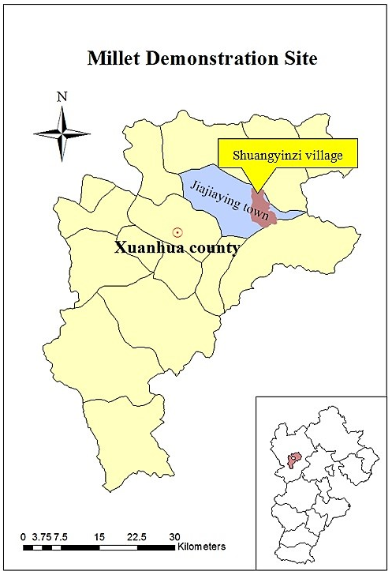
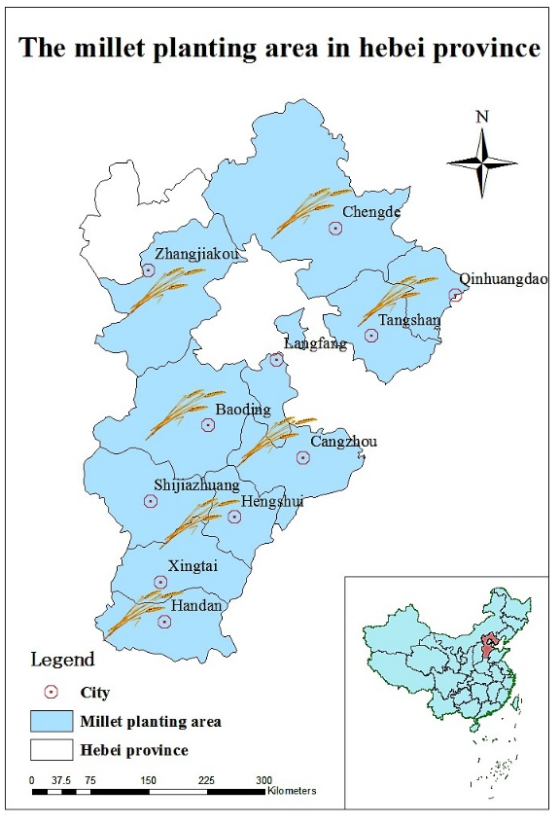

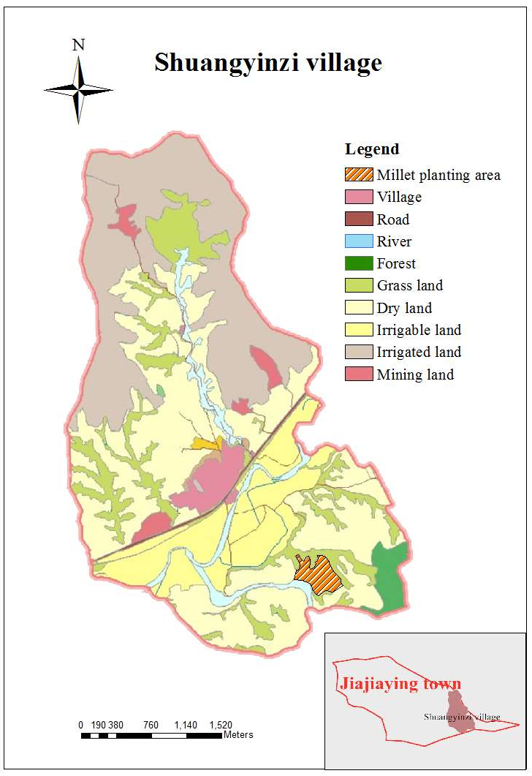

Zhonghua village, Zhangbei County, Hebei Province
Crop: Oat; Selected Traditional Variety: Sanfensan
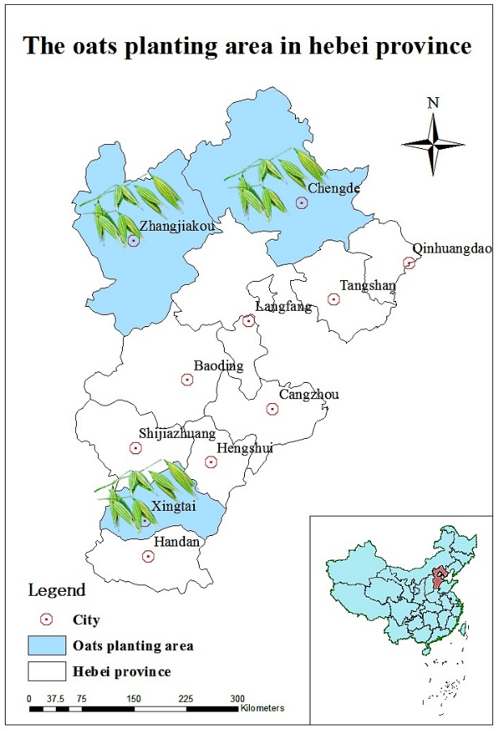
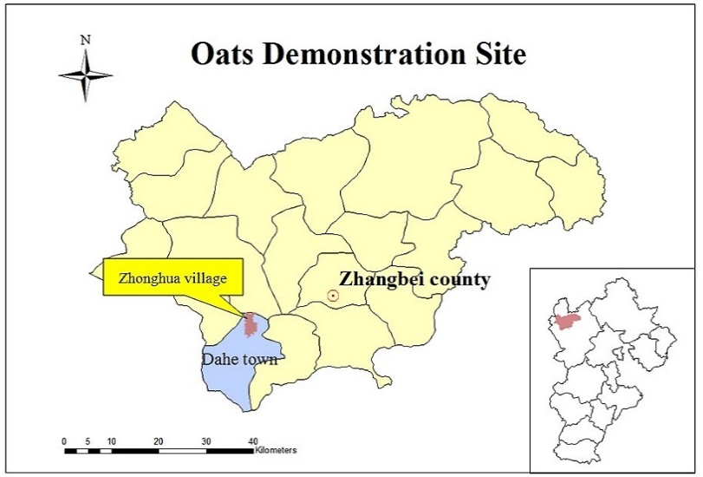

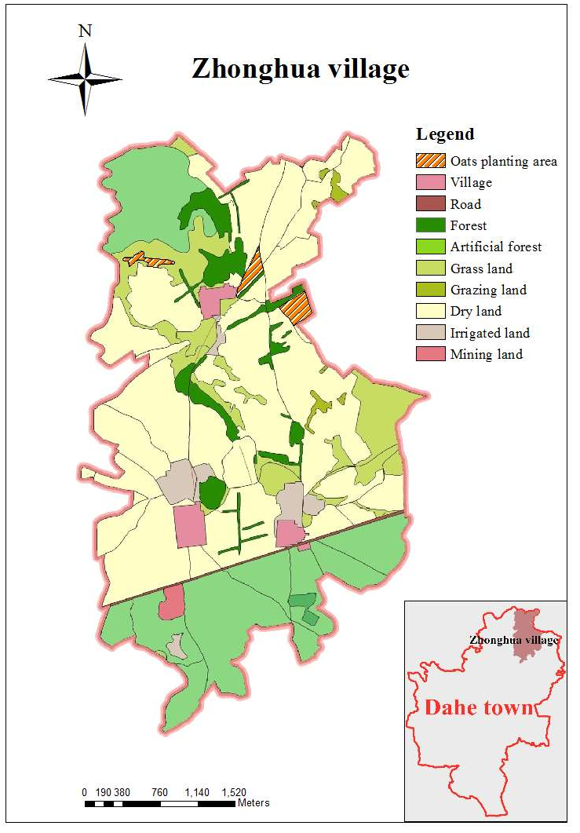

Shandong village, Muling City, Heilongjiang Province
Crop: Soybean; Selected Traditional Variety: Suinong 4
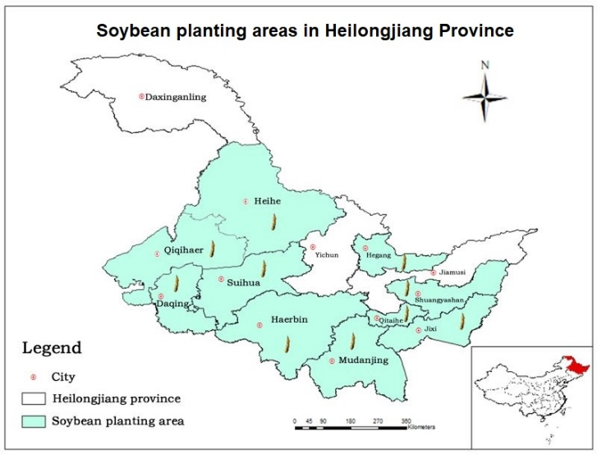
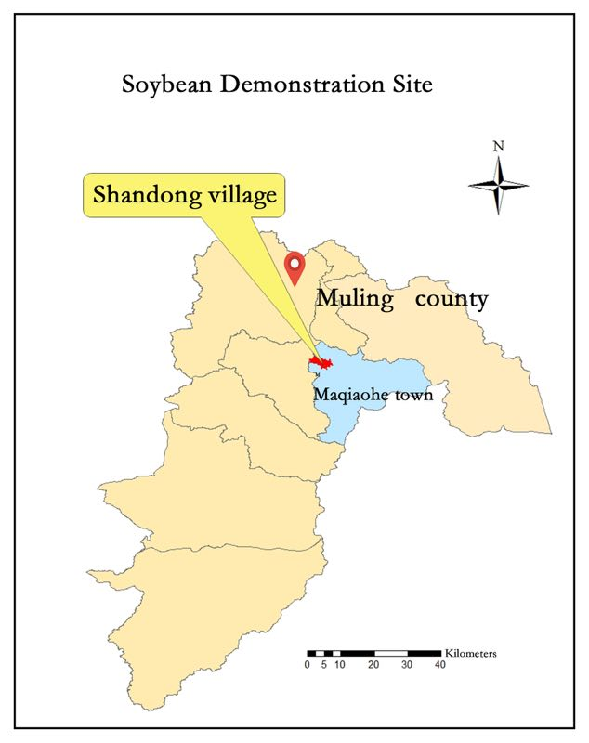

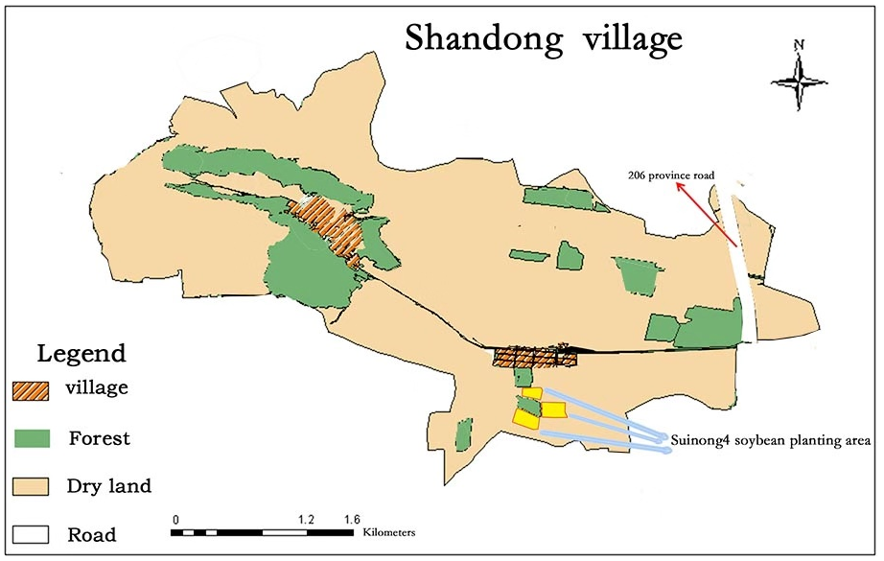

Sandaogou village, Kaiyuan County, Liaoning Province
Crop: Soybean; Selected Traditional Varieties: Kaiyu 9, Kai 8157, and Dabaimei
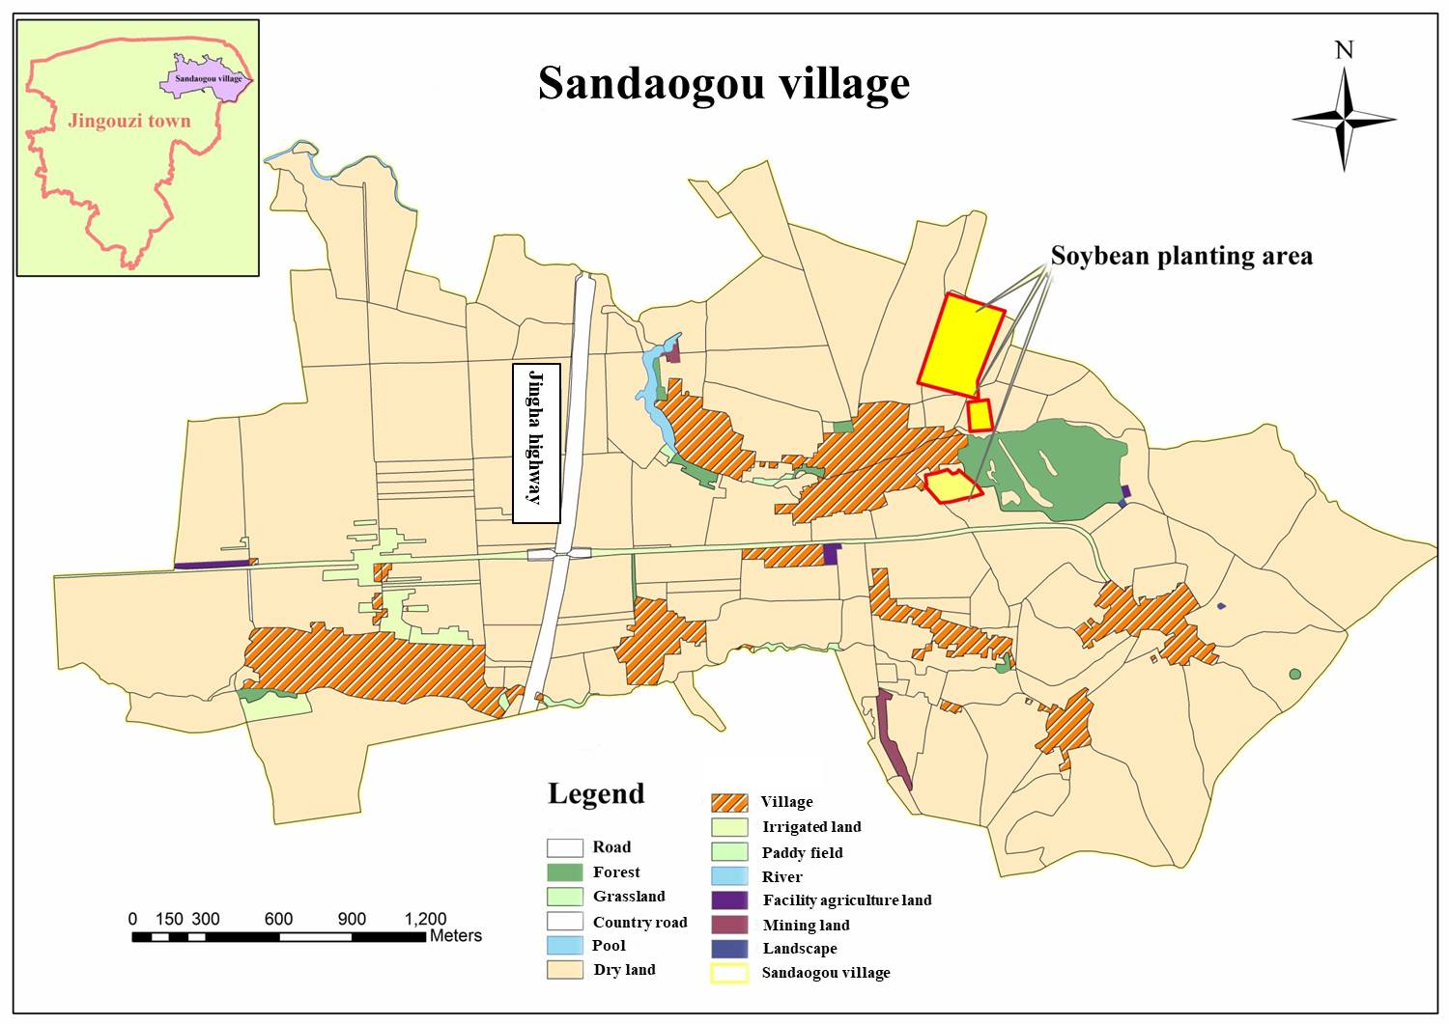
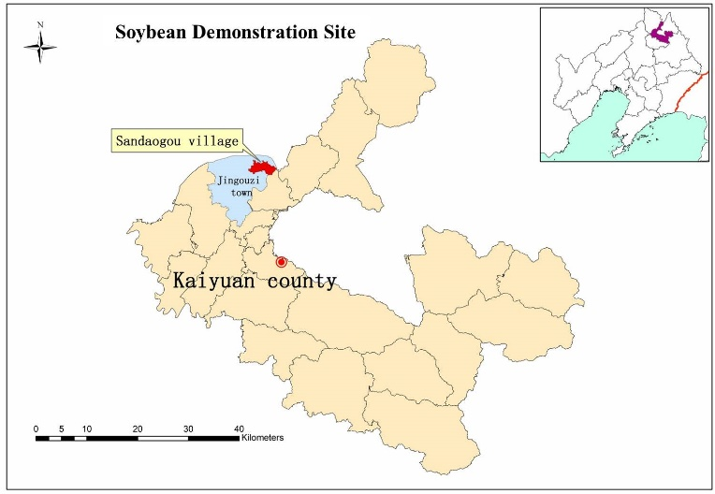
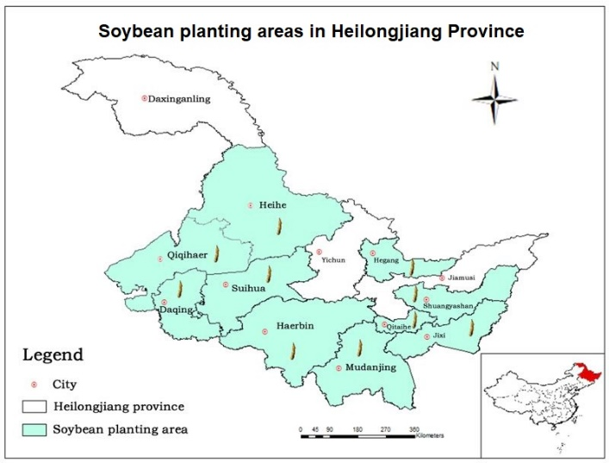
Yangjie village, Yuanjiang County, Yunnan Province
Crop: Rice; Selected Traditional Varieties: Mazha Gu and Honghezi Gu
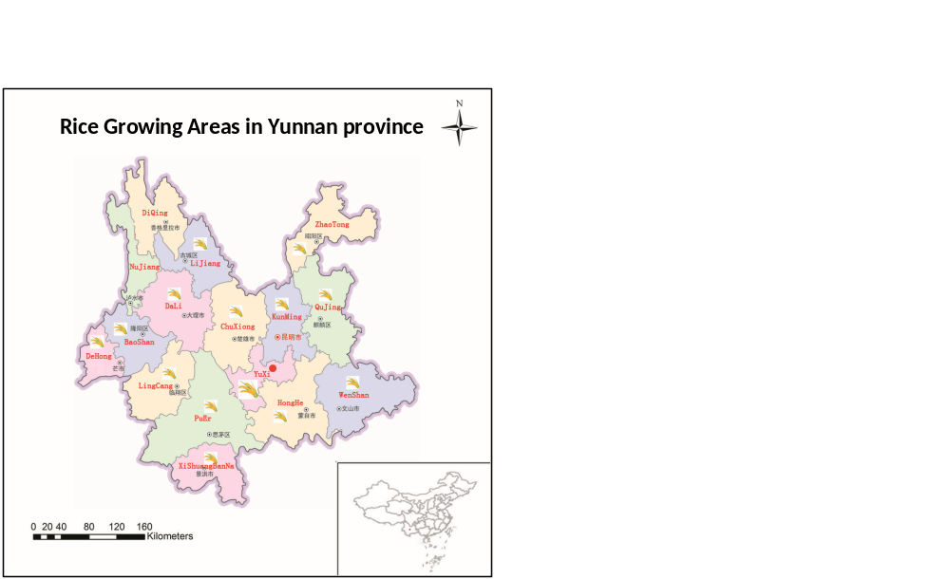
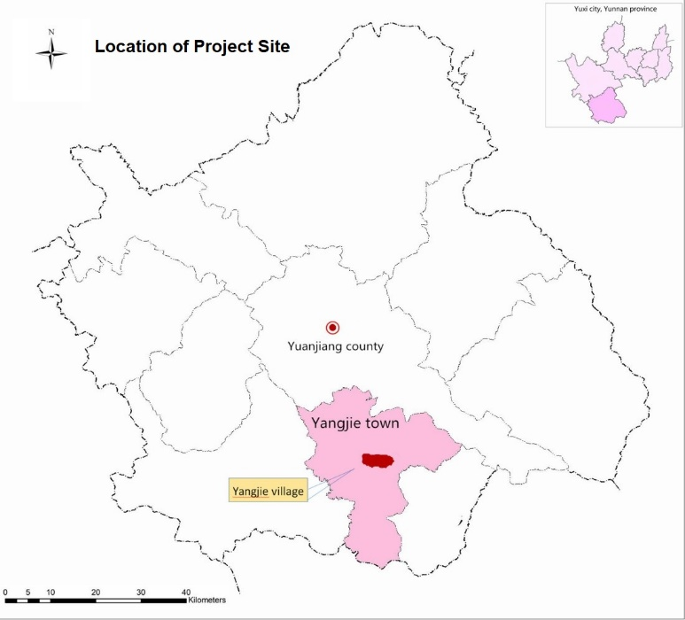

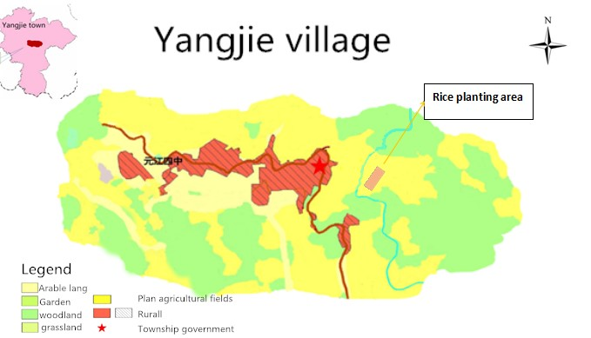

China National Biodiversity Conservation Strategy and Action Plan (2011-2030).
Vavilov, N.I. 1949. The origin, variation, immunity and breeding of cultivated plants. Chron. Bot. 13:1-54.
FAO. 2008. China Country Report on the State of Plant Genetic Resources for Food and Agriculture.
FAO statistics cited in: Carter, CA 2005. China’ Agriculture: Achievements and Challenges. ARE Update 14(5): 5-7. University of California Giannini Foundation of Agriculture Economics.
Development Report of Chinese Oat Buckwheat Industry, Twelfth Five-Year Plan, as cited in the PPG baseline assessment for oat, Hebei province.
China’s Fourth National Report on the Implementation of the Convention on Biological Diversity, November 2008, p ii.
Traditional crop varieties are local varieties of a crop that have developed over time through adaptation to their natural and cultural environment of agriculture and due to isolation from other populations of the species. The selected varieties have been maintained by local farmers in their fields for generations.
National Bureau of Statistics of China, April 2011.
Zhonghu, H., & Bonjean, A. P. (2010). Cereals in China. CIMMYT.
Exchange rate used in this document is USD 1 = CNY 6.9 based on the approximate average exchange rate during the period of baseline assessment, Sep-Nov 2018 as per www.oanda.com.
National Bureau of Statistics of the People’s Republic of China, Major Figures of the 2010 Census.
https://www.cbd.int/
http://www.fao.org/plant-treaty/en/
http://www.fao.org/docrep/015/i2624e/i2624e00.htm
https://sustainabledevelopment.un.org/sdg2
IPCC, 2014: Climate Change 2014: Synthesis Report. Contribution of Working Groups I, II and III to the Fifth Assessment Report of the Intergovernmental Panel on Climate Change [Core Writing Team, R.K. Pachauri and L.A. Meyer (eds.)]. IPCC, Geneva, Switzerland, 151 pp.
Ratnadass, A., Fernandes, P., Avelino, J. and Habib, R., 2012. Plant species diversity for sustainable management of crop pests and diseases in agroecosystems: a review. Agronomy for sustainable development, 32(1), pp.273-303.
Altieri, M. and Nicholls, C., 2018. Biodiversity and pest management in agroecosystems. CRC Press.
FAO. 2017. Climate-Smart Agriculture Sourcebook - Second Edition. Available online from: http://www.fao.org/climate-smart-agriculture-sourcebook/en/ Accessed 8 April 2019.
Mercer, K.L. and Perales, H.R., 2010. Evolutionary response of landraces to climate change in centers of crop diversity. Evolutionary applications, 3(5‐6), pp.480-493.
Luo, Y., Long, X., Wu, C. and Zhang, J., 2017. Decoupling CO2 emissions from economic growth in agricultural sector across 30 Chinese provinces from 1997 to 2014. Journal of Cleaner Production, 159, pp.220-228.
Lin, B. and Fei, R., 2015. Regional differences of CO2 emissions performance in China’s agricultural sector: A Malmquist index approach. European Journal of Agronomy, 70, pp.33-40.
https://unfccc.int/news/china-meets-2020-carbon-target-three-years-ahead-of-schedule
Urban areas are those with more than 2500 inhabitants according to INEGI.
July 2018.
Wen, J. and Q. Min. September 2017. Reviewing the Progress in the Identification, Conservation and Management of China-Nationally Important Agricultural Heritage Systems (China-NIAHS). Sustainability 2017, 9, 1698; doi:10.3390/su9101698. MDPI.
http://www.fao.org/giahs/giahsaroundtheworld/designated-sites/asia-and-the-pacific/en/
Capacity scorecards have been done at the national level and in each of the target provinces during the PPG phase. These are available with FAO and MARA, and can be provided if necessary.
Fu, Y., Chen, J., Guo, H., Hu, H., Chen, A. and Cui, J., 2010. Agrobiodiversity loss and livelihood vulnerability as a consequence of converting from subsistence farming systems to commercial plantation‐dominated systems in Xishuangbanna, Yunnan, China: A household level analysis. Land Degradation & Development, 21(3), pp.274-284.
Shen, S., Wilkes, A., Qian, J., Yin, L., Ren, J. and Zhang, F., 2010. Agrobiodiversity and biocultural heritage in the Dulong Valley, China. Mountain Research and Development, 30(3), pp.205-212.
Zimmerer, K. and Vanek, S., 2016. Toward the integrated framework analysis of linkages among agrobiodiversity, livelihood diversification, ecological systems, and sustainability amid global change. Land, 5(2), p.10.
Kahane, R., Hodgkin, T., Jaenicke, H., Hoogendoorn, C., Hermann, M., Hughes, J.D.A., Padulosi, S. and Looney, N., 2013. Agrobiodiversity for food security, health and income. Agronomy for sustainable development, 33(4), pp.671-693.
GEF-6 Programming Directions. Extract from GEF Assembly Document GEF/A.5/Rev.01, May 22, 2014.
http://www.fao.org/nr/cgrfa/cgrfa-home/en/
SDG Indicators: Metadata repository. https://unstats.un.org/sdgs/metadata. Accessed 10 April 2019.

